HTM

HTM is the Spanish market leader in high tech transport and installation services. We have a network of branches located strategically all over Spain, as well as current and continuous partnerships with companies all over Europe. HTM has a human potential that carries a great experience in the field of logistics and more specifically on the movement of materials with high added value.
We also offer temporary storage or in transit processes for the products we handle with a full warranty and reliability for handling such materials . We provide up to date and detailed information to our customers along the entire supply chain process.
Our company is specialized in the movement of large technological systems in the various segments such as medical systems, information systems, photography, banking and of course computer systems. We also have qualified personnel and the right resources for to cover widespread distribution needs within Spain and Portugal for consumer electronic products (TV, PCS).
As a partner of TecDis we have an extensive European network with correspondents in major cities of the European continent also including international shipments of these products. These services will be credited with a high level of quality and price competitiveness for repeated shipments to specific shipments.
At present, in our portfolio, customers have recognized our name within each market segment of high technology.
Your TecDis partner in Spain and Portugal
HTM SL
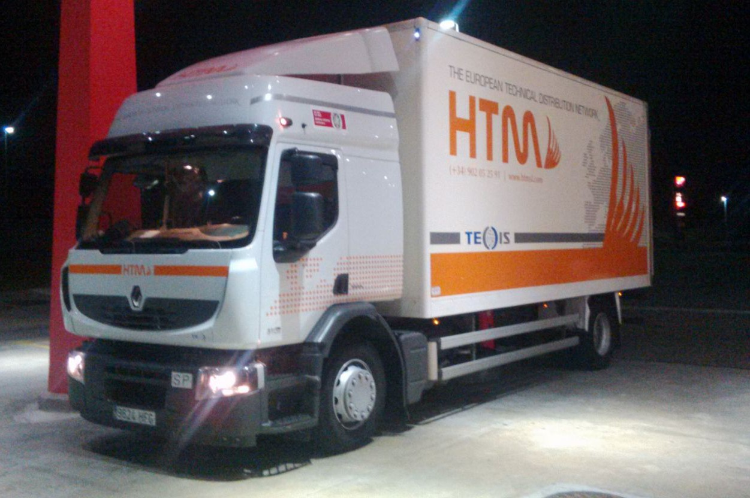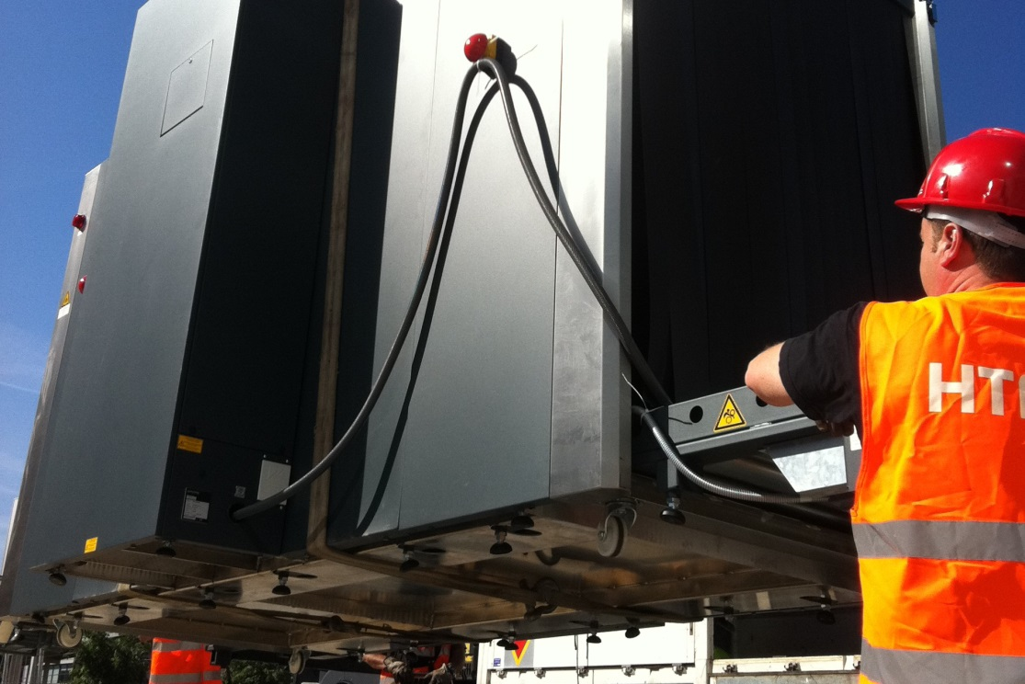
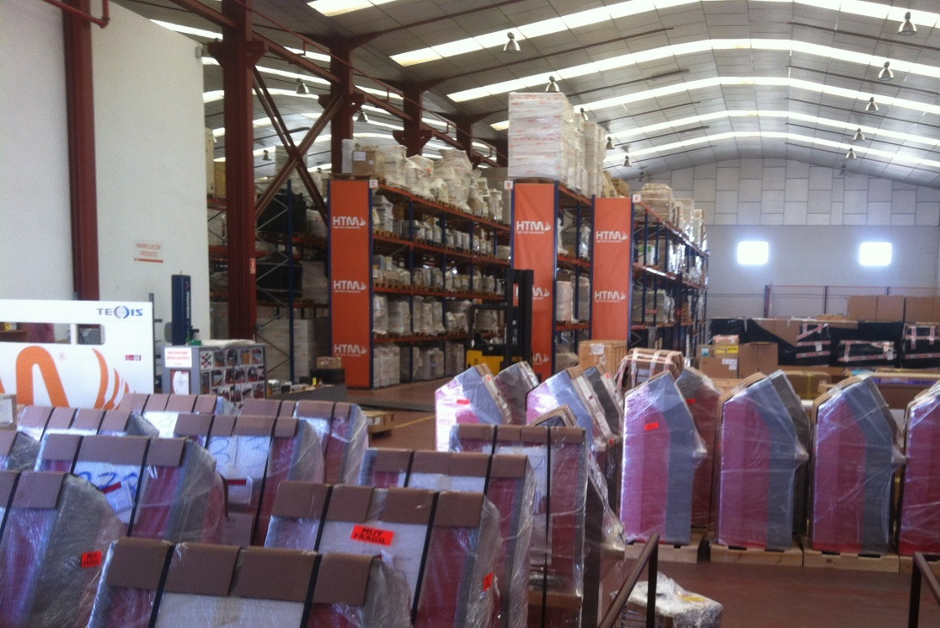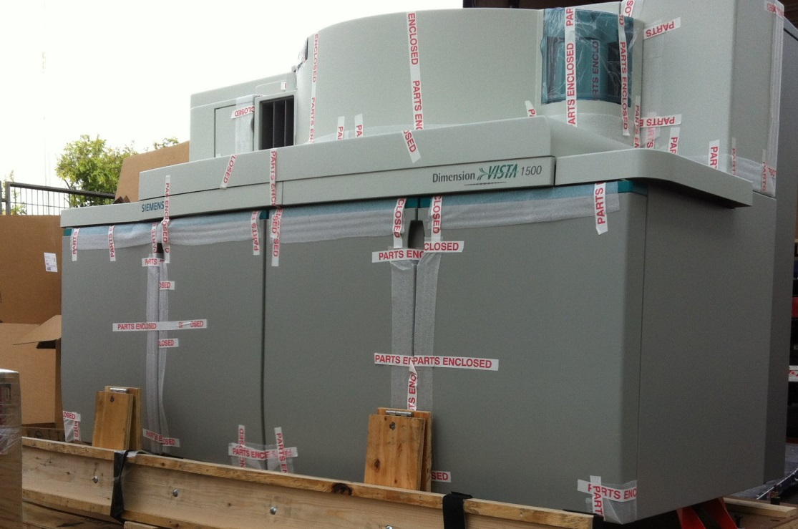

HTM HEAD OFFICE ADDRESS
Pol. Ind. Los Frailes
C/ Los Frailes Nº 52
Daganzo de Arriba
28814 Madrid
Website URL
www.hightechmovements.com

JUAN CARLOS ALVAREZ DEL VAL
Director Comercial
Tfno: +34 902 052 591
Móvil: +34 636 577 472
Fax: +34 917 850 169
jcarlos.alvarez@htmsl.com

