IT & Data
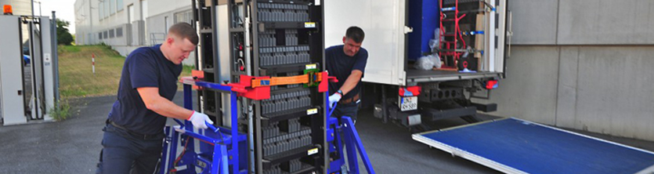
TecDis is responsible for the logistics of data rack hardware from production to final mile and positioning, using our dedicated, specialist vehicles. Our warehouses include technical areas for the building and configuration of data cabinets, allowing us to pre-stage hardware and merge orders in line with the end user requirements.
Included in our data rack logistics service offering is the on site our specialist handling equipment provides the capability to manoeuvre large and heavy data racks up stairs and across delicate flooring without having to depopulate servers.
The same applies to the whole spectrum of critical and comprehensive IT systems, including components and peripherals. We deliver to end users and distributors. Global & European roll outs from staging down to on desk installations and end user training.

- Pre-staging facilities
- Configuration and hot staging
- Cabling and connectivity
- Cabinet / rack build
- Product testing & configuration
- Software loading / data wiping
- Data cabinet and server installation

- Data centre roll outs / relocations
- Asset management
- E waste / WEEE / RMA processin
- Unpacked transportation
- Stair walking/climbing equipment
- Ultralift equipment for tilting
- White glove delivery
