Power
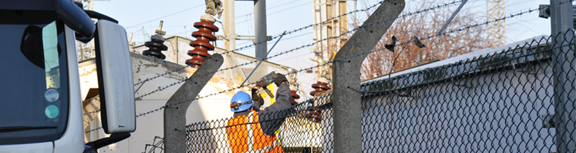
Power is the key element linking the high tech sectors. The high tech systems which we install require a reliable power supply in order to function at their optimum efficiency and maintain performance during a disaster recovery period.
As a common component across the majority of our customers the TecDis network has a great deal of experience in managing logistics projects of such systems. Often these systems need to be installed into obscure locations that, such installation require the use of our specialist handling equipment and trained operators.

- Detailed surveys and RAMS (risk assessments & method statements)
- Pre delivery configuration
- Battery charging
- Merge in transit order management
- Reverse logistics and disposal
- Crane lifting and management
- Data centre specialists
- DR and crash stock management
- Rooftop installation
- Low voltage switch gear
- Motor control panels
- L.V & H.V switchboards
- Uninterruptable power supplies
- Substation units
- Transformers and generators.
