Tecnotrans

Tecnotrans is the Italian market leader in high tech transport and installation services. We have a network of branches located strategically all over Italy, as well as current and continuous partnerships with companies all over Europe.
Tecnotrans has a human potential that carries a great experience in the field of logistics and more specifically on the movement of materials with high added value.
Our company is specialized in the movement of large technological systems in the various segments such as telecommunication, medical systems, information systems, printers, gaming machines, banking and of course computer systems. We also have qualified personnel and the right resources for to cover widespread distribution needs within Italy for consumer electronic products (TV, PCS).
We offer long term storage in combination with value added services for most of our bigger customers throughout the country. In addition we also offer temporary storage or in transit processes for the products we handle with a full warranty and reliability for handling such materials.
We provide up to date and detailed information to our customers along the entire supply chain process.
As a partner of TecDis we have an extensive European network with correspondents in major cities of the European continent also including international shipments of these products. These services will be credited with a high level of quality and price competitiveness for repeated shipments to specific shipments.
Tecnotrans represents TecDis in Italy.

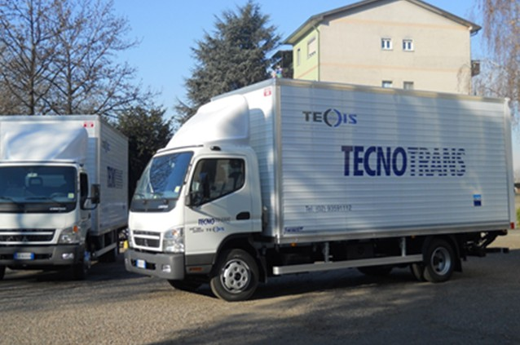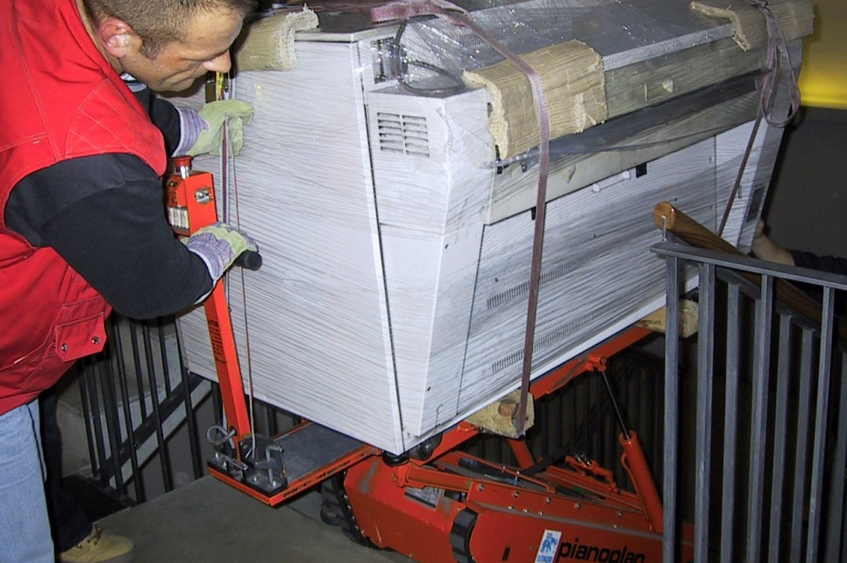
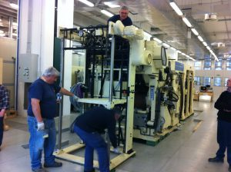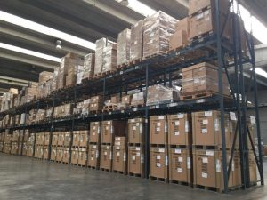


TECNOTRANS HEAD OFFICE ADDRESS

Tecnotrans srl
Via Cesare Castiglioni, 20
20010 Arluno
MILANO
Italy
Website URL
www.tecnotrans.eu

MR LUCA ALBANI

Procuratore
Phone: +39 0289 756 504
Fax: +39 0289 756 485
Mobile : +39 3356 240 857
luca.albani@tecnotrans.eu
Website URL
www.techmovesolutions.com

Emmett Coulter
Tel: + 353 (1) 822 2344
Mob: + (353) 86 8207648
Email: emmett@techmovesolutions.com

