High Tech Transport
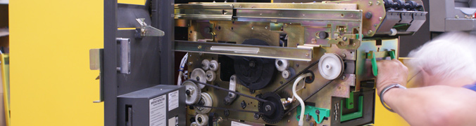

TecDis partners have specialist vehicles designed to meet the requirements for handling and moving delicate and high tech systems. Vehicles have air-ride suspension, high capacity tail lifts and hard bodied loading areas with strapping points and padding to safely secure equipment for transit. The diversity of our partner network fleet means that TecDis vehicles can cater to our customers high tech transportation requirements, offering everything from small vans for time critical items to 40ft vehicles for large projects with multiple systems or lorry loaders for large systems which require specialist lifting.
TecDis drivers and crew members are trained in line with manufacture standards and experienced in the most critical elements of high tech transport, the product handling, loading/unloading, protecting & securing the load and delivering the equipment to its final location.

Key characteristics of our high tech distribution services
- Own, high performing network
- Seamless quality standards
- Seamless product definition and execution
- 2 man premium distribution / handling
- Fixed schedules / leadtimes
- Central coordination
- Full transparency of shipment status
- Specialised fleet
- Special equipment for load security
- Air-suspended vehicles
- Mobile communication devices
- Consistent service levels across the network
