Office & Imaging
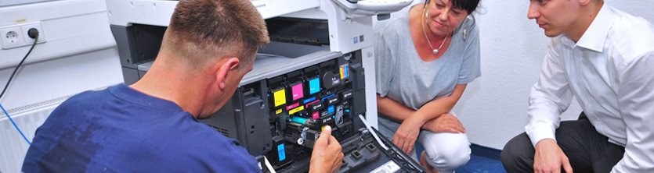
In the area of office equipment, TecDis assures the shipper as well as the consignee perfection down to the last detail. We handle the majority of the physical distribution for our document management and imaging customers. Whether it is copiers, scanners, large-sized printer systems, and facsimiles etc. – our special equipment provides safety in all logistics phases.
Trained teams which, in addition to the transport requirements, are also familiar with the technology of the products are your partner for final mile and installation on-site. Upon request professional technical briefings and product introduction is offered. We can offer the option of environmental disposal in line with existing legislation. Alternatively we organise return shipments, refurbishment and support resale.
- Unpacked delivery
- Installation and network setup
- Removals and WEEE recycling
- Software configuration and firmware upgrades
- Repair and maintenance
- Asset management
- Security cleared staff for access into high security buildings
- Train the trainer programs
