Banking & Retail
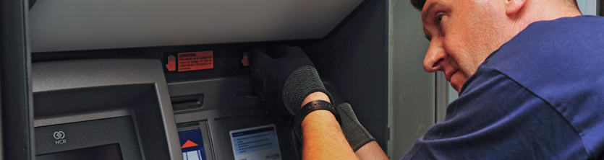

TecDis provide Banking and Retail logistics including the delivery as well as the pre-staging and commissioning of automatic cash dispensers (ATM‘s), bank statement printers or self-service terminals are our strengths in the banking and finance sector.
Relevant product knowledge supplemented with distinct manual knowledge ensures that the devices are not only professionally built in and installed, but is also safely secured.
We also offer customer specific rebuilding and refurbishing services to prolong the lifecycle. A service for reverse logistics and project management from end-to-end complement our offer.

- Pre delivery setup and staging
- Software loading and testing
- Delivery and installation
- Reverse logistics
- Accessory / ancillary design and manufacture
- Serial number asset checking
- PES and SC cleared staff
- Data wiping and E-waste management

