Tech Move Solutions

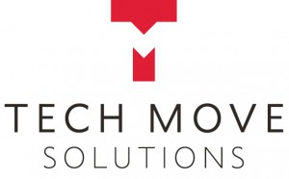Tech Move Solutions is the Specialist Services Division of Network International and has been assisting companies for almost 20 years in the movement of high value, sensitive equipment.
Our clients include brand leaders in industries such as I.T., Medical, Telecoms, Office Equipment, Power Supply and Banking. We work closely with companies whether small or multinational to ensure that their individual requirements are met in full. The services that we provide are vital in ensuring the safe movement of your equipment whilst at the same time minimising any disruptions to your organisation. All work is carried out by our own experienced crews and our fleet of dedicated, company owned, high spec vehicles that are equipped with the latest security and tracking facilities.
As is the nature of what we do, our crews are available to carry out your work 24-7, 365 days a year and we guarantee the security of your equipment at all stages. As a division of Network International we are strongly linked to a dedicated, company owned fleet of vehicles, servicing the Ireland – UK market on a daily basis. We operate vehicles between three depots in the UK (London, Birmingham, Manchester) and Dublin, Ireland, every day both inbound and outbound. This service enables us to provide a total in-house, one stop solution to companies for the safe and secure movement of their equipment.
We pride ourselves on providing the highest quality, best in class services to our customers. We operate a flat management structure enabling us to make swift business decisions to support our customers’ changing needs. Our flexible, yet focused business approach ensures that we deliver the right solution for our customer needs.
Your TecDis partner in Ireland
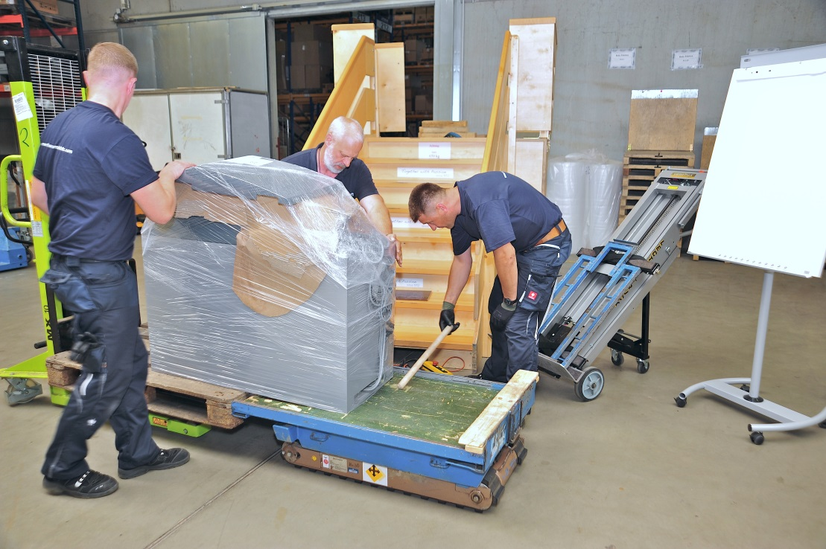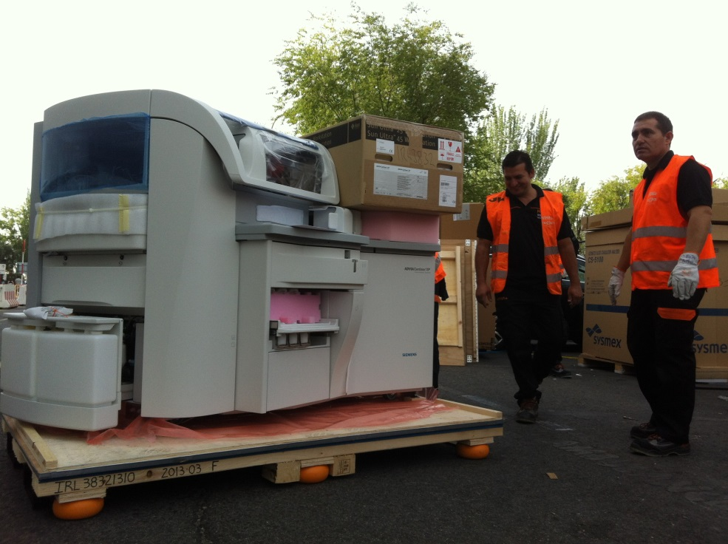

Tech Move Solutions Office Address
Tech Move Solutions
Unit 308
Northwest Business Park,
Blanchardstown, Dublin 15,
Ireland
Website URL
www.techmovesolutions.com

Emmett Coulter
Tel: + 353 (1) 822 2344
Mob: + (353) 86 8207648
Email: emmett@techmovesolutions.com

