

The combined experience
As pioneers, the high calibre partners of the TecDis network have significantly influenced and progressed the development of high tech logistics in Europe and beyond.
For more than 10 years this group of logistics specialists has provided successful solutions for technical distribution; always in close partnership with leading companies in the high tech and health care sector.

Our ambition
To always be the strategic partner of choice to gain competitive advantages for our customers, based on continuous quality leadership and forward thinking solutions. TecDis is already the leading network for technical distribution services in Europe and can look back on 10 years of successful European partnering. With ongoing globalization and a global customer base we are going to expand our network strategically.

The combined resources
Our capabilities and competitive advantage have developed continuously over the years. A common customer base and an increasing complexity in our tasks are our daily motivation.
We have grown with the challenges and needs of our customers and the industry. Today we are market leader in the most important European markets for technical distribution services for sensitive high tech and health care products and expanded our network continually to the main global markets.

The combined target
TecDis is the logical consequence of the close co-operation already practised by the partners in the high 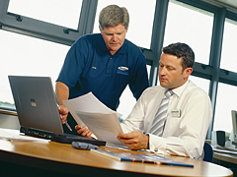tech sector.
Together we focus on end-to-end services, seamless and reliable for our common customer base. With the global brand "TecDis" we will set an example to further extend our leadership position in the future.
We will do this through:
- The consistent development of joint resources including personnel, fleet and state-of-the-art secure logistics terminals and platforms
- Specific further development of our value added service activities
- The continued creation of tailor made and innovative solutions for our customers
TecDis – the strategic partner to reach your business and logistics targets globally. Challenge us!

