Fitness
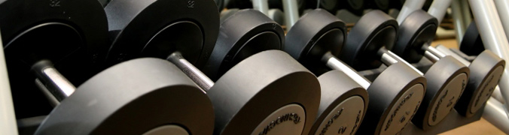
For the dynamic fitness, wellness and lifestyle market TecDis is your partner.
Products handled comprise fitness equipment, solariums as well as the entire spectrum of modern sensitive lifestyle devices.
TecDis offers tailor made roll out-solutions including pre-installation of the equipment in one of our logistics terminals. This guarantees minimal assembling times on-site and we do not disturb your ongoing business. We ensure that the equipment will be handed over ready for operation.

- Delivery, installation and removals
- Rollout management
- Pre-installation
- Machine calibration
- Waste removal and clean down
- Repair and maintenance
- Return and recycling of used equipment
- Studio compliant handling equipment
- Floor walk and instructor briefing
- Exhibitions and road shows

