Vending & Gaming
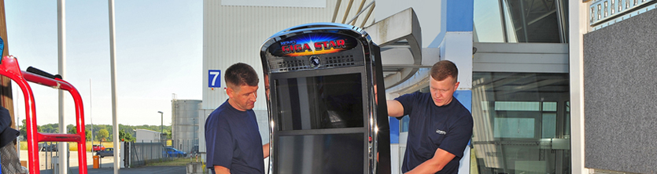

The extensive TecDis network provides full coverage for the installation and maintenance services of the vending and gaming industry. Our wide geographical coverage of Europe gives TecDis the capability to provide full service to this industry with it’s diverse geographical locations of active field units. Our specialist equipment and vehicles are well suited to the handling of vending and gaming equipment including the ability to move the equipment upstairs and into their final position.

- Delivery, installation and removals
- First fill & ready for use
- Software upgrades
- Maintenance programs
- Facia replacement
- Asset and estate management
- Airport and secure zone deliveries
- Exhibitions and road shows
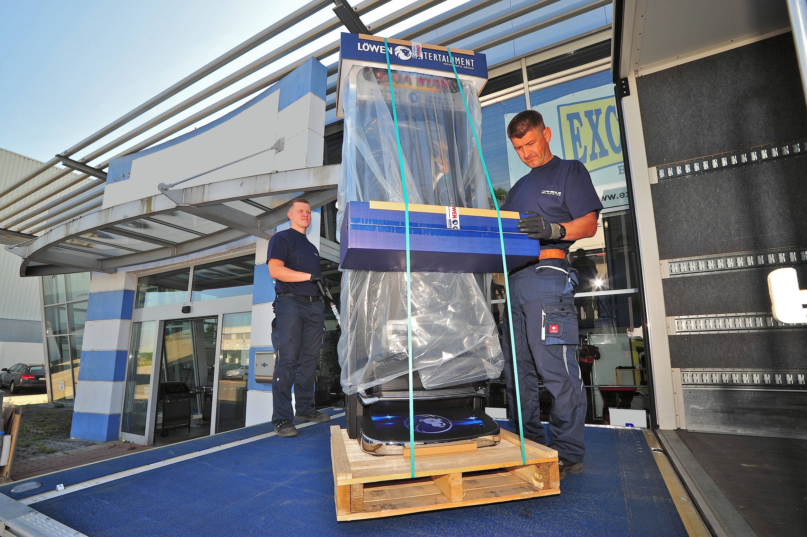
Edit

