Access control
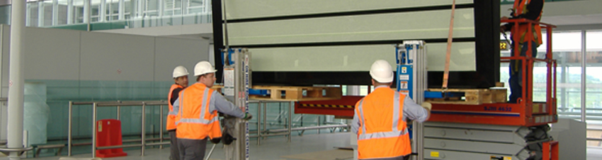

TecDis includes partners with experience of major project roll-outs of access control systems for public transport. The partner network skill set and experience includes access control renewals and upgrade projects. Scope of work is based around site delivery, specialist lifting, plant handling and installation solutions for many equipment types. Paying close attention to employee training and detailed operational planning for every aspect of the work.
- Kiosk installation
- Traffic management systems
- Ticket vending machines (TVM)
- Electronic information boards
- Passenger control barrier systems
- Quantity Surveying
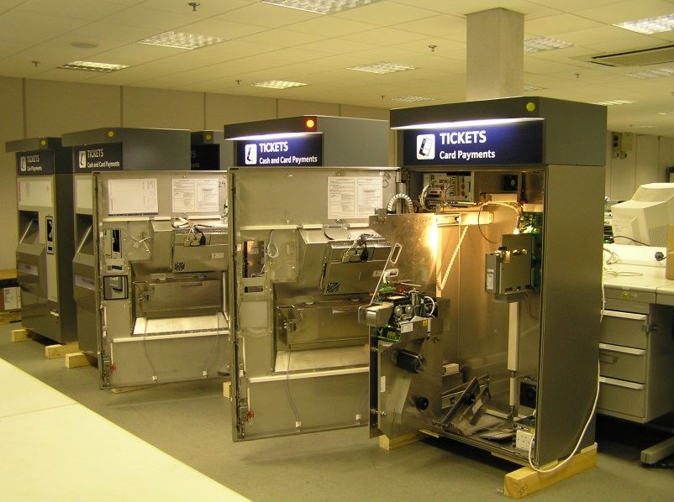
Edit

