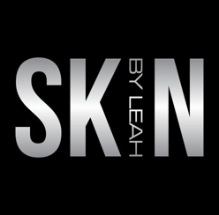
Front cover
Page 1
*Hydrafacial MD *Laser Genesis *IPL (Limelight)
*Vascular *Microneedling MD *LED Light Therapy
*VI Peel *Customized Facials & Peels
*Dermaplane

CUSTOM FACIALS
Page 9

SIGNATURE FACIAL $85 FOR 50 MINUTES
This customized facial is designed to refresh, clear, hydrate and refine skin according to your skin type. This facial increases circulation and prevents damage from daily environmental skin stressors. (hand and scalp massage included).

CLEAN PORE TREATMENT $90 FOR 50 MINUTES
A customized acne facial, according to severity of your acne, includes: skin analysis, deep cleansing facial, exfoliation and extensive extractions, followed by high frequency treatment to help kill bacteria in the skin. A balancing and antibacterial cooling mask hydrates and promotes healing leaving the skin clarified. 60 min. LED LIGHT THERAPY Included.

SIGNATURE O2 LIFT - A BREATH OF FRESH SKIN - $90 FOR 45-60 MINUTES
This luxurious treatment infuses oxygen, plant derived stem cells, peptides and a high concentration of enzymatic botanicals into the skin leaving it luminous, refreshed and rejuvenated.

FIRE & ICE RED CARPET FACIAL $125.00 (recommended Monthly)
The Fire and Ice Facial, by iS Clinical, is famous for its INSTANT brightening, smoothing and tightening of the skin. … This intensive clinical treatment is designed to resurface the skin, reduce fine lines and wrinkles and deep clean blocked pores. It truly is the secret weapon in the beauty industry and of some of Hollywood’s top names, including Halle Berry and Gwyneth Paltrow are loyal to this. It’s known in LA as the “Red Carpet Treatment”
We begin by applying a resurfacing masque (“fire”) that combines a powerful mixture of glycolic acid, retinol, vitamins, and antioxidants to remove old, dry skin. Next, we follow with the “ice” stage by applying a soothing masque made of hyaluronic acid, aloe vera, green tree extract, and peppermint to cool and hydrate the skin. The results: a beautiful, refined complexion without the downtime or side effects of more invasive treatments. The Fire & Ice facial is for all skin types and ages.

Back cover –
page 12


LEAH SHAFER
Aesthetician & Owner

BOOK ONLINE
www.SkinByLeah.com Or Call/Text (720) 608-3933
LOCATION: Skin By Leah 8683 Lincoln Ave #200 Lone Tree, Colorado 80124
BY APPT. HOURS:
Monday 10:00-am-4:00pm Tuesday 10:00pm-6:00pm Wednesday 10:00am-6:00pm Thursday 10:00am-6:00pm Friday 10:00am-6:00pm Saturday 10:00-4:00pm Sunday: Closed

EMPTY PAGE. DO NOT USE

Page
3
TESTIMONIALS
Leah is someone I definitely trust with my skincare needs because she truly cares about people and their issues. GRETCHEN ROSSI Realty TV Star/Housewives of Orange County
I have been seeing Leah Shafer for Hydrafacials. Ever since my first Hydrafacial my skin has had a healthy glow and texture. As an Aesthetic Professional, she helps me feel my personal best. CYNDY MARSH, R.N.
Having ethnic skin I’ve been hesitant about having treatments but Leah immediately put me at ease. She has taught me so much about my skin and how to care for it. Each time I’ve left with my skin looking and feeling amazing. MEMORY HOGAN - Real Estate Agent
I have now had two facials by Leah and each time my skin feels so refreshed and new! She has also helped my teenage son who has acne. Leah knew exactly what he needed and is already getting clearer skin. Worth every penny. KASSIAH MYERS - Mother of Five
I’ve been seeing Leah on a regular basis because she always goes above and beyond to ensure that I’m comfortable. She made the experience all about me and my skincare needs. She is highly knowledgable and offers creative options to make sure I get what I need. ERIN STEFANEK - Marketing Exec.
Page 2

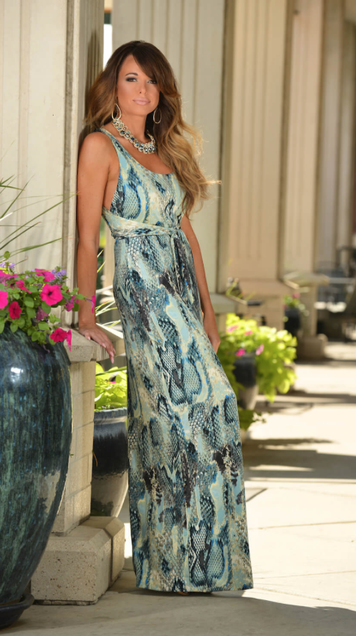
Leah Shafer Medical Aesthetician & Owner
As a teenager, I had cystic acne so bad that I would ditch school to swim in the ocean because the salt water seemed to dry out and heal my skin. I was on such a mission to clear my skin that I spent my weekly allowance on skin care products I saw on TV. Then, I memorized every ingredient. I was so intrigued by the beauty industry that, by 19, I began a career as a make up artist for Lancome, Mac, Bobby Brown, Prescriptives, and Stila. By 23, I was a skincare consultant for the Georgette Klinger Salons in Beverly Hills and Orange County California. I was honored to learn from the world’s most demanding clients.

I Understand Why Your Skin Matters
Admit it. We take more pictures of ourselves than ever…and then try to “fix” our blemishes with photo filters. I understand your frustrations. Some of you know I’ve had a parallel career as a professional singer with dozens of network TV appearances; where the HD cameras take extreme close ups…Yikes!). I also sing the National Anthem at NFL, NBA, and MLB games, where their 200 foot-wide JumboTron screens constantly remind me that skin imperfections are magnified. I will help get your skin more naturally beautiful so you can use less photo filters ;-)

Page 6
LASER IPL Skin Resurfacing
IPL Limelight (recommended every 4 weeks)

FULL FACE $300 (package of 4 = $1,020)
SMALL REGION IPL hands/spot treatment IPL $150 (package of 4 = $500)
CHEST $350 or (package of 4 = $1,190)

Page 5

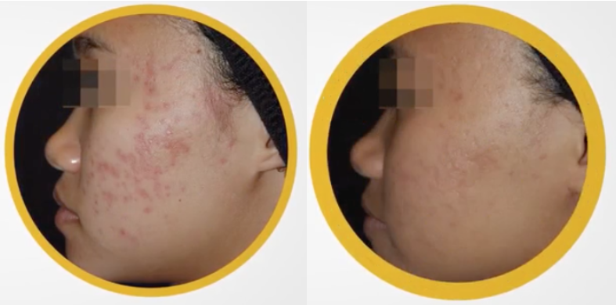
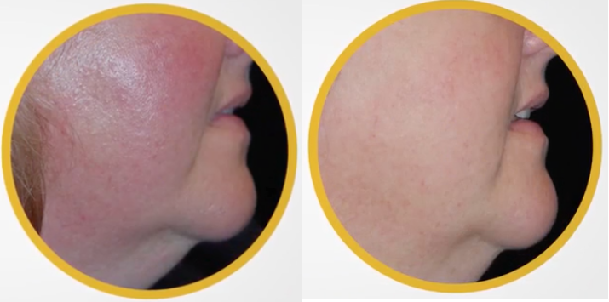
LASER GENESIS
VASCULAR/Broken Capillaries
This is a non-ablative procedure that improves skin textures, redness/rosacea, enlarged pores, and scars w/ NO DOWNTIME. (recommended every two weeks)
Individual Treatment $250 Series Package of (6) $1,275

Empty page – do not use

WHAT IS MICRONEEDLING?
MicroNeedling is a safe, effective and minimally invasive procedure which creates a series of micro channels on the skin, resulting in glowing, smoother and younger looking skin but without the downtime or trauma that is associated with laser or chemical treatments. Face $250 Face & Neck $290
Page 7
EMPTY PAGE…DO NOT USE
Page 10
MY FAVORITE I PEELS

I PEEL/ORMEDIC LIFT $90.00
Organic ingredients with medical effectiveness work to rebalance regenerate and restore skin while stem cells boost cellular turnover Skin Type indications: Unbalanced, irritated, sensitive (aloe vera based).

I PEEL / SIGNATURE FACELIFT $90.00
The Signature Facelift peel delivers wonderful results right away. For Redness-prone, dry/dehydrated, smoker’s skin, tired/dull.post-microdermabrasion, oily/acne.

I PEEL / LIGHTENING LIFT $90.00
Lactic Acid blended with kojic acid and a cocktail of brightening agents to reduce all forms of pigmentation, sun spots, uneven skin tone, hyperpigmentation, redness prone.

I PEEL/ WRINKLE LIFT $90.00
The ultra-resurfacing blend of glycolic and retinol visibly reduces the appearance of fine lines and wrinkles, leaving skin firm and revitalized.
Wrinkle Lift Solution is an outstanding peel. It’s powerful enough to exfoliate the skin thoroughly, yet gentle enough that the skin does not flake for days afterwards. It leaves the skin feeling smooth, soft, and plumper.

I PEEL / ACNE LIFT $90.00
Blend of AHA’s and BHA’s with protective agents to effectively treat all grad of acne. ( Hydrafacial extractions available upon request for additional add on) Skin Type: Acne, oily, acne-prone, aging.

I PEEL / BETA LIFT SEVERE ACNE $90.00
30 minutes: This powerful non-blended salicylic acid treatment quickly and effectively targets and improves moderate/severe acne. Skin Type Indications: Acne, oily, aging.

I PEEL PERFECTION LIFT FORTE $90.00
ADVANCED concentrated blend of lactic acid, salicylic acid and resorcinol works synergistically to quickly and effectively reduce the appearance of advanced aging, pigmentation and acne. This EXTRA STRENGTH treatment reveals a younger you in 1 single treatment. Skin Type Indications: Advanced aging, pigmentation, acne.

Page 8

DERMAPLANING $65
This is a non-invasive skin care procedure that thoroughly exfoliates the topmost layers of skin and provides a smooth, even complexion. This procedure is intended to treat deep scars, but gentler versions can be used as hair removal or exfoliating treatments. KISS YOUR PEACH FUZZ GOODBYE!

LED LIGHT THERAPY $50. Add Light Therapy to any service for $40

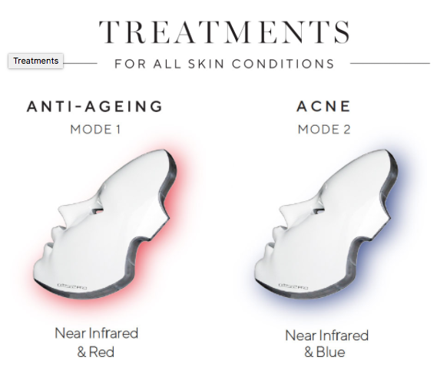
We use the Deesse PRO. It is the market leader in LED masks and provides the highest strength in LED output. Light therapy is great for Anti-Aging, Acne, Post Procedure, Pigmentation Optimization, and Roscacea. The PRO has four modes depending upon your skin type and outcome. Zero downtime.

Anti-Aging Acne

Page 11
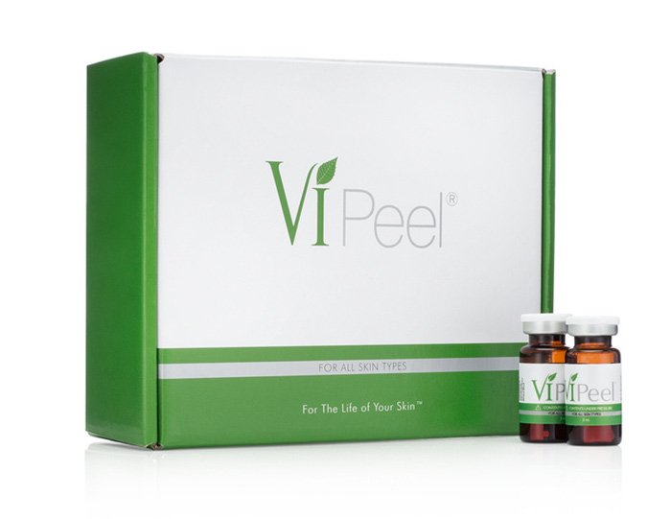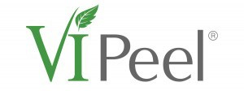Medical Results Yet Simple & Painless
VI Peel $250.00
Your Peel For Anti-Aging Skin
The aging process can cause your skin to become lax, pigmented and rough. Sun exposure and environmental assault just adds to the problem. Aging is inevitable but the VI Peel can make a difference in as little as 7 days. More than 10 years of experience with satisfied patients across the world. Specifically formulated to rejuvenate aging skin and help prevent future damage.

VI Peel with Precision $250.00
Your Peel For More Advanced Aging Skin
Precision is a booster to be used together with the VI Peel. It is formulated with the same synergistic blend of ingredients as VI Peel but at a higher concentration. For when your peel needs that extra boost! Specifically formulated to rejuvenate harder to treat aging skin and help prevent future damage

VI Peel with Precision Plus $300.00
Your Peel For Sun Spots and Pigmented Skin
Hyperpigmentation is a condition when patches of skin become darker than the surrounding skin. Although it is usually harmless, it can be difficult to treat effectively. The VI Peel Precision Plus can help restore the skin tone you deserve. Specifically formulated for pigmented skin.

VI Peel PURIFY with Precision Plus $350.00
Your Peel For Acne Scars and Skin Damage
During your battle with acne, you can be left with scarred skin and sometimes increased pigmentation. Acne scars will often fade over time but sometimes they need a little help. VI PURIFY with Precision Plus will help eliminate acne scars and skin damage leaving your skin smooth and clear. Specifically formulated for acne scars.

Page 4
HYDRAFACIAL MD is for…
Fine Lines and Wrinkles - Elasticity and Firmness - Even Skin Tone and Vibrancy - Oil and Congested skin - Enlarged Pores - Brown Spots
Signature Hydrafacial $149 (30 min)
Deep cleanse and exfoliation, extracts, and hydrates your skin utilizing super serums filled with antioxidants, peptides and hyaluronic acid
Age-Refinement Hydrafacial $175
Includes DermaBuilder to reduce the appearance of fine lines and wrinkles. Plumps your skin to a youthful state.
Platinum Hydrafacial $250
The ultimate Hydrafacial Experience! Begin the detoxification process with Lymphatic Drainage. Then, the signature Hydrafacial deeply cleanses, exfoliates, extracts and hydrates the skin while addressing your specific skin concern with a Booster of your choice. Treatment concludes with LED Light Therapy to reduce signs of aging.

