2017 Branding Guide
Vertical Logo Horizontal Logo
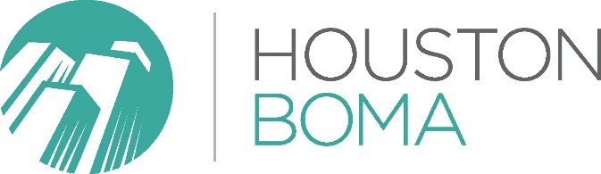
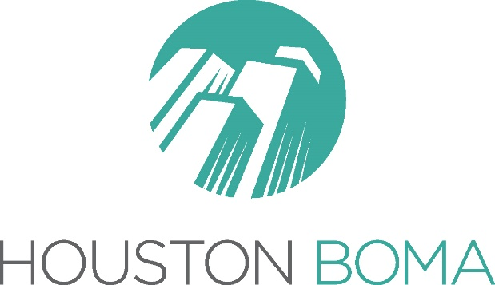

Main Font:
Gotham Light
Alternative Serif/Stylized Font:
Chaparral Pro
Chaparral Pro Bold
Chaparral Pro Light Italic
Logo Colors:
Green - CMYK: 72,13,44,0 | RGB: 64,168,157 | HEX: 40A89D | PMS: Pantone 2401 C
Dark Grey - CMYK: 61,52,50,21 | RGB: 99,100,102 | HEX: 636466 | PMS: Pantone Cool Gray 10 C
Light Grey - CMYK: 32,25,26,0 | RGB: 177,177,177 | HEX: B1B1B1 | PMS: Pantone Cool Gray 5 C
Red (Accent) - CMYK: 4,91,84,0 | RGB: 230,62,57 | HEX: E63E39 | PMS: Pantone 2034 C

