HOMEPAGE

HEADER
1a
Centrinel LOGO (See Branding Document)
Secure Connections Written Under (see wireframe)

1b
Home / About Us / Contact / Login

BODY
WELCOME TO CENTRINEL
The premier IT Solutions Marketplace of the 21st Century for both Providers & Customers

1d & 1e have a look at digitalmarketer.com – Similar concept
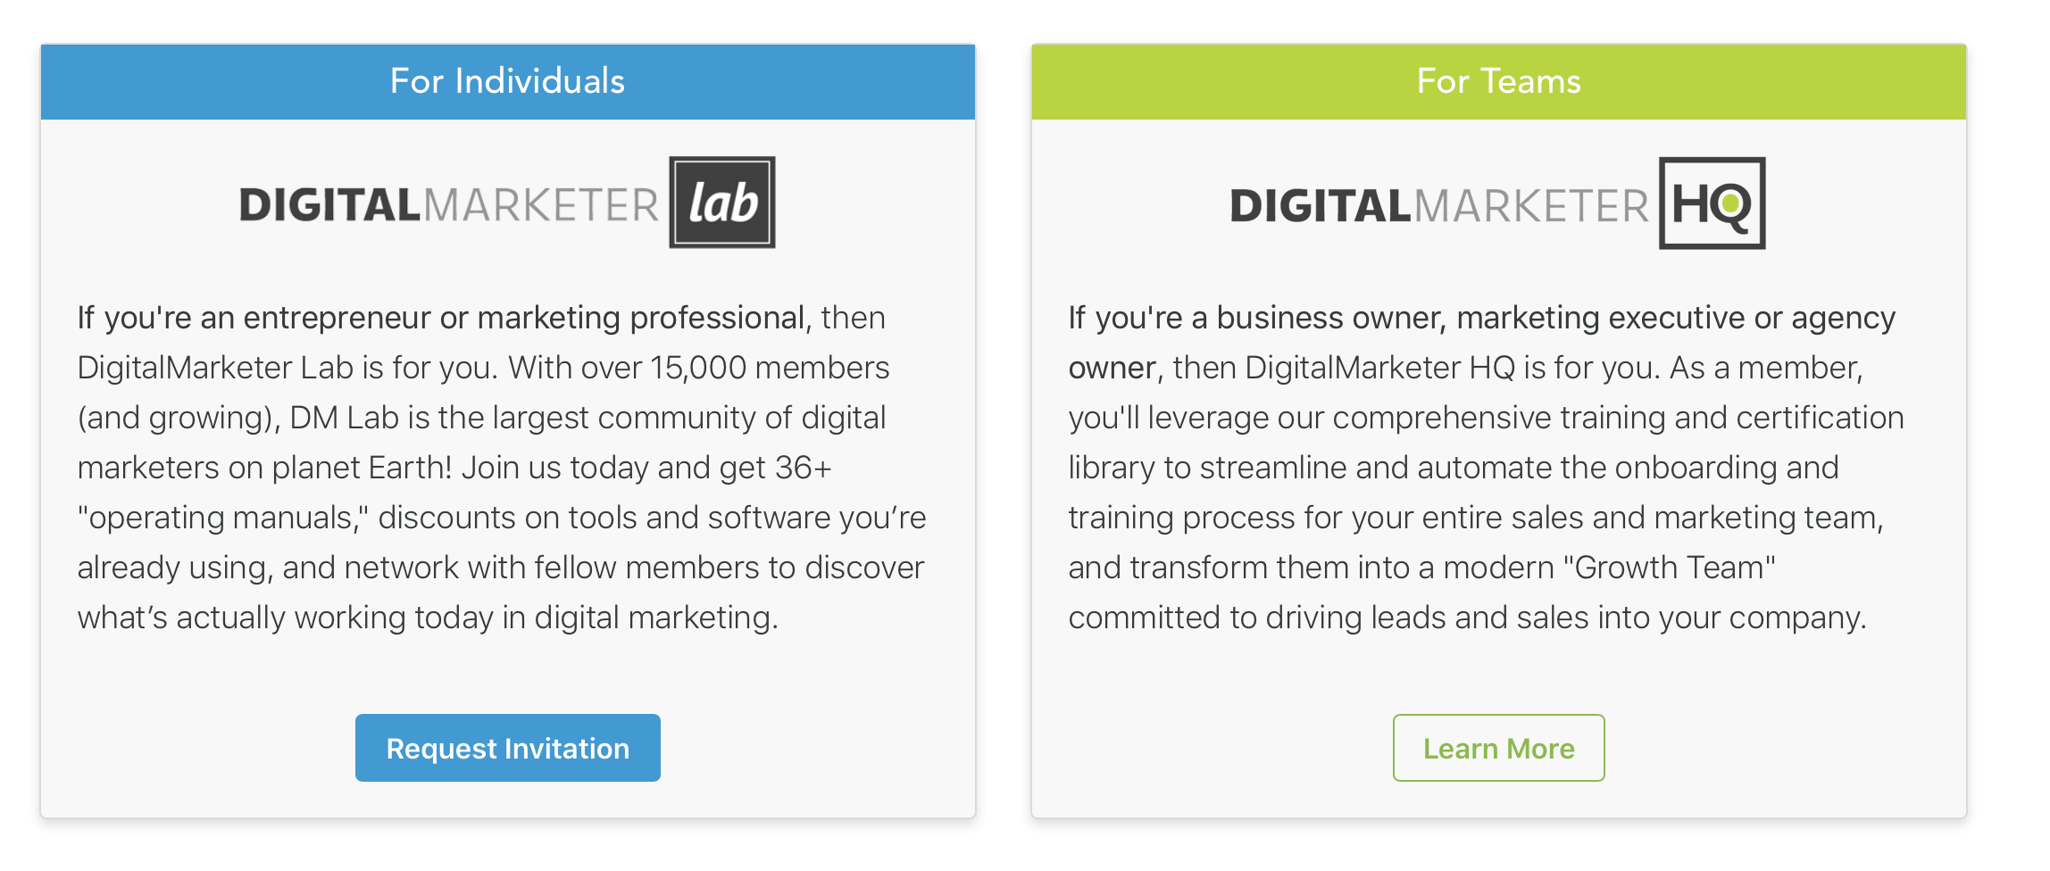
1d
CUSTOMERS
Members with IT Infrastructure Projects
If you are a technology leader with IT Infrastructure projects - from IT Directors, CIOs, and CTOs, to other key decision makers, such as CFOs and CEOs, Centrinel is your answer. We even help procurement teams have a new approach. We find solutions that work for your project needs, through a secure, free platform. With years of experience in the marketplace, we match your proposals with the best providers. All industries can be serviced: financial, legal, health care, federal, state & local, retail, construction, hospitality and many more. Join us today for the solution you’ve been searching for. procurement

BUTTON: Request Invitation

1e
PROVIDERS
Members who manufacture or are certified to Resell Hardware, Software, Cloud & Managed Services.

If you are a provider who manufactures or is certified to resell hardware, software, Cloud & professional services, Centrinel is your solution. Through our systemized marketplace, we bring quality leads to your doorstep, allowing you to focus your energy and time on what matters most - serving your customers well. Leveraging 40 years of industry experience, we create something beyond the average lead-gen; this is intelligent lead gen that can dynamically channel your leads by sales territories. Join our network today to transform your business by streamlining your marketing strategies.

BUTTON: Learn More

INTRODUCING CENTRINEL

CUSTOMERS
1. Save Time
With Centrinel as your marketplace solution, we act as the secure liaison between you and providers. This eliminates presales meetings and calls by reducing your responsibility to filling out a digital discovery questionnaire. This allows Centrinel to provide you with multiple design proposals - in less than half the time.
2. Expand Your Reach
We search the globe to find your best designs. Centrinel curates the finest solutions for your IT needs. By leveraging our growing database of premier providers, we purposefully bring you a diverse selection from the best engineers and technology leaders in the market today.
3. Secure Your Connection
During the initial phase, your identity is protected until we make a secure connection. Before releasing contact details, Centrinel provides you, the customer, with pricing, design, and provider selections to make powerful decisions. We then introduce you to the ideal partner to finalize your IT needs.
Button: REQUEST INVITATION

PROVIDERS
1. Simplify Your Process
Centrinel protects the value and identity you’ve worked so hard to build, while automatizing the customer’s experience. This marketplace streamlines your sales efforts, creating a digital process for project requests. Diversify your efforts, future proof your organization, and let us sell on your behalf.
2. Extend Your Marketing, With Minimal Costs
Centrinel becomes your marketing arm. We spend our money on marketing, advertising, and quality lead generation. Every dollar spent drives customer IT projects to your door. And for you, the process is free, with a small commission for secured projects. We save you time and money, letting you focus on building revenue.
3. Receive Vetted, Actionable Leads
We invest our time contacting customers on your behalf, every single day. Clients are vetted through an in-depth questionnaire to find the best match. Centrinel provides an invaluable service to customers that equates to opportunities for you.

Button: LEARN MORE

HOW IT WORKS

2a - Customers
Customers anonymously submit Project Requests via a detailed, Discovery Questionnaire.

2b - Centrinel
Centrinel is the premier IT solutions marketplace, revolutionizing the connection between IT Infrastructure Providers and Customers in an automated, global process. For Providers, this service delivers consistent, quality leads with minimal effort. For Customers, it creates an anonymous, secure buying process that is fast, easy, and free.

2c - Providers
Providers receive Customer requests & submit Project Proposals.

WHY CENTRINEL

INSERT PHOTO
“After 18 years on the sales side of the IT industry, I understand the pain points both the Customer and the Provider encounter on a daily basis. During the complicated and multi-layered process of IT Infrastructure exchanges, I knew there was a better way to bridge the gap between the two parties. That’s how Centrinel came to life. Our aim is to make the process secure and protected. We empower the customer to make quality choices, while enabling the provider to access exceptional projects through systematized, consistent, and healthy competition. Centrinel creates keys for both sides of the equation to unlock their best outcomes.”
~ David Guercia, Founder and CEO of Centrinel

