FLAT OVAL DUCT WORK
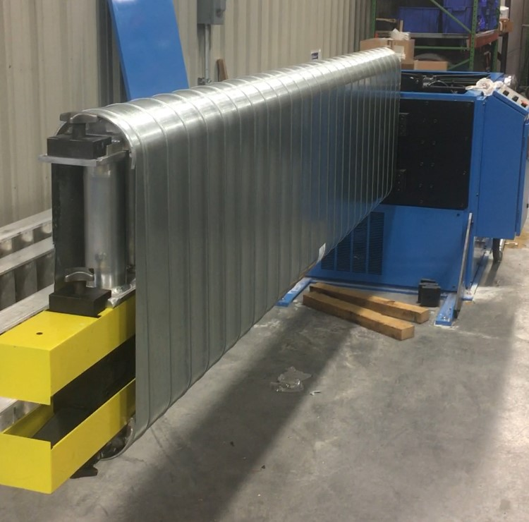
Flat oval spiral ductwork offers the appealing look of regular round spiral but with the abilities to provide airflow in tighter space restrictions like rectangular duct such as low ceilings. The flat oval process starts with round ductwork that is stretched to a list of given flat oval sizes. There are a certain amount of flat oval sizes that the round pipe can be stretched into so consult the factory for a list of available sizes.
Galvanized pipe is manufactured with spiral lockseam construction, seam type RL-1, from minimum hot dipped steel meeting ASTM A527. Spiral pipe and fittings are available in stainless steel, aluminum, galvannealed and aluminized. Dual wall round ductwork is available with a perforated inner wall and with any of the listed material types for the outer wall. A solid inner wall is also available and with 1" or 2" insulation thickness.
Due to the numerous major and minor sizes that are available, flat oval duct work is made to order. Contact us for current lead times and a chart of available sizes.

PRODUCT DESCRIPTION:
- Pipe is available in shorter or longer cut lengths, standard length is 10’-0”
- Various flange connections are available loose or installed
- Round and rectangular saddle taps available
- LEEDS wrapping services available

