Language: DE, EN, ES, FR, IT

Site: www.nubive.com (currently WordPress) but free to change to any other CMS

Colour: friendly, serious and not too fancy, as we sell high quality nutrition products – packaging examples are at the end of this document.

Pictures: all pictures you see below are just place holders… just the red framed graphics showing raw material, sachet (Nescafe) and Easy to consume must be designed.

Responsive: 100% mobile support must be granted

Amazon link: Link from Product overview and product detail page to Amazon ASIN that customer can purchase from Amazon Website

Content: no hardcoded content, text and all elements must be editable via editor. Publish-unpublish function, link table to add QR codes for new products must be editable.

- Landing page head line:
  - DE - Wohlbefinden durch intelligente Forschung
  - EN - Well being through smart research
  - FR - Bien-être grâce à la recherche intelligente
  - IT - Benessere attraverso la ricerca intelligente
  - ES - Bienestar a través de la investigación inteligente

Graphic with many ingrediencies (raw material) …falling down eider into sachet or capsule

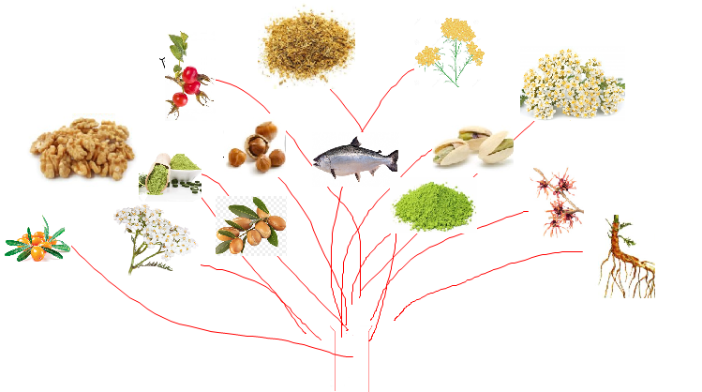
-1
This raw material is eider packed in Capsules or Sachet

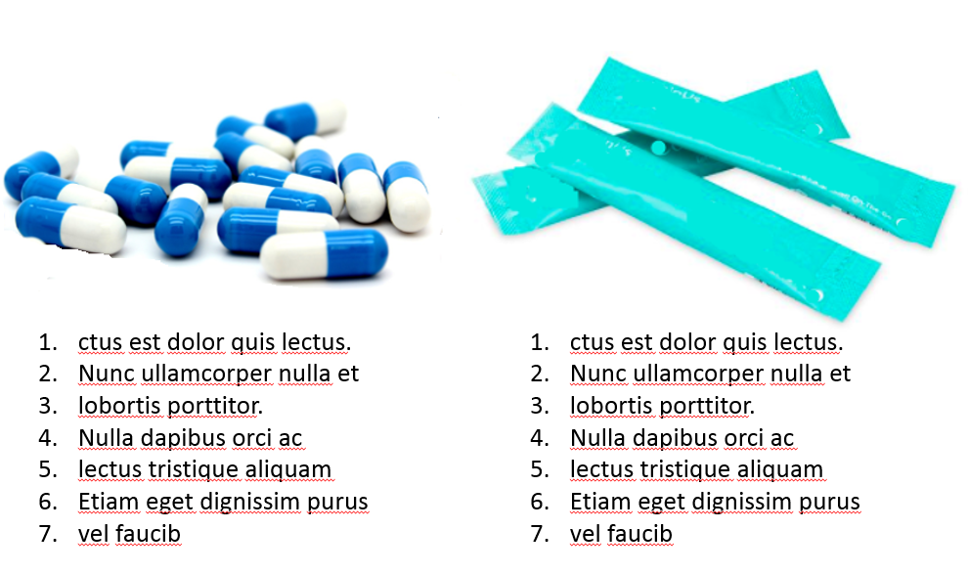
-2

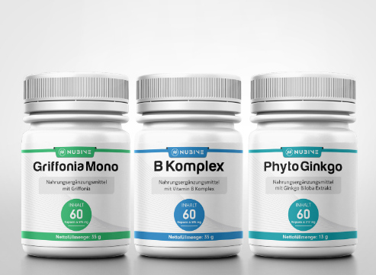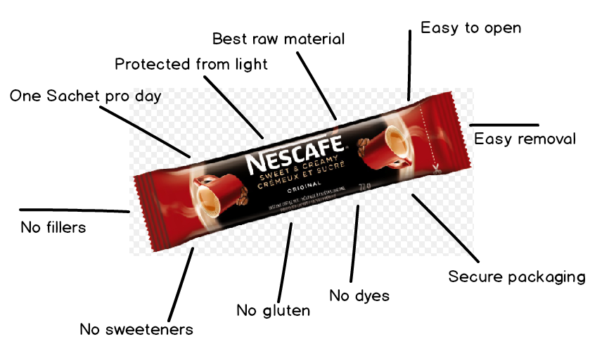

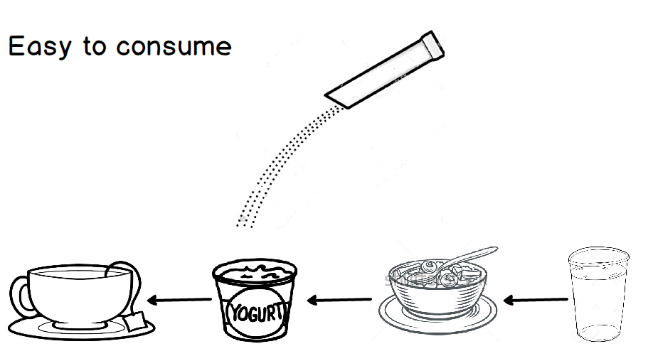
Figure-3

Smart living    Nutrition supplements | Smart dieting  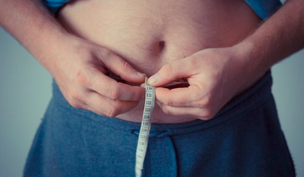  Dieting supplements | Smart body  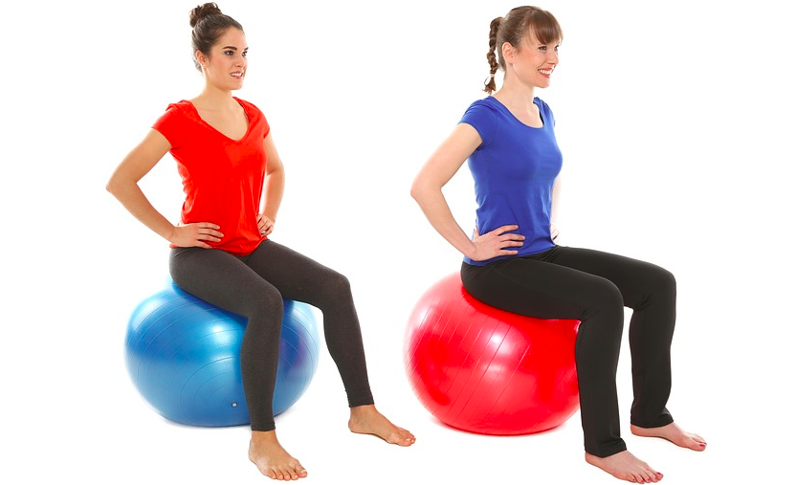  Sport supplements

Product overview with link to detail product pages:

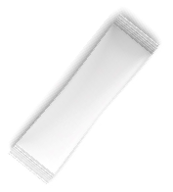Smart Brain Komplex  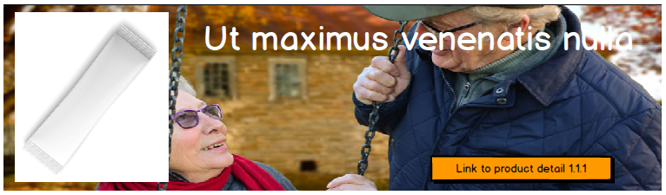  Link to detail product page  Product 2 | Product 1  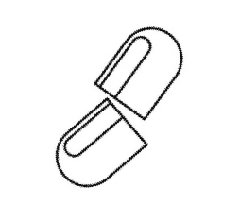Griffonia Mono  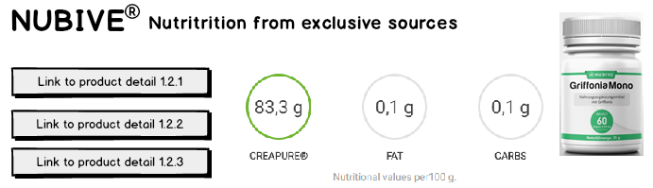 | B-Komplex  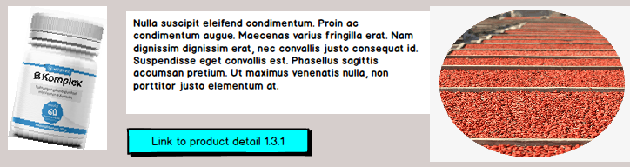  Product 2  Cosmetic oil  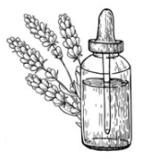Product 1  Product 2

- About us
- Blog
  - Smart living
  - Smart dieting
  - Smart body

- Social Media
  - Instagram
  - Facebook
  - Pinterest

Product detail page – with button to place order at AMAZON.

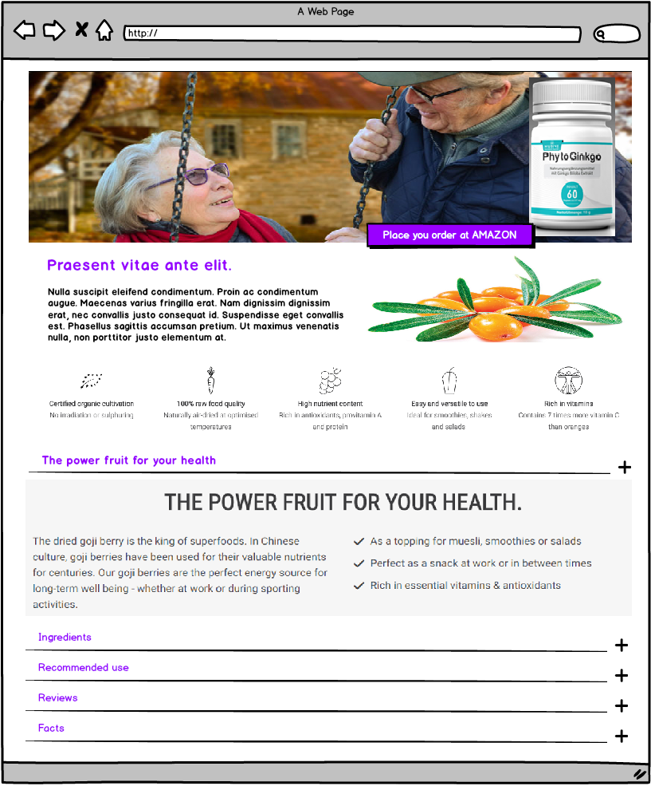

CMYK: 72-0-27-1

