FRONT COVER
truck image to be used

- Fuel save ECO Tuning
- Driver training
- Rolling road (Dyno) Testing facility
- Measured power and fuel consumption
- Live data on performance and efficiency
- Guaranteed return on investment
- No obligation trial period
- Insured and warranty provide
- ISO9001:2008

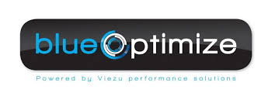

blueOptimize
- 5% - 20% savings on fuel
- Optional Power and Torque increase up to 25%
- Up to 20% reduction on Co2 emissions
- Up to 30% less gear changes
- Lower average RPM's
- Reduced engine and gearbox wear
- No negative impact on reliability
- Greater ability to manage heavy loads
- No mechanical modification – only software upgrade
- Return on investment within 2 – 6 months

about us
case study

Is this safe?
Yes, this is completely safe. We always stay within the designed limits of each vehicle. The performance is already there, and we can de-restrict it and deliver it more efficiently without making any mechanical changes to the vehicle. Modifications are made via the on-board computer (ECU). Engines are down-tuned by manufacturers by as much as 50% for a variety of reasons such as marketing, global climates, production costs, fuel qualities, emissions standards, tax categories, insurance brackets and more. Due to this down tuning there is a lot of room to improve the performance of the vehicle without causing any problems or reliability issues. In production, the manufacturer can build one engine to fit many different models is far more cost effective than producing a different engine for each model. Don't be surprised to see a 380hp, 420hp, 480hp all using identical engines/transmissions.
How will this save fuel?
After tuning, the additional torque will enable the driver to drive more efficiently. The greater the power/weight ratio of a truck, the sooner the driver can move up through the gears and keep the truck in the 'green band' or 'sweet spot' of the RPM. Carrying lighter loads will obviously increase this ratio, but that's not always possible of course. Therefore increasing the torque will have the same effect. The earlier the gear changes and lower RPM's means less throttle input is required to maintain the same speeds as before. The additional torque is a tool for the driver and can be used in two ways: One is to accelerate the truck faster in which case you will not achieve fuel savings but you will get to your destination quicker. Or two is to use the extra torque to move through the gears sooner than before, maintaining normal acceleration speeds but using less throttle input than before tuning. This is guaranteed to save fuel, 100% of the time!
We offer driver training with our tuning (SEE PAGE 7), on our specially designed truck Dyno (rolling road) facility. We can show your driver how to maximise the benefits from tuning to achieve the best possible fuel savings, while measuring the fuel consumption data in real time. All performance and fuel economy gains are proven on our rolling road.

Why don’t manufacturers do this?
The simple answer is they do! As mentioned earlier, when you are looking to buy a new truck, but can’t decide if you want a 400hp, 450hp or a 500hp model, ask the question ‘what are the differences in each engine?’
These engines are often identical! Not a single component is different in most cases, depending on the size of the power gap.
So where does the power come from? This is done through software in the ECU which controls the amount and power output the engine can produce. Now, in order to sell different models at varied price ranges without having to keep designing new engines at a huge cost, the software in the ECU can be adjusted instead. The badge on the front will be changed also!! Manufacturers wont custom tune every vehicle to suit their customers needs, they need their trucks to cater for a wide range of uses and many different conditions worldwide. Have your truck custom tailored for your needs and see HUGE benefits.

Two forms of tuning – Remap or ECM module

Remapping
- Remapping refers to a process where we read out the software from the ECU (brain of the vehicle), modify the software parameters then reprogram the new software back into the ECU. The performance gains are instant. The original setup is always saved in case you ever decided to put your truck back to standard. We always work within the safety parameters of the engine, and make no mechanical or pressure changes so reliability is never compromised.
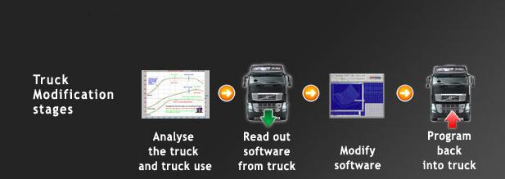

ECM Tuning Module
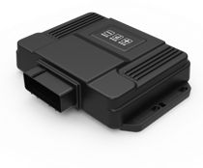
- We can make the same changes to the engine without altering the original software of the ECU. Our ECM tuning module includes an OEM fit wiring harness which connects directly to the original Injection system jack plugs on the engine or ECU without the need to modify any of the vehicles wiring, meaning it can simply be removed without any trace or footprint left behind.

Driver training and Dynamometer testing
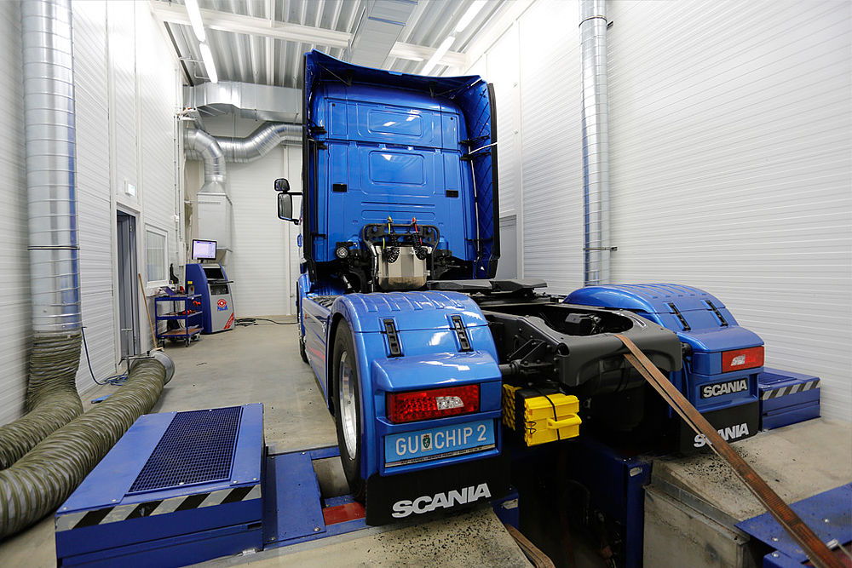
Our state of the art Truck dynamometer, also referred to as a ‘Rolling road’ is one of a kind. It allows us to accurately measure the performance and fuel efficiency of truck engines without leaving the workshop. This means we can data log, test and accurately tune each vehicle so that they are running at optimal performance when leaving our workshop.
It is essential your drivers are using the benefits from tuning appropriately in order to maximize the fuel savings. We provide training both in house on our state of the art rolling road, where we can simulate real world conditions indoors while testing the vehicle. We can simulate heavy loads and uphill gradients while also monitoring the fuel data and performance of the engine. We can show the driver where gear changing is most efficient, and how to achieve cruising speed as efficient as possible. The rolling road also allows us to accurately tune and test each vehicle to guarantee it is running at its optimal performance.
We also offer ‘on the road’ training days, where we go out with your drivers for a day and improve their driving habits in order to save fuel. All driving habits which affect fuel economy are covered, including correct braking, stop/start driving, road anticipation, use of exhaust brake, use of cruise control etc.
We do this during your work day where possible, so as you have no downtime as a result of training and the training is carried out as your trucks are doing their every day work.

How much money can I expect to save?
It is hard to predict exactly how much fuel you will save due to varying factors such as driver ability, vehicle condition, road conditions, weather, type of work, fuel quality etc.
However we have conducted a simple table below which shows potential fuel savings for a typical truck which burns 1000 litres per week for 48 weeks annually at a price of €1.00 per litre diesel.

Average Savings per year | 1 truck | 5 trucks | 15 trucks | 30 trucks
5% | €2,400 | 12,000 | €36,000 | €72,000
15% | €7,200 | €36,000 | €108,000 | €216,000
20% | €9,600 | €48,000 | €144,000 | €288,000

Viezu Technologies Ireland Ltd.
Maynooth road
Kilcock
Co. Kildare
w23e5r9

WWW.VIEZU.IE
INFO@VIEZU.IE
Phone: 01 6859034 – 086 178 2428

