
FIELD KITCHEN
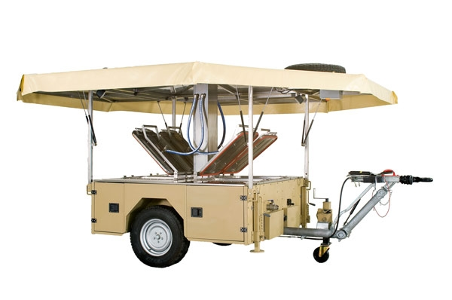
Salayl Field Kitchen is an Highly advanced Catering System Designed for mobile applications with the armed forces, civil defence and disaster control organizations as well as charity aid and event organizations.
Trailer field kitchen is ready for use almost instantly, Cooking can begin as soon as the kitchen is set in the proper place and position Each cooking units operate independently so different meals can be prepared at the same time.
Salayl Field kitchen can come up with special solution that allows to cookdifferent world cuisine.
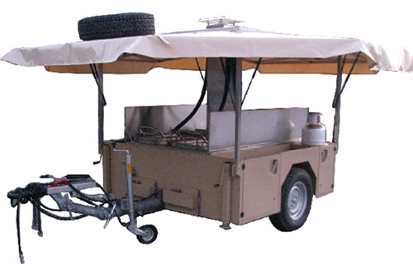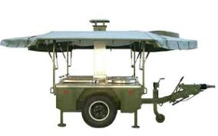

Color Options: Transportation by land, sea or air
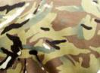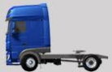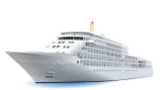
Beige Khaki camuoflage Truck Aircraft Ship Rail system

Integrated weather protection

Rain Snow Air Dust
1
TECHNICAL DATA:

Is ready for use almost instantly. Cooking can begin as soon as the kitchen is set in a proper place and position. Each cooking unit operates independently so different meals can be prepared at the same time. The following cooking methods are possible: cooking/boiling, stewing, steaming,frying and baking.
cooking systems can be fuelled by diesel or kerosene.the burners are odourless and quiet and above all, efficient. incorporate four burners made from corrosion-proof materials. The burners heat levels can be adjusted from 15kw to 25 kw with a single control knob. The field kitchen is suitable for travel on roads as well as on unpaved paths over fields. It is specially designed for off-road or cross-country travel.
- Standard accessories: air compressor, generator, water treatment system, working tables, solid fuel burner, 69 pcs. kitchen utensils
- Optional: tent, cotton fat absorbing fleece, platform, collapsible water tank

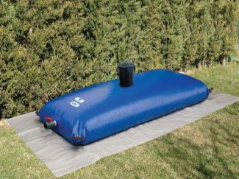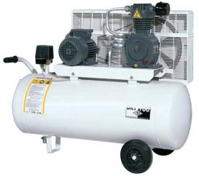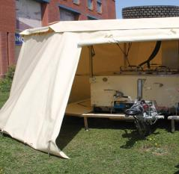
2 tons water tank air compressor Awning

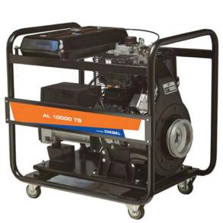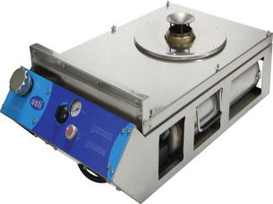
Generator Liquid Fuel Burner

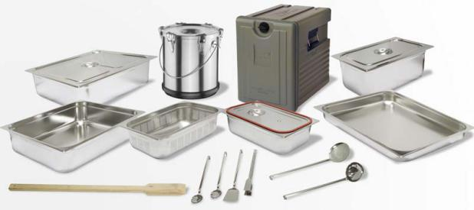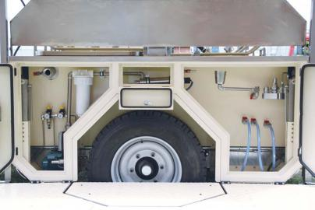

Standard Accessories Water Treatment

2
COOKING EQUIPMENT
- 2 × 190lt. Boiling Pan
- 2 × 50lt. Frying Pan
- 2 × 34lt. Hot Water Unit
- 2 × 132lt. Oven (3 × GN 1/1 Tray
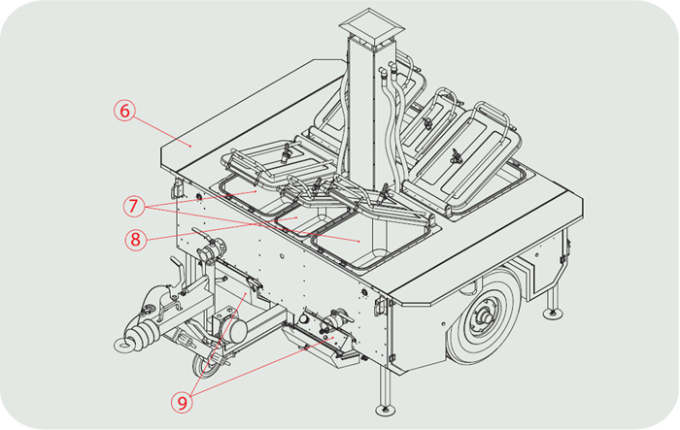

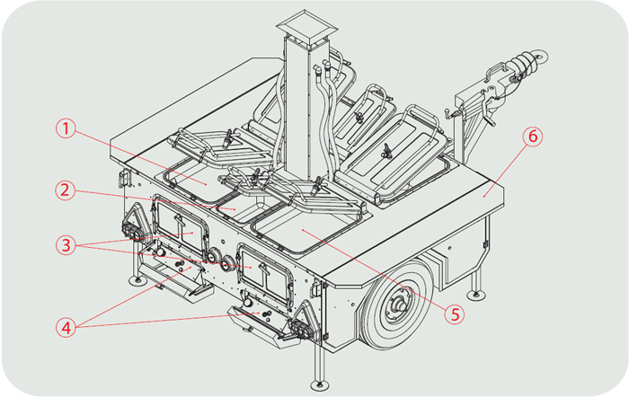

1. Left Frying Pan
2. Hot Water Unit
3. Ovens
4. Burners
5 Right Frying Pan
- Working Bench
- Boiling Pans
- Hot Water unit
- Burners 3
CONTAINERISED KITCHEN
The SALAYL container kitchen is built up in a Standard 20’ ISO container but there are also other models in expandable shelters.Optional lifting supports can be mounted on the corners of the container for lifting and lowering of the container kitchen from and onto the transport vehicle.
All the interior walls, ceiling and floor are made of stainless steel to ensure compliance with the strictest hygiene requirements under field conditions. The floors also have floor drain for easier cleaning.
Preparation area is designed for the preparation of food for cooking and the preparation and portioning of cold meals.In the cooking area each cooking unit is heated and controlled separately.
For storage of the food the kitchen is equipped with a refrigerator and a freezer. For cooking and washing-up, the container kitchen is supplied with fresh water from the water tank which is installed under the container.
Dishes and kitchen utensils for the preparation and cooking of meals can be cleaned quickly and hygienically by the professional dishwasher.
The power is supplied via a 37 kw diesel fuel generator.

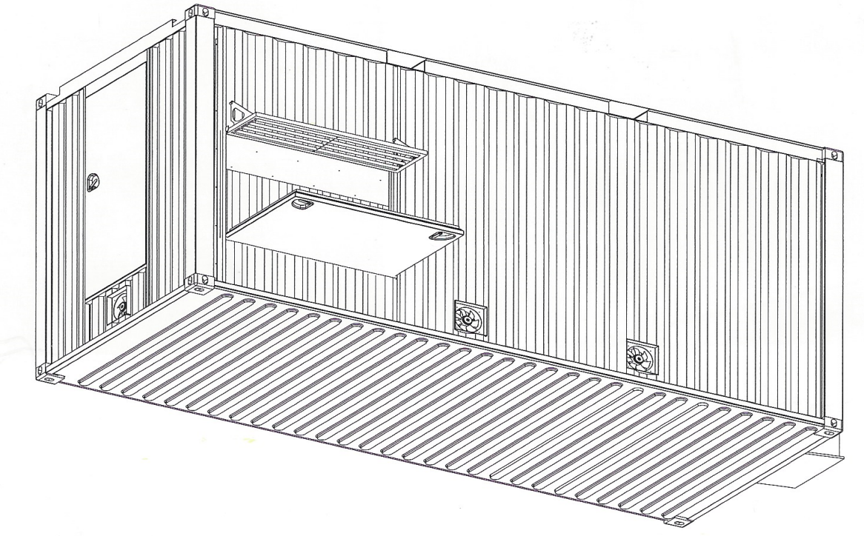

4

INTERNAL VIEW

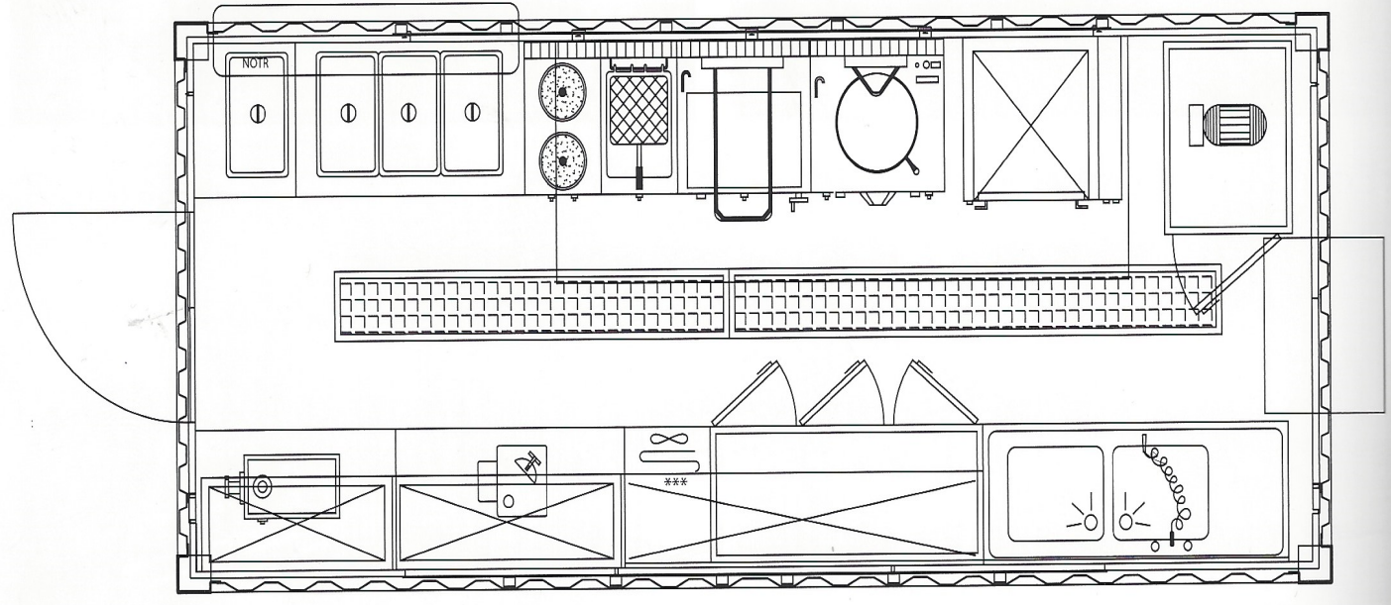

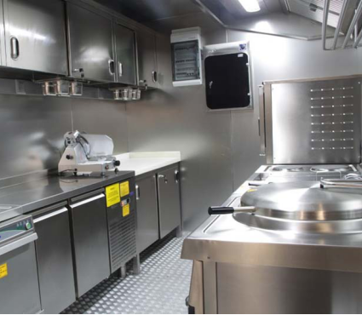
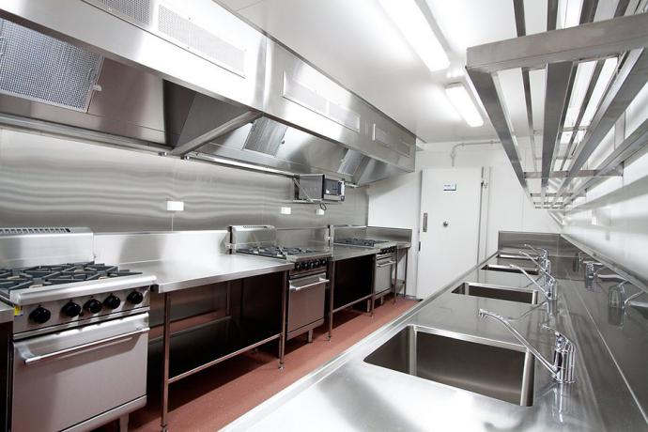

5

SHOWER AND LATRINE CONTAINER

containers are produced and shipped as ready to use with electrical wiring, plumbing, clean and waste water pipes, toilet unit, basin, taps are all included. All materials used in Karmod wc - shower containers are selected from top quality certified brands that conform to international standards. - shower containers can be produced based on different plans according to customer preferences. Optionally customer can have the container completely with wc units, completely with showers, or with required number of wc and shower units.

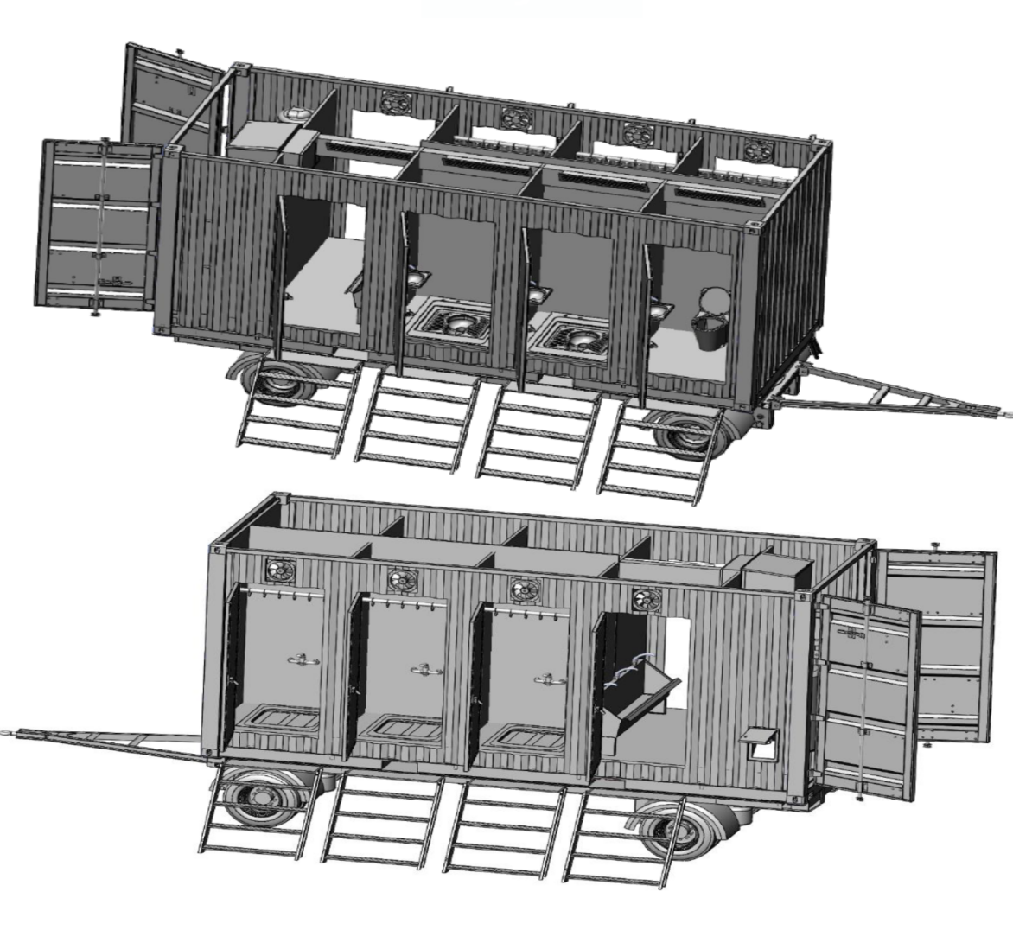

6

TRAILER
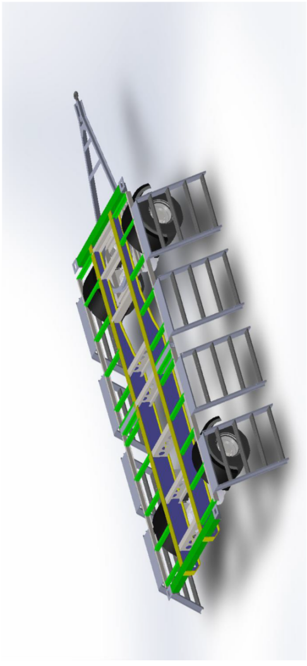
TRAILER STUCTURE | SA 2.5 Sand Blasted + Epoxy Painted steel
Axles | 2 Axles
Wheels | 8+1 Tires- 7,5 J x 16
Capacity | 11,000 kgs.
Drawbar | A- frame drawbar
Suspension | Leaf Spring Suspension System
Electrical System | Traffic lights accdg. To regulations
Brakes | Air Brake System

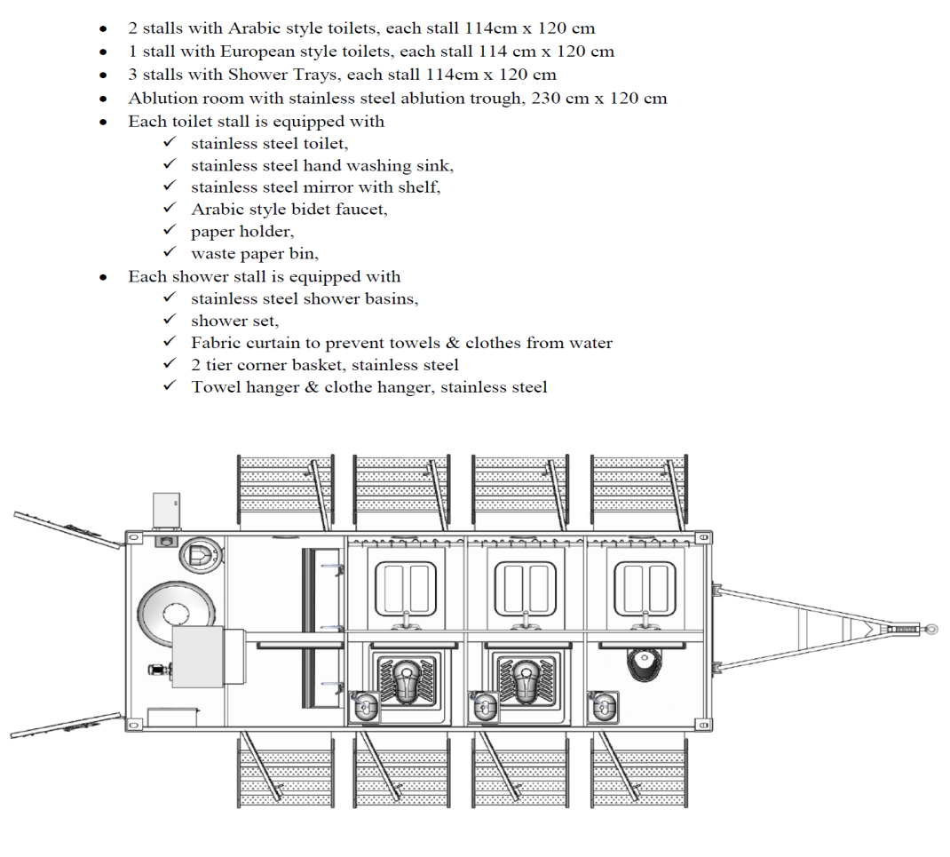
7


ABLUTION UNIT

SALAYL can provide customized ISO container solutions to meet all military requirements, as well as the needs of civil defense organizations and disaster relief groups during the field operations.

Technical data:
The unit includes 3 showers, 3 WC and 8 wash hand basins. It comes complete with an in-built engineering area equipped for diesel water heating system, water pumping, ventilation and diesel generator.
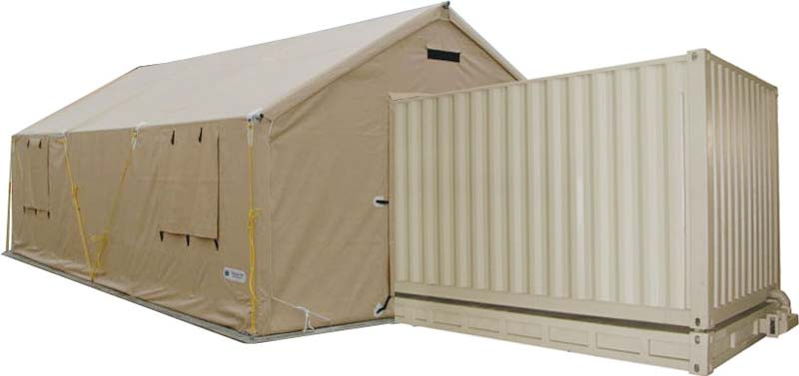
Sanitary Container

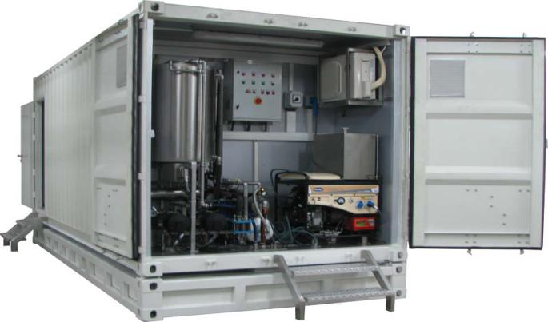

8

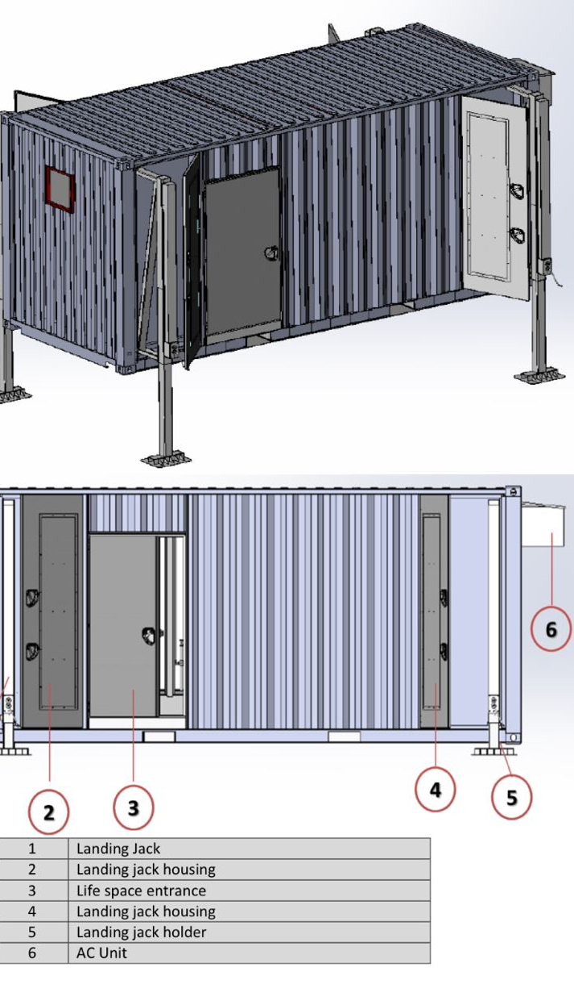

Internal View

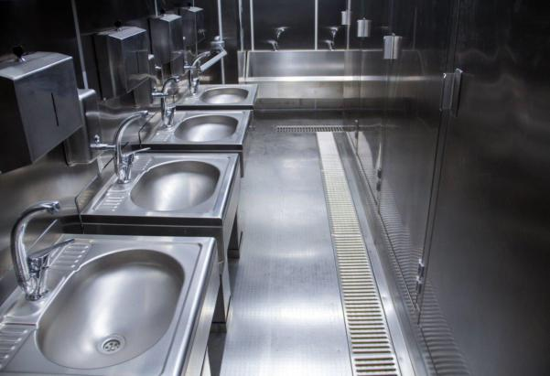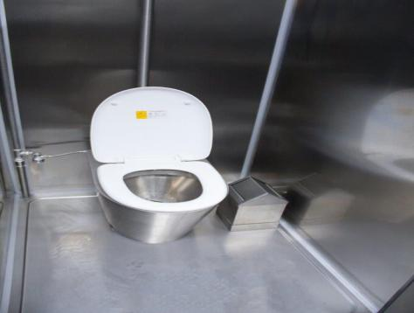

9
LAUNDRY CONTAINER

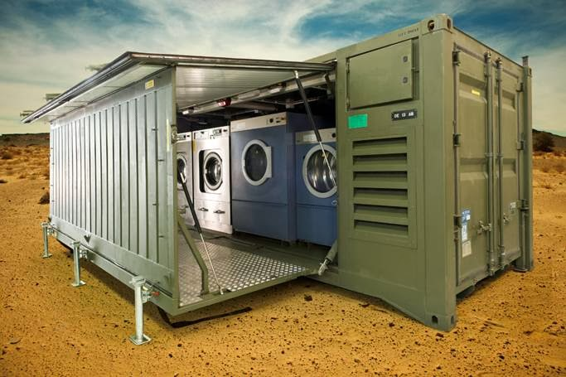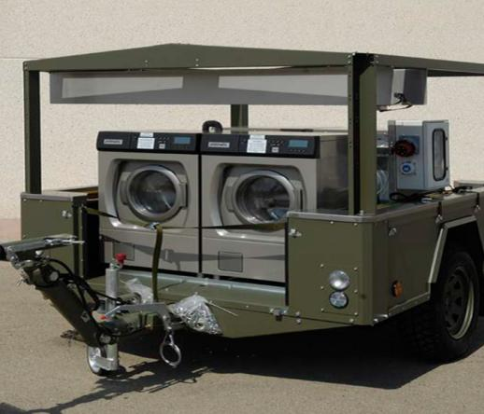

The Containerized laundry unit is designed to support 500 to 1000 people in the field. It includes washer extractora of new generation with the efficiency and dryers resulting in a capacity of over 60 kg of dry linen per hour.
The washing machine with low energy consumption are equipped with water recycling system. All the equipments are industrial and heavy duty type. The fine positioning of thye equipments optimizes the ergonomy and the hygiene tanks to the partition in areas of the unit.
The unit is fully autonomous with an in board power generator, in continuous services. This 20 ft. ISO container can be easily set up in operation in one hour.

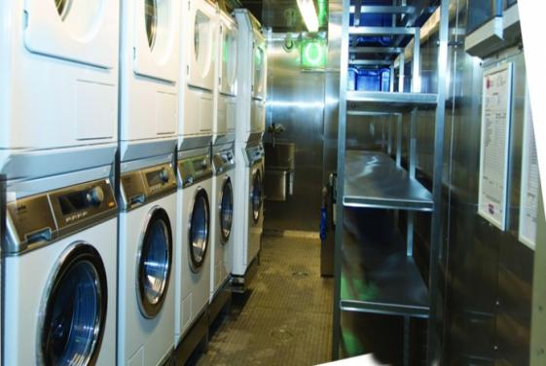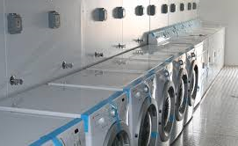

10

WATER PURIFICATION CONTAINER

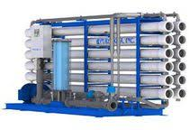

SALAYL WATER PURIFICATION CONTAINER IS DESIGNED TO PRODUCE HYGIENE AND DRINKING WATER FROM ANY WATER SOURCE.
Wether conventional or not conventional such us rivers, lakes, reservoirs, harvested rainwater and ground water ( fresh or microbioligical polluted water) The aims of the water purification Container are- to improve the raw water quality in order to make it suitable for “ Hygiene Water” production - to produce sufficient amount of water to supply the water purification system. To fioll the automatic mode a hygiene water tank container, - to fill in automatic mode a drinking water tank container. All equipment and accessory necessary for producing potable water and hygiene water will be incuded in WPC.

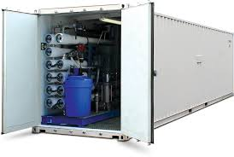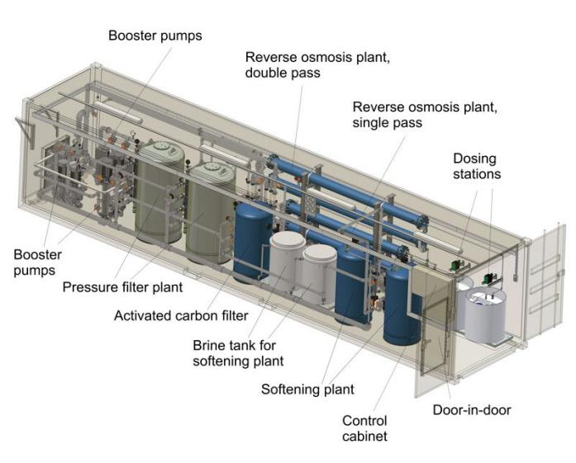

11

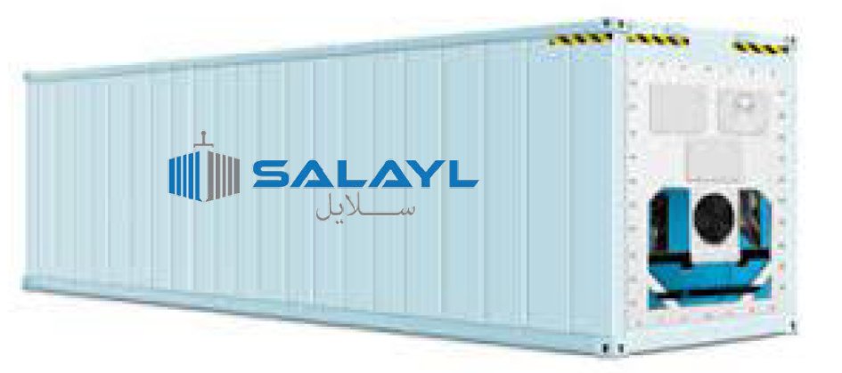

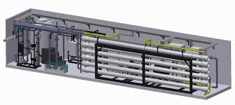

Special design SALAYL water purification system are the best sulutions to produce large amount of clean drinking water ( up to 2000 t drinking water per day) The components are installed ready for operation in a 20 ft container.

12
WEAPON/ GUN CONTAINER AND STORAGE SOLUTION

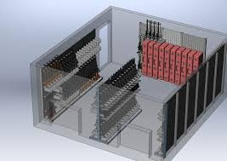

SALAYL CUSTOMOIZED FOR WEAPON/ GUN CONTAINER STORAGE
Whether a unit is deploying or training, It’s important to ensure its weapons remain in the same condition when they arrive as when they were shipped. Custom Shipping container that is capable of storing and shipping modern small arms and crew serve weapons with all of the repair parts and associated collateral gear that comes with it. In short, a weapon shipping and storage solution that fits the needs of your base.

Standard Features Include:

Durable contruction, includinbg corrugated steel sides, roof, and swing doors on one side as well as a heavy duty steel floor and forklift pockets. Adjustable shelving, Exterior paint choices of military standard green or standard tan.

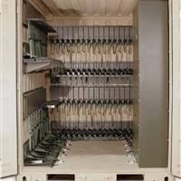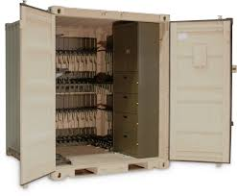

13

CONTAINER JAIL

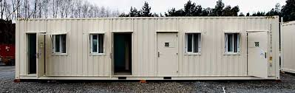

Shipping containers are strong, durable and easy to modify, which means that they can be converted into prison cells within no time at all.
A number of different prisons have used shipping containers as cells,
There is a multitude of different advantages to be gained from using these containers as accommodation for prisoners.They can be erected relatively quickly, cost less to put in place than cells that are created from conventional building materials and allow for greater adherence to an allocated budget.
Using shipping containers as cells also minimises on-site operations required in order to create new accommodation at correctional facilities.It can improve the consistency of the cells, as shipping containers are fabricated within a controlled environment.

Internal View:

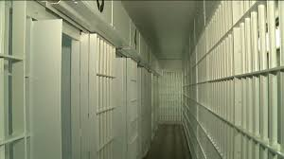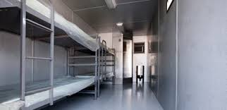

14

CONTAINER SHOOTING RANGE

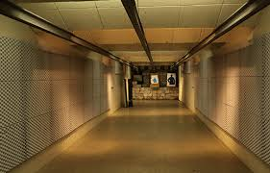

SALAYL Shooting Range Industries offers complete, self contained two lane modular shooting solutions built into a mobile bullet proof container. Our Modular Shooting Solutions come complete with Shooting Stalls, Target Retrieval Systems, Bullet Traps, Lighting, and HVAC Systems. Our products are built to the highest specifications and are delivered fully assembled. Our Modular Shooting Designs are available in various lengths and are fully customizable for style and convenience.

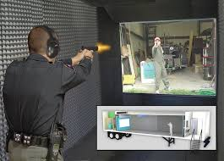

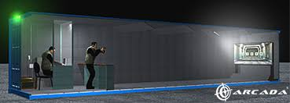
15

MORTUARY CONTAINER

SALAYL Mortuary Container is designed for temporary storage of dead men
Units are equpped with cooling device, stainless steel holders,beds with nameplates, electric installation; lights, switches, external power supply box.
It will design according to the demand.

INTERNAL VIEW:
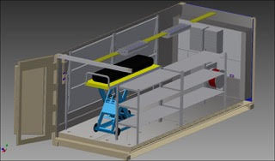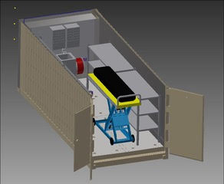

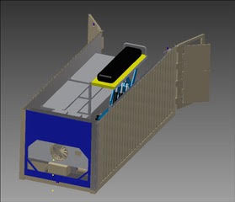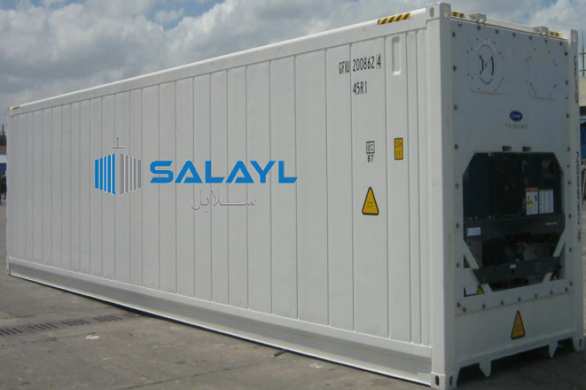

16

CONTAINER SERVICE STATION
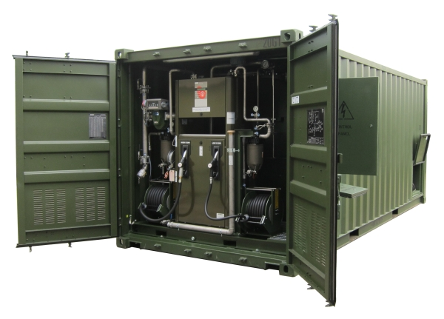

SALAYL- COMPLETE CONTAINERISED SERVICE STATION
Compact fuel installation for the storage and supply of fuel to vehicles.Built according to the overall criteria of Petroleum Product Installation Regulations.
Easy transportation, fast commisioning and reduced works.
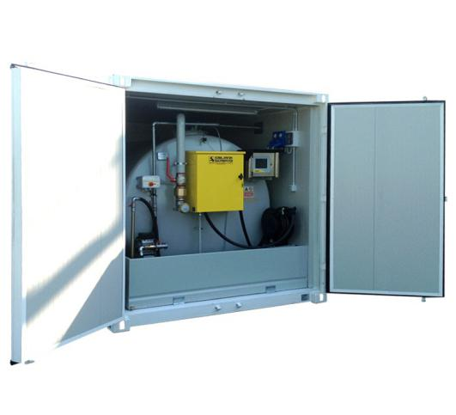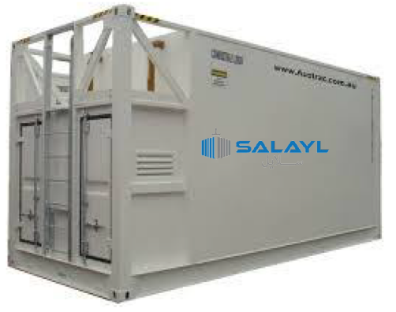

17

BAKERY CONTAINER
Container bakery is used for bread baking in field conditions for armed forces, civil defense and emergency rescue services and humanitarian organizations.
Baking with the container bakery includes the different steps involved in the process: kneading, dividing, manual forming, fermentation (rising), baking and natural cooling.
The mobile bakery is specially designed to subsist to the need for bread of the soldiers in the field. The system is fully autonomous for power with its diesel generator.
The complete unit is fitted in a 20’ container.
The unit is compact and can be displayed in a very short time.

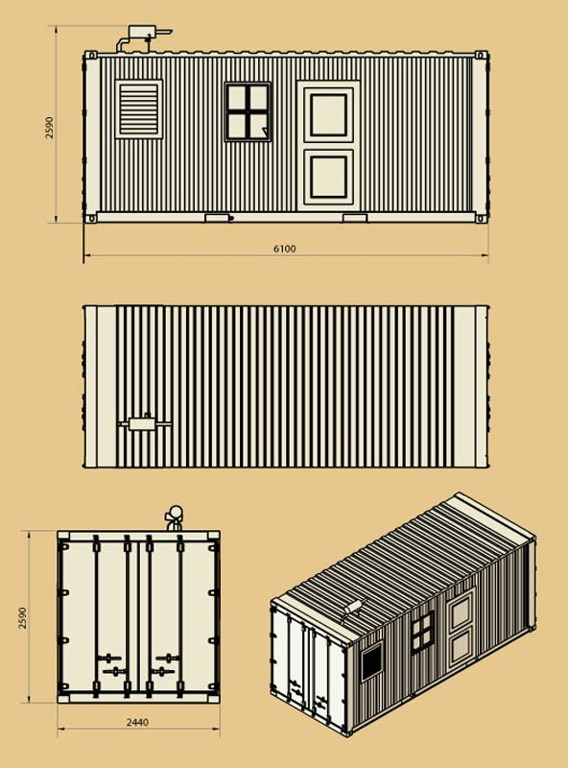

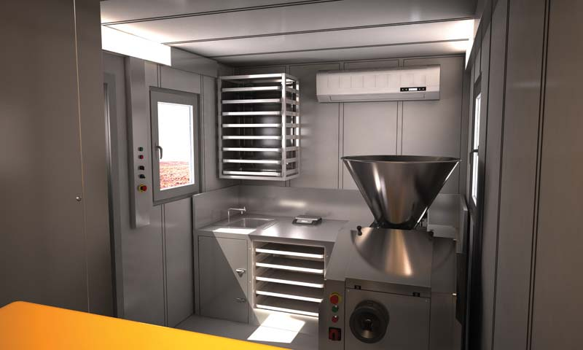
All the interior walls and the ceiling and floor are clad in stainless steel to ensure compliance with the strictest hygiene requirements under field conditions. The bakery is full electric powered and it is entierly autonomous with its own diesel powered generator. Having arrived on site MILITARY TYPE CONTAINER BAKERY is ready for operation within the shortest time.It is transportable on lorries,
aircraft, train, ships and can be airlifted by helicopter.

18

COFFEE SHOP CONTAINER

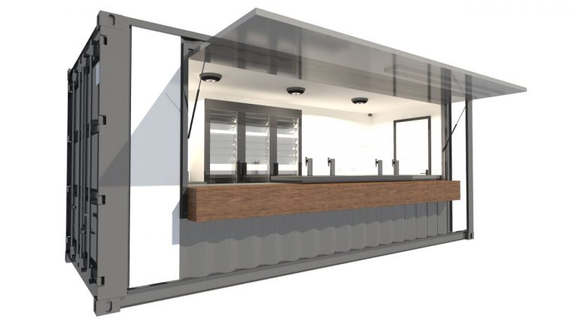

SALAYL Container Cafe!
Everything you need to start serving customers is right here, with stainless steel prep counters, professional espresso machine, refrigerator, glass display unit and more. We can even brand your Container Cafe to suit your identity!

DESIGN FOR COFFEE SHOP
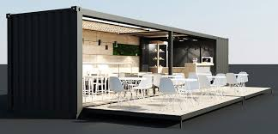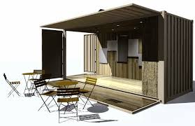

19

OFFICE & ACCOMMODATION CONTAINER
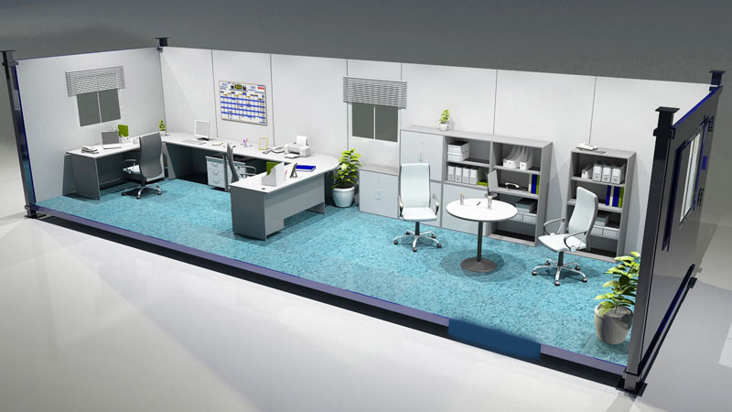

Office and accomodation

SALAYL supplies office and accomodation containers for most needs.

Depending on the customer’s specification we can outfit each 20ft container to accommodate 1-4 people.
We can also use the same technology as we have developed for our kitchen systems and combine a series of 20ft containers to form larger structures. These might be used as dining halls, meeting rooms, open-plan offices, etc.

We produce units made from solid steel or based on flat-pack containers. The flat-pack units, which are prefabricated and assembled on-site, may be stacked 4 high on a truck for transportation.

SALAYL can build accommodation and offices capable of withstanding most weather/climate conditions.
Prices and specifications on request.

20

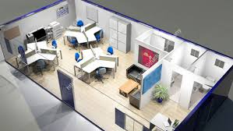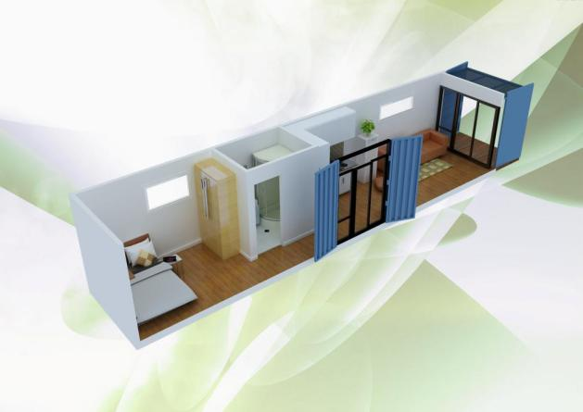

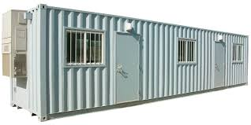

- Immediately available
- Quick assembly on site
- Expandable at any time
- Excellent heat and sound insulation
- Various additional equipment available

21

GYM CONTAINER

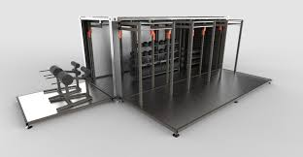

SALAYL CONTAINER: Solution for your outdoor Training
Outdoor training is the new concept of fitness, with more and more people wanting to train outdoors. We are seeing a real change in the way the world looks upon physical activity and your customers become ever more demanding and eager for new and exciting challenges.The container solution is able to offer a truly innovative concept, and offer a unique product in line with the latest trends in the fitness market.

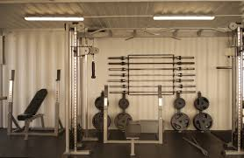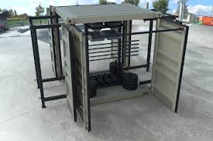

22

HOME CONTAINER

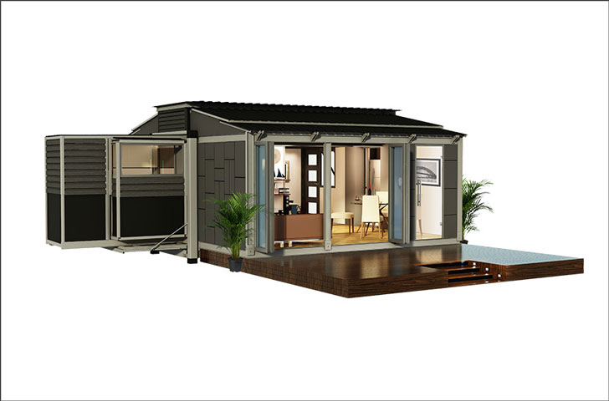

These Modular Shipping Container Homes are fully-functional housing units that are stored in shipping containers.
Salayl offers a good and reliable homes as well, why not have your home and pool made out of a shipping container?
One shipping container is 20 ft long but, in fact, it unfolds into 54 m2 of living space, , it transforms into a very livable home, complete with rooms, a pull-out bathroom and kitchen, as well as 3.5 m high ceilings.
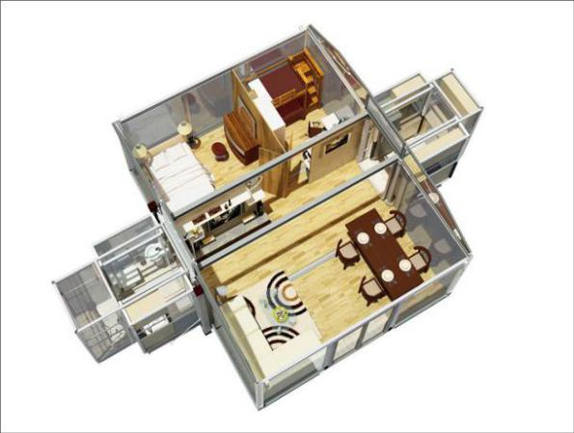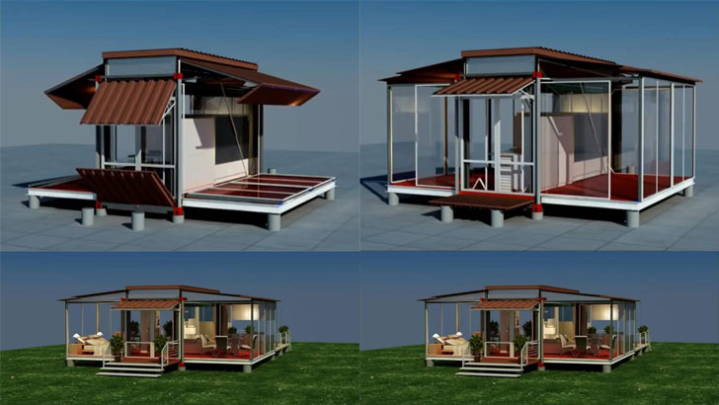

23

STORAGE ROOM CONTAINER

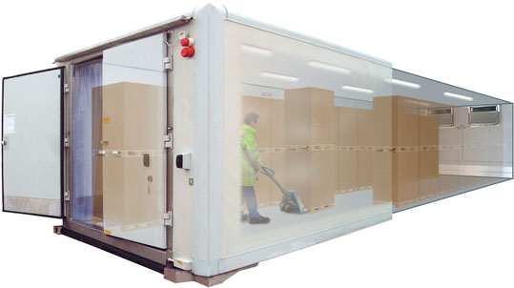

Salayl customised containers offer a huge volume of approximately 76mᶟ of storage space. They require minimal site preparation and can be delivered to create an instant warehouse.
the perfect solution for additional storage requirements. They can be delivered to just about any location, offering an instant and secure space with minimal capital investment.

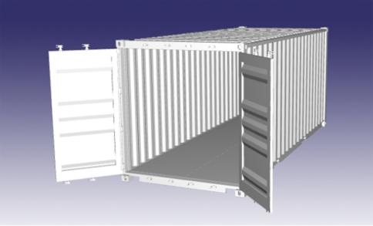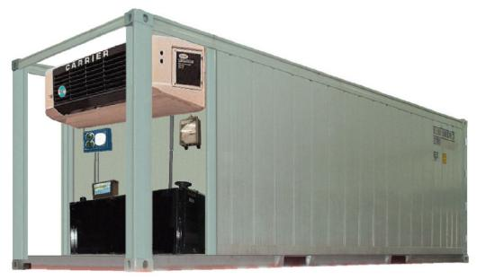

24

WORKSHOP CONTAINER

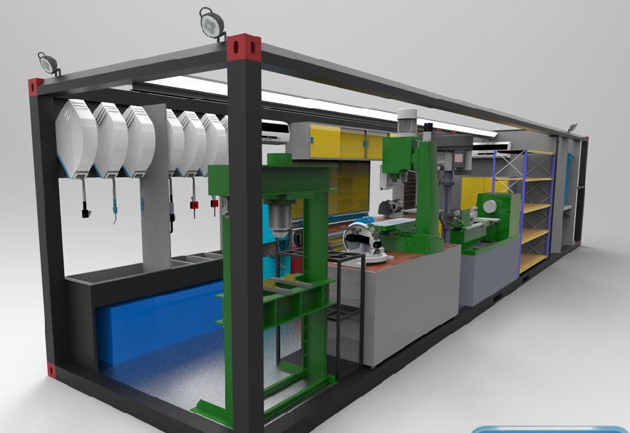

Workshop conversions are one of our most frequent projects. We can produce anything from a one off individual container conversion to large scale jobs involving multiple containers for large companies. When converting containers to workshops, we start by drawing up detailed plans , in conjunction with our client, to ensure precise results.

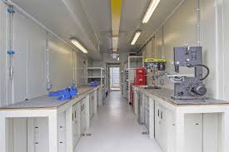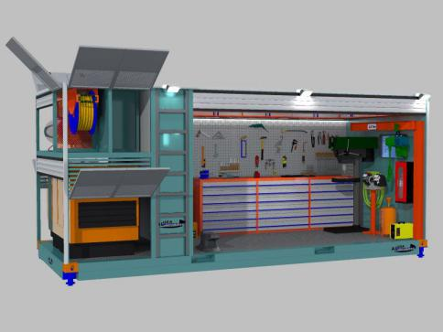

25

HOSPITAL and CLINIC CONTAINER
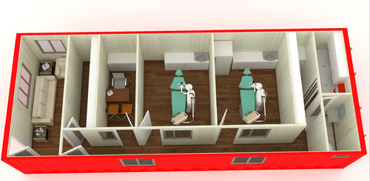

Mobile Container types of mobile hospitals has been specifically designed for the purpose of obtaining benefits in the field of military space. Military facilities, municipalities, rural areas, small towns, and in areas without institutions buildings due to civil disaster or a similar field clinic field is equipped to meet the needs of the people in. Models are with standard features, but depending on the needs of medical equipment more options can be offerred.

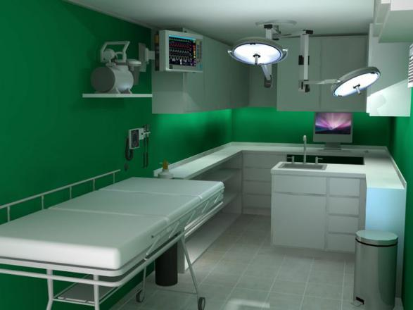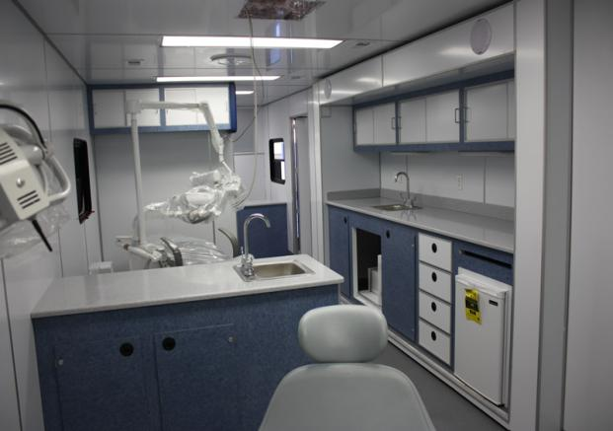

26

Lay- out and design
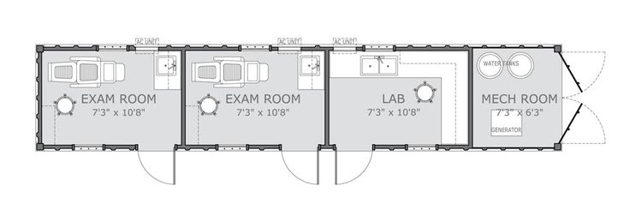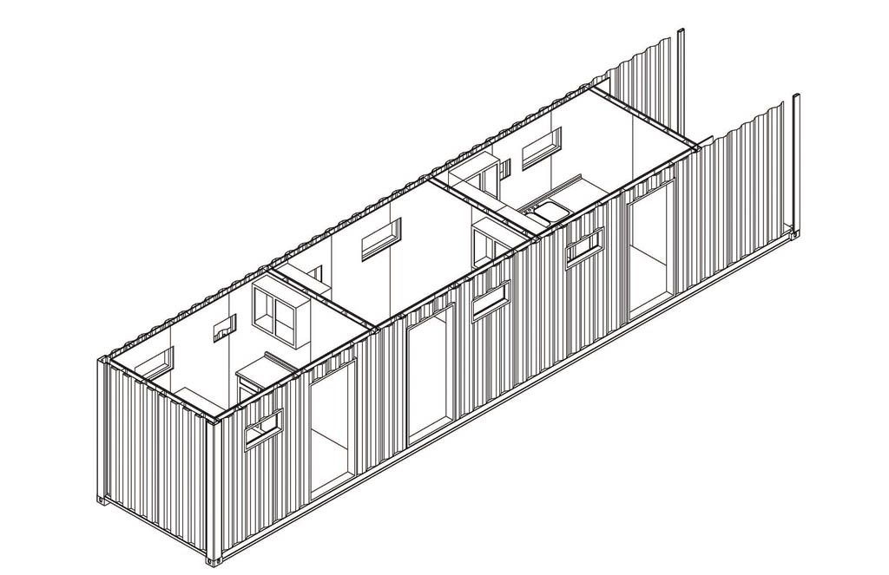

27

