Website R2 Software

The open source software industry has grown enormously in recent years. More and more customers from software companies choose an open source solution. R2 Software is going to fulfill this increasing demand.

Core business

Reselling software subcriptions (business to business).

Side business

Selling consultancy and Training to customers

Goals:

- Binding of customers to R2 IT Group
- Sales of subscriptions to customer
- Enlarge network R2 IT Group
- USP: Sales of complete package, Software, consultancy and training

Products

There are a couple of products/ services that R2 will provide. Below you will find an overview of the Products:

- Redhat subscriptions
- Docker subscriptions
- Nagios products
- Customized consultancy for the customer
- Customized training for the customer

Style

Behind the website should be a cms system like wordpress.

Key Partners  - Partners  - • Docks  - • Redhat  - • Dupaco  - • Nagios  - • Cisol  - • Opsmen  - • Products  - • Licenses  - • Consultancy  - • Exercises | Key Activities  - • Sales of Software Licenses  - • Providing Consultancy  - • Providing Training | Value Proposition  - Software solution for the customer  - • Installation and implementation of the software solution  - • Training to staff customer  - • Good working IT solution for customer  - • Support service  - • Need to buy licenses has been fulfilled |  | Customer Relationships  - Customer relationships are extremely important, the goal is to build and maintain as long as possible for the longer term  - Customer Relationship by Removing Licenses at R2 Software  - Pay close attention to customer relationships | Customer Segments  - Companies that are among the top 100 companies in the Netherlands.  - Companies without own partnership with Software Provider
 | Key Resources  - Consultants  - Trainers  - Partnerships |  |  | Channels  - Webshop/site  - Op de beurs  - Mailchimp  - Via onze partners
Cost Structure  - • Purchasing Software  - • Hiring Consultants  - • Hire Trainers  - • Marketing costs |  |  | Revenue Streams  - • Licenses  - • Customized services for the customer  - • Customized training for the customer  - • Pay by quotation

Web lay-out

Logo R2 Software: 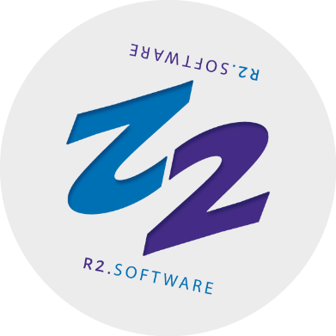

The website includes the following pages:

1. Home page
2. About us
3. Portfolio
3.1 Red hat
3.2 Docks
3.3 Nagios
3.4 Yoursafetynet
4. Contact

Home page: At the top a menu (and if u like a header with call to action). In addition, there must be a grid containing the 4 logos of the products and a button to go to the product page. For the rest, the home page is free to set up.
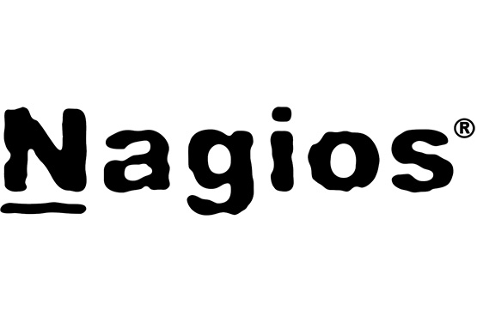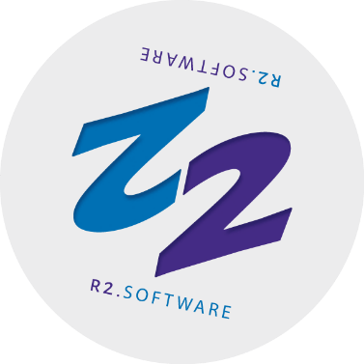

About us page: Free to set up.

Portfolio:

4 pages with a product group each:
1. Red hat
2. Docks
3. Nagios
4. Yoursafetynet

- Red Hat
On top space for short info/bullets about Red hat. Further, a grid with 8 columns. In the columns 2 buttons both lead to a popup. A popup for information and a popup for requesting a quote.

- Docker:
On top space for short info/bullets about Docker. Further, a grid with 3 columns. In the columns 2 buttons both lead to a popup. A popup for information and a popup for requesting a quote.

- Nagios:
On top space for short info/bullets about Nagios. Further, a grid with 4 columns. In the columns 2 buttons both lead to a popup. A popup for information and a popup for requesting a quote.

- Yoursafetynet:
On top space for short info/bullets about Yoursafetynet. Further, a grid with 2 columns. In the columns 2 buttons both lead to a popup. A popup for information and a popup for requesting a quote.

Contact page: option to send mail to R2 Software. Further free to set up.

