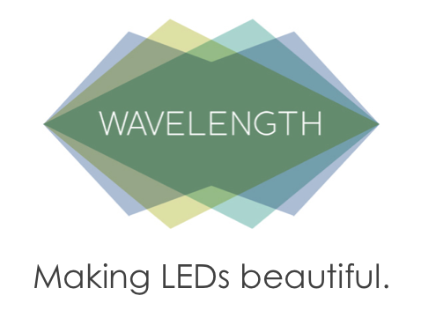 | 
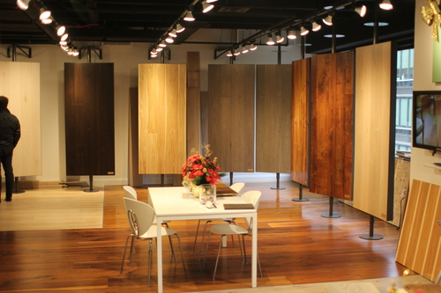 | 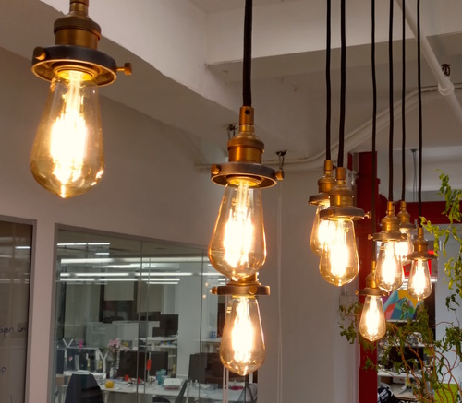

No Upfront Cost – Turnkey LEDs
Wavelength Lighting provides LED lighting as a service – fully implemented and managed LEDs at no upfront cost. Wavelength takes the risk, hassle and capital cost out of adopting LED’s energy saving technology. Wavelength guarantees net-savings for customers on day one, and continues to guarantee savings and performance for the full term of the contract. And the savings add up! A project can be installed 2-4 weeks from kickoff, and projects continue to generate savings for up to 10 years.

Wavelength Lighting

Why use Wavelength?
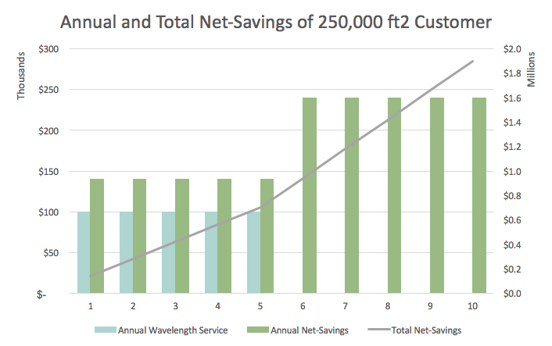
Wavelength’s customers understand the value of LEDs but don’t want to deal with the risk, hassle and capital cost on their own. Wavelength starts saving customers money the first month – typically a net-savings of about 4.7 cents a square-foot per month. Wavelength will design aesthetic LED systems and install the best available technology.
Wavelength provides LEDs at the best cost with its as-a-service structure, which puts the cost of lighting into clients’ monthly operating budget for less than they save. By installing projects immediately, Wavelength eliminates the cost of foregone savings that would accumulate from delayed implementation.
It can be risky to adopt new technology, especially when salespeople try to sell more than is needed. Wavelength has access to better equipment and at better cost than is widely available on the open market and passes that quality and savings on to its customers. Wavelength guarantees performance for 5 years, which removes the risk of a failed project.

The Best Team in LEDs
Wavelength is a team of lighting experts who get the evolution of lighting and efficiency. Simply put, we come in up every day with one goal: to provide an excellent service that saves money and uses less electricity. Part of the team focuses on the supply chain of the very best equipment that customers have come to appreciate. Part of the team focuses on the project management of each installation. And, part of the team focuses on resolving any questions customers might have in their transition. Together we make up the best team in LEDs and work tirelessly to make it easy to upgrade.

Testimonials
“Wavelength made a huge improvement in the lighting for our headquarters. The installation process was as smooth as can be and the service since has been excellent.” – Oscar Health
“In a museum, quality lighting is paramount. Wavelength has been a great partner in helping us transition to LEDs that look great, save us money, and make lighting management so much simpler.” – Children’s Museum of Art, New York
“We are so happy to have had Wavelength’s help building out our new office space – they put their lighting expertise to work delivering beautiful LEDs and fixtures. It was cost-effective, removed lighting from the build-out budget, and it’s been a joy to work with them since.” – Thoughtworks, Inc

Email: customers@wavelengthlighting.com Phone: 347 878 WAVE Website: wavelengthlighting.com

