[ Cover Page – A3 to 4 sided A4 flyer / brochure ]

Title:
High Temperature + High Performance Trace Heating
= The demanding World of CSP process maintenance !

Brief:
The operation and reliability of high temperature / high performance Trace Heating in CSP (Concentrated Solar Power) plants is critical to the optimum performance of the plant itself.

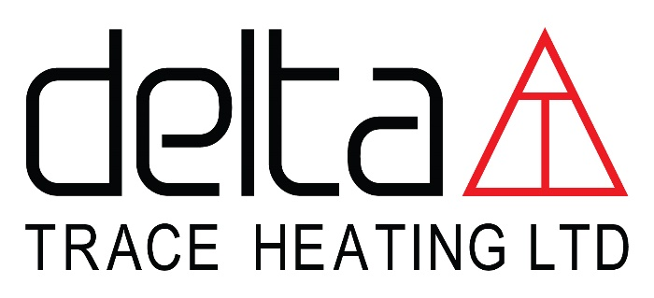
“Dedicated Trace Heating Specialists”
www.deltat.co.uk

[ Inside Cover Page – Part 1 CSP Key factors ]
“Dedicated Trace Heating Specialists”

Key factors vital to ensuring long term performance and reliability include:

DESIGN:
Extensive trace heating experience with detailed design and application knowledge paying particular respect to high temperature performance Mineral Insulated (MI) heating cables and units.
Delta T has proven expertise and a long successful track record in engineered system solutions for high and very high operating temperature trace heating.

MATERIALS:
Use of the highest quality MI cables and associated fully compatible ancillary equipment to conform to strict specifications and end user requirements.
State of the art control systems to provide user information for simple and efficient long-term plant operation and ease of maintenance routines.
Delta T command conformance to our own strict in-house MI cable specifications and control systems provided by trusted 3rd party partners.
Heating unit manufacture, controller hardware and software are produced to specific and exacting Delta T technical standards under our direct control and quality conformance.

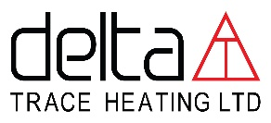
www.deltat.co.uk
[ Inside Back Page – Part 1 CSP Key factors ]
“Dedicated Trace Heating Specialists”

PROJECT MANAGEMENT:
Understanding of all contract interfaces, project deliverables and design and performance criteria demands high quality management and skilled supervision services.
Delta T offer proven site management and supervision expertise in Logistical Planning / Project Quality Systems / Health & Safety / Engineering Standards / Design and Application.

INSTALLATION SERVICES:
Fully trained, highly experienced and skilled installation labour is vital to ensuring trace heating design and performance criteria are met particularly with high operating temperature requirements.
All Delta T installers are directly employed with trace heating cumulative capability and experience of MI cable installations measured in many years on the job.
Depending on specific project requirements, our supervisors / installers can be deployed in small teams to supplement / assist / support site based main contract labour if preferred. Full control and responsibility for work and installation standards is however always maintained by Delta T.

COST OF OWNERSHIP:
Ability to pro-actively work with and fully interpret client’s requirements to lower cost of ownership / increase product life cycle and simplify maintenance routines.
Delta T can demonstrate 40 years of specialist trace heating experience working with many major clients across the World delivering high performance, reliable engineered trace heating systems.
Our expertise is regularly called on to assess and improve the operation and control of existing trace heating systems provided by others to deliver increased reliability and significant savings in power usage and maintenance costs.

www.deltat.co.uk
[ Back Cover Page – Who are DT / Contact ]
Based in London, Delta T are an independent specialist trace heating engineering company, with 40 years’ experience in successfully providing turnkey high temperature trace heating solutions to the power industry, working with many major clients across the World.
Their complete understanding of project execution from design to hand over together with their own exacting specifications, ensure that the client receives a true single source point of responsibility that they can rely on.
- NO design misinterpretations
- NO material specification mismatch / poor performance / product failures
- NO interface / compatibility problems with 3rd party material suppliers
- NO application / installation issues
- NO test / commissioning issues

- SMART CONTROL SYSTEMS specifically tailored to the plant operation / process with access to critical user information to significantly reduce ongoing maintenance routines and cost.
- FULL AUDITABLE drawings / specifications / install records / test data from design through to as built.
- A RELIABLE INTEGRATED ENGINEERED SOLUTION underpinned by SYSTEM WARRANTY and on call AFTER SALES SERVICE.
- A COMPLETE SINGLE SOURCED SYSTEM DELIVERED ON BUDGET AND ON TIME.
We would welcome the opportunity to meet and discuss our capabilities further-
PLEASE CONTACT;
PAUL SMITH (Mob: +44(0)7765 407731) or PAUL BARKER (Mob: +44(0)7836 592974)
Email: enquiries@deltat.co.uk
DELTA T (TRACE HEATING) LTD – POWER DIVISION
LONDON EN6 IHS
Tel: +44 (0)1707 659812
“Dedicated Trace Heating Specialists”
www.deltat.co.uk

