When to refer to Activ8 Health club?
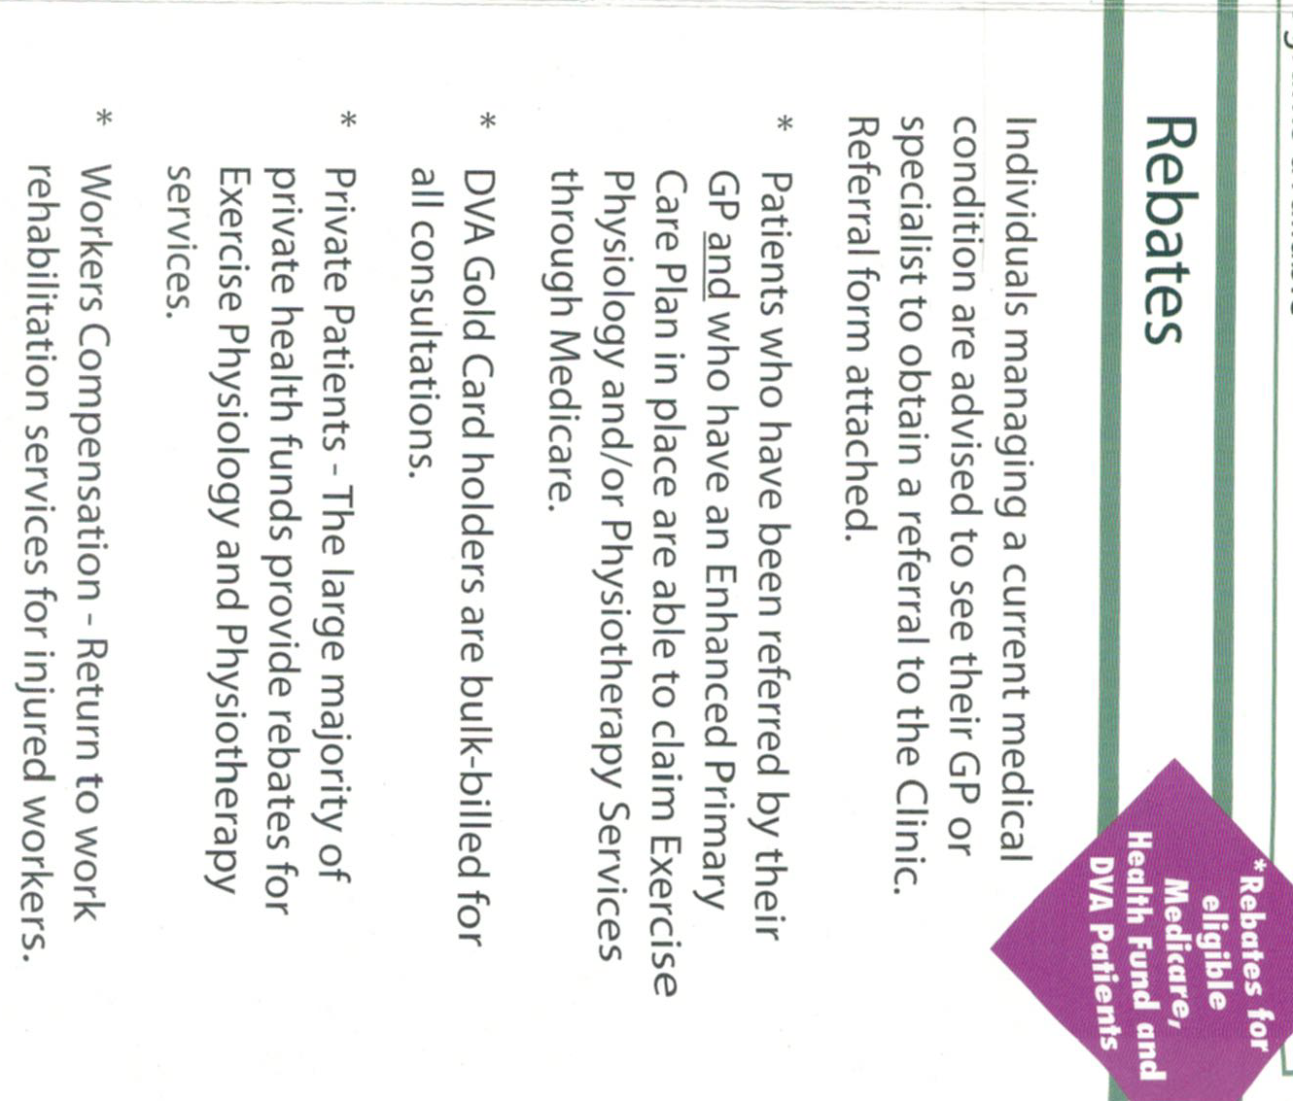
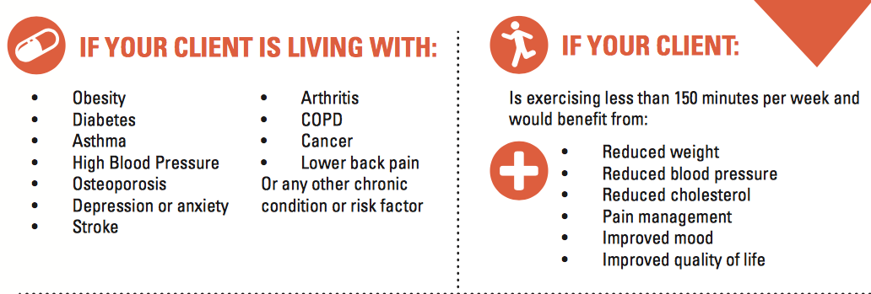
Services we specialize in: Rebates

Chronic Disease Management (CDM) plans
Diabetes Programs: 1:1 & Group
Work Cover
DVA
National Disability Insurance Scheme (NDIS)

The Activ8 Wellbeing Progression:

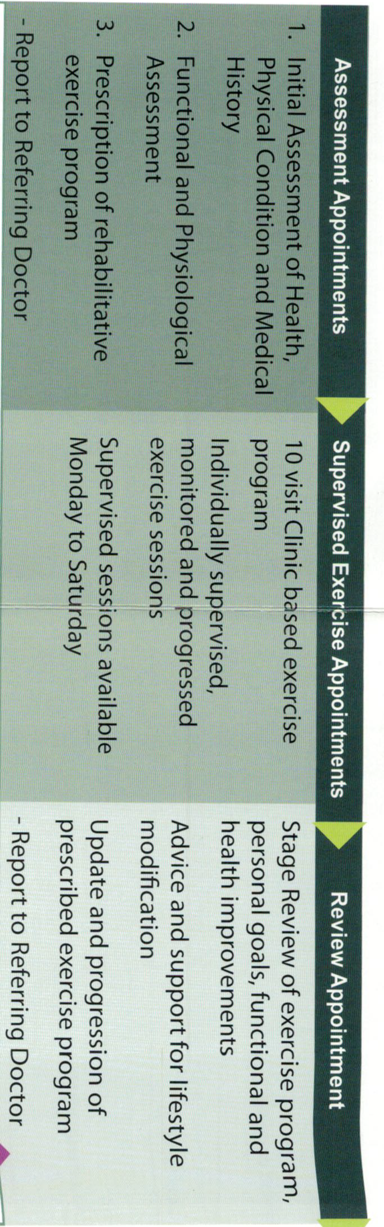
1. Progress to specialized small group exercise run by exercise physiologist to introduce aspects of self-management

2. Ongoing 1:1 reviews and assessment of functional and health improvements from Exercise Physiologist

3. Seminars/advice regarding lifestyle modifications

4. Ongoing updates and progressions of exercise program

- Report to referring doctors
1. Final Progression to our “self-management’ program

2. 24/7 heath club membership

3. Ongoing Participation in small group training run by exercise physiologist

4. Ongoing 1:1 review and assessment from Exercise Physiologist

Referral through:

- CDM (chronic disease management) (Exercise physiology: 10953)
- Diabetes Group Assessment (81110)
- Diabetes Group (81115)
- Aboriginal health services (81315)
- WorkCover
- DVA
- Private Patient

Add referral sheet on the back

