Dear [First Name]
It’s another extraordinary year for Lab Rescue LRCP. This year, I write to you for the first time, as the President of Lab Rescue. After more than a decade of involvement with the Rescue, it’s remarkable to reflect on how the Rescue has grown and adapted to meet the needs of homeless Labs.
After starting as a small volunteer organization rescuing just one or two hundred Labs a year, we have grown to an organization with hundreds of volunteers working to save nearly 1,000 Labs each year. This year has involved its own set of new challenges and new achievements.
For the past several years, we’ve witnessed an increase in eager adopters - more caring people willing and able to provide a loving home for a Lab (or two) for the rest of their lives. We are delighted to find Labs in need for these wonderful people. For the past two years we have reached beyond our previous geographic region to areas where the numbers of dogs in need is heartbreaking. We are so glad to offer hope where there previously was none.
At the same time, we’ve seen the Labs that make their way to the local shelters we have worked with for many years change. We are now routinely approached to save an increasing number of older Labs and Labs with pre-existing conditions that others can’t afford to fix.
Lab Rescue of the LRCP has always been a group that saves everyone who can be saved. What that often means is we must spend more money and keep a needy Lab in our care for much longer. Last year, we rescued and restored sight to Helen, a blind, diabetic 9 year old who had suffered from years of neglect. Helen remained in Lab Rescue care for almost 18 months until she found a family who could meet her special needs.
Since the end of the economic crisis, our average cost to save a lab has increased from $650 per dog to more than $750. Many dogs require so much more than routine care.
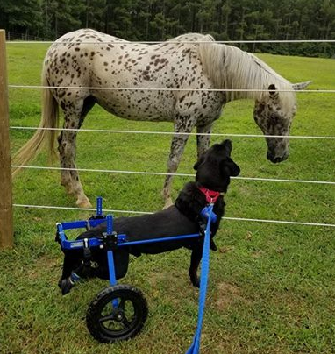
Early in 2017, we rescued Ramsey, a Lab already dependent on a wheelchair. He was given weeks to live, maybe a month. Ramsey is still with us; happily adopted in June of 2017. He is just one of dozens of Labs we saved this year who prove that you don’t have to give up on a dog in need; that love and care can increase both the length and quality of a dog’s life and provide infinite joy for his family.
When hospice care is needed we step up. When orthopedic issues, such as knee and hip surgeries, and arthritis medication are needed, we don’t hesitate. When dogs who have experienced years of neglect have a chance at a new life, we swoop in and save them.
We need your help to save every Lab we can.
This year we have gone even further, literally! We also rescued 26 Labs from hurricane-impacted areas of the United States. We couldn’t anticipate the need or plan for it but we found a way to save Labs displaced by the storms.
Your financial support gives us the ability to say yes, every time we’re needed.
What’s involved in helping hurricane impacted dogs? A lot! From the moment that Hurricane Harvey touched down in Houston, Lab Rescue worked daily to connect with shelters and rescue workers who were on the ground. Initially, their need was to establish temporary shelters; row upon row in any kind of warehouse they could find.
Then, Lab Rescue got involved. We committed to taking every Lab identified as needing a new home. Our first transport took 3 days to reach us and had 25 Labs (one was a last-minute surprise addition: “Stowaway”). Many didn’t even have names so we named them. Another transport arrived a week later with one more dog who was too ill to travel initially.
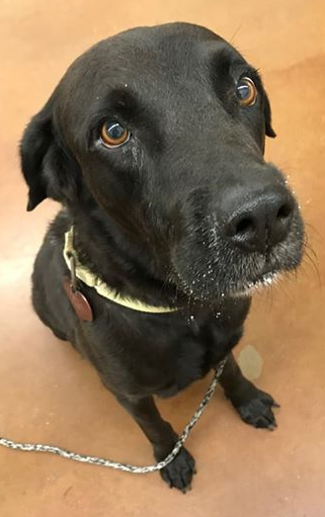
As I write this letter, I can share the story of Lab Rescue's latest survivor! Hurricane Irma hit Turks & Caicos as a Category 5 storm destroying so much, including the animal shelter. A local rescue partnered with the shelter and arranged for 16 dogs to be transported to our area. Crunch, a 3 year old black Lab
Your donations mean that we can spend the extra funds on transporting young, healthy Labs for whom families in our service area anxiously await. We can meet the dramatically increasing need for heartworm treatment created by the many dogs from farther and farther south in North Carolina. That means hundreds of dollars for each dog we save from the certain painful death of heartworm and restore to good health.
My request to you for this year is simple. Please donate now to make sure that we can continue to be the organization that can be there for every Lab that needs us.
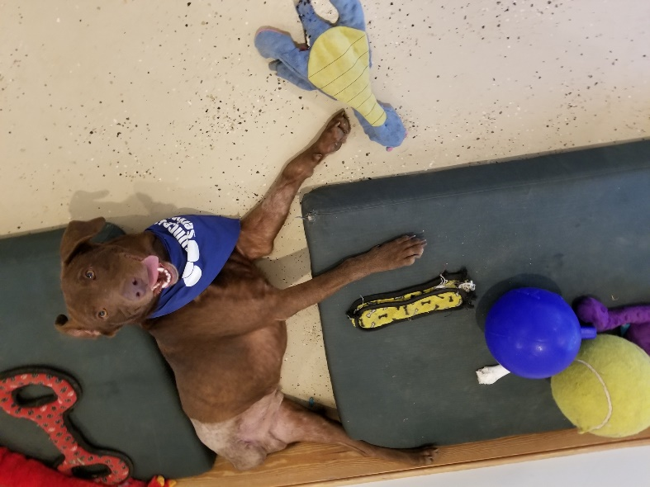
Right now, we are in the process of helping another special Lab. Too many of us have lost our Labs to cancer and we know that treatments for dogs are 30 years behind the treatments possible for humans.
Lab Rescue has rescued Chevy who not only will be treated for his cancer, but whose tumor has been included in a study on osteosarcoma, with the hope of advancing cancer treatment for all dogs. One of our loving foster homes has already welcomed this special Lab into their home, knowing that the treatment will be difficult and it may not be successful.
Today, his leg has been removed and he’s recovering from that surgery; his treatment has also begun. Chevy is 5 years old and his fosters tell us that he’s sweet as can be. Just as we hoped for Helen last year, we anticipate Chevy will live a long and happy life.
When you donate to Lab Rescue, you give us the opportunity to save Labs like Chevy and hundreds of others. Your generosity means we are one step closer to saving them all.
Thank you for being part of the Lab Rescue pack and for your generosity.

Sincerely,
Wendy Finn, President
Lab Rescue LRCP

