ICONFIT BOX For Product Series + Simple Generic Sachet

GOAL
Design needed for a smaller (96x128mm bottom, 160mm high) cardboard box to be used for a series of ICONFIT (iconfit.eu) diet and sports nutrition products. The box must have designated areas for product specific data that are easily editable for using to package different products (like editable product name, weight, claims, text, nutrition data chart etc.)
Inside the box I will need to package 7-10 powder sachets (98x165mm). This needs to be a very simple , basic generic sachet with only:
- Front main logo „ICONFIT” and web address „iconfit.eu”
- Text in the back bottom area „MANUFACTURED in the EU by European Foods LLC. ICONFIT is a registered trademark of European Foods LLC. See www.iconfit.eu for details.”

Type of sachet (bent bottom, sealed sides and top) ///////////// BOX draft:
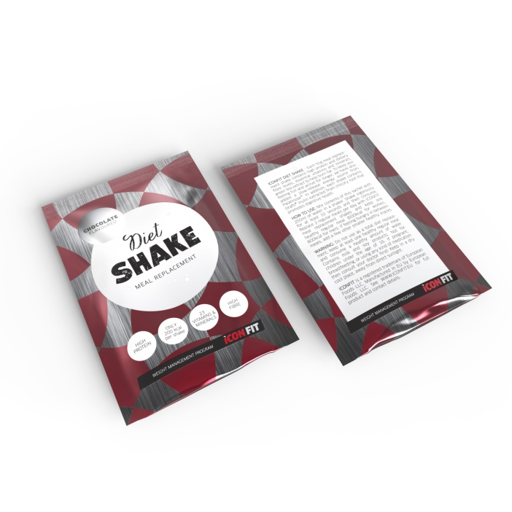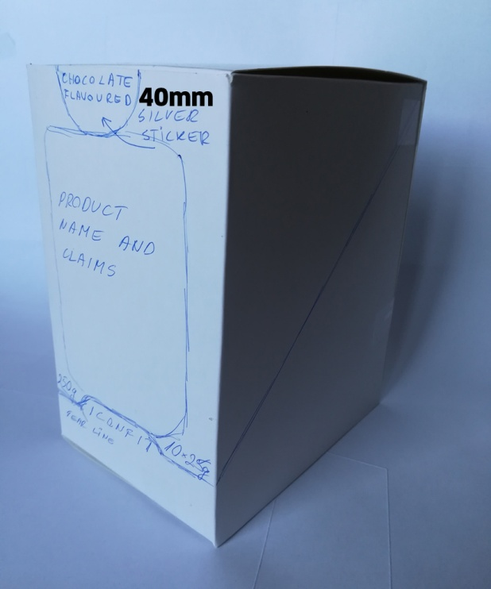

DESIGN should match the current ICONFIT products design a bit so customer can still understand it’s the same ICONFIT brand, but should not be an exact copy. You may use the pattern and/or elements from previous packaging but do not have to.
Would be still good to use at least some of the „red-black-white” combo but to give a more fresh look for the design and also to be solid, trustworthy result.
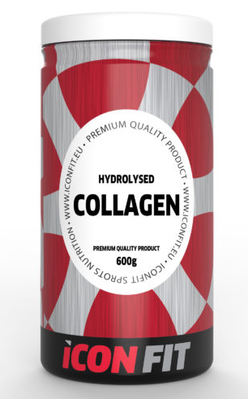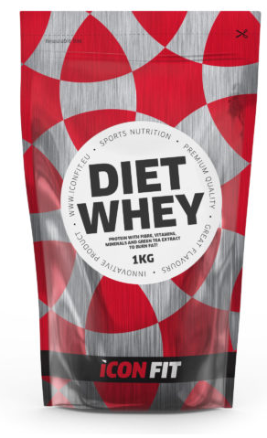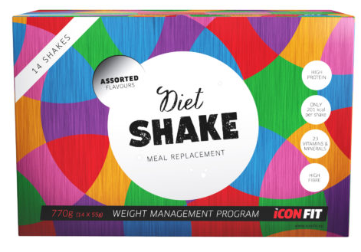

BOX DETAILS
Measurements, material and printing
Measurements 98x128mm bottom (will be self-locking bottom) and 160mm high. Drawing attached – just disregard the tear line from drawing – final tear line shape in the front is up to you with the design.
Material 285g white cardboard. Printing CMYK+lacquer (matte or shiny lacquer is to be decided)
Top part of the box should be removable by customer (by tearing off).
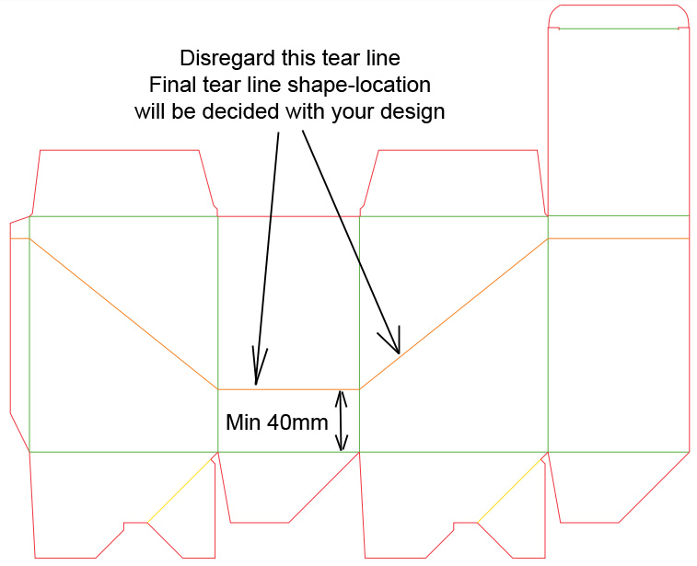
Today I don’t plan to sell sachets on shelves separately 1 by 1 but box should be also possible to use in supermarket like this to hold sachets. Of cource I will then in the future need new sachets that also have full product nutrition information and barcodes – now sachets will not have that yet.

Product Flavour
Will have different flavours but flavour info will be added with 40mm round silver shiny sticker with „Chocolate Flavoured” or „Strawberry Flavoured”. Box will have both flavours printed in the back for nutrition data. The sticker also acts as a seal for the box.
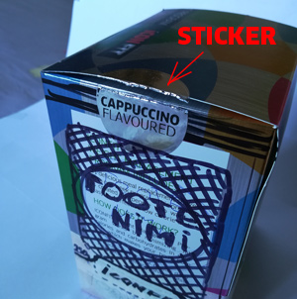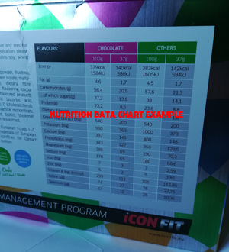

DATA ON THE BOX
FRONT SIDE
Bottom Part (after tearing). Only ICONFIT logo to display and small ICONFIT.EU
Upper part (possible to remove by tearing): Designated areas for product specific data like:
- Product name „DIET WHEY” , „WHEY+ COLLAGEN” , PROTEIN No1” ... etc. Changeable.
- 3-4 claims like „High Protein” , „High Fibre”, „With Green Tea Extract”, „With 23 Vitamins & Minerals” , .....etc” - Changeable
- „Net 350g” and „7x50g” – also changeable as some products have different weight.
SIDES OF THE BOX
Bottom part (after tearing) to display product name and 3-4 product claims (same as front of the box)
Top part (removable by tearing) may but does not have to have any text or data.

BACK SIDE
Product specific text area on top and also nutrition data chart. It should be easy to edit the text contents to match each product.
Text to use for 1st version of the box design:
ICONFIT DIET WHEY is based on premium whey protein concentrate with added Orafti™ fibre, 23 essential vitamins and minerals and green tea extract to help burn fat. It’s an excellent high protein and low calorie product that gives your body the much needed protein and keeps you feeling full for hours. INGREDIENTS: Whey protein concentrate, Orafti™ fibre from Chicory root, vitamin and mineral blend ((Vitamin A (retinylacetat), Vitamin D (cholecalciferol), calcium, copper, iodine, iron, magnesium, manganese, potassium, phosphor, selenium, sodium, zinc, ascorbic acid, vitamin E, niacin, calcium D-pantothenate, pyridoxine hydrochloride, thiamine mononitrate, riboflavin, B12, folic acid, biotin), cocoa powder (only in chocolate flavoured), flavouring, psyllium seed husks powder (psyllium ovata), green tea extract, sweetener sucralose. HOW TO USE: Mix contents of 1 sachet with 250ml of water in a shaker. Shake vigorously for 10 seconds and consume within 30 minutes. WARNING: Do not use as a sole source of daily nutrition.
Nutrition chart may have different number of columns and lines for different products. So also should be easily editable. Use maximum area of the box back.
NOTE: In case you see there is not enough room in the back for both the text and nutrition data chart, then one or the other may also be moved to side of the box!

TOP OF THE BOX
Possibly ICONFIT logo. No need for product specific data.

SACHET – Same to be used for all products. No different data or product info printing.
Very simple sachet with using only 2 colour cylinders to print (must keep cost low on this). Match elements of the design with the box as much as possible with the limitation of the 2 printing cylinders to use only.
Need to use white+red (red same as ICONFIT logo). Some areas may be without printing so silver, like „FIT” in the logo. See other reference print files for logo red colour choice.
Front only with ICONFIT logo and maybe small address „iconfit.eu”
Back side with text: „MANUFACTURED in the EU by European Foods LLC. ICONFIT is a registered trademark of European Foods LLC. See www.iconfit.eu for details.”
Some nice examples from competing products (not my products).

PHD Diet Whey – Nice and simple design. Not too much data to overwhelm.
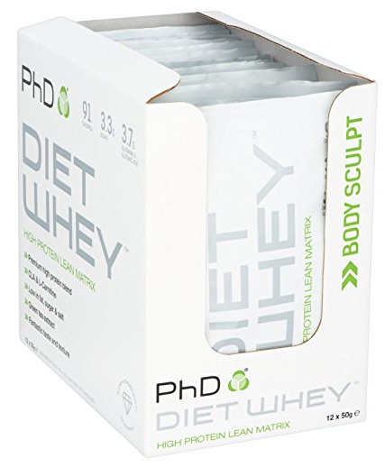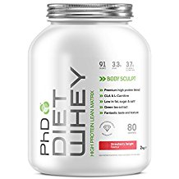
World’s best selling protein. Solid, quite simple and again not too much data.
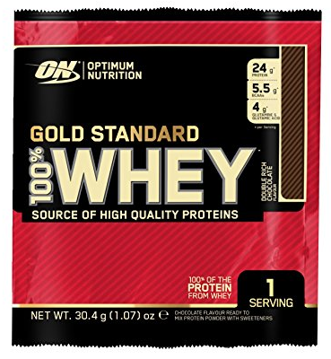

Different product but again nice clear and simple design. 