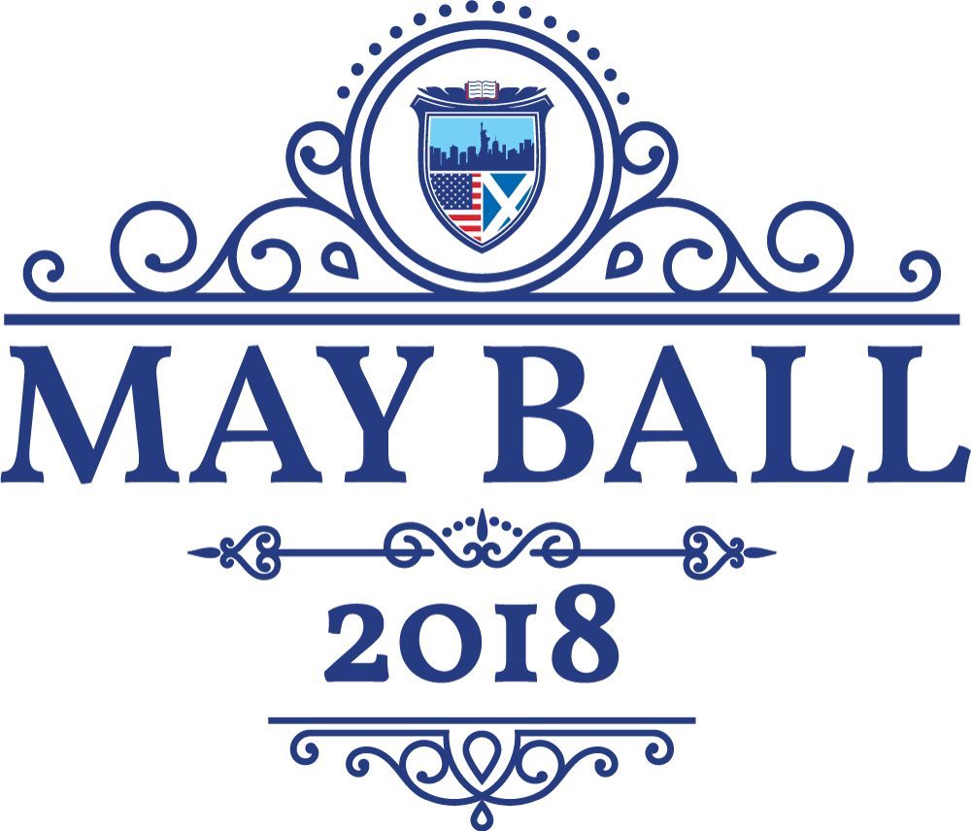

Sponsorship Brochure

The University of St Andrews Alumni Club of New York, a registered 501(c)3 charity, invites you to participate in our 5th annual May Ball. From its inception, the May Ball has been a means to foster the community of alumni, parents and friends of the University of St Andrews and other Scottish universities in the greater New York area. Historically attended by over 350 people, our May Ball grants sponsors access to a select audience who are always looking for ways to reconnect with the St Andrews spirit.

All sponsors will have the opportunity to showcase their products in a featured slot of our silent auction, which includes a variety of items donated from around the world. Any donated items are tax-deductible. Additionally, all sponsors will be listed in our ball brochure which is handed out to each guest as they arrive. Sponsorship level will dictate treatment and placement of logo or other advertisement within the brochure.
  Gold Sponsor  $10,000 | As the premier sponsor behind this prestigious event, the Gold Sponsor will be the driving force behind the black-tie gala dinner.  The Gold Sponsor will receive the following benefits:  - Billed as the event cohost, appearing alongside the Alumni Club of New York.  - Prominent display on the event invitation, tickets, the front page of the brochure and any other printed or electronic materials.  - Special recognition from our keynote speaker during the banquet.  - 3 Complimentary Tickets
  Silver Sponsor  $5,000 | Our two silver sponsors will help to support the two ballrooms, one featuring modern music and the other featuring traditional Scottish cèilidh dancing.  Each Silver Sponsor will receive the following benefits:  - Prominent display in their respective ballroom through banners, table decorations and other signage.  - Recognition from our keynote speaker during the banquet.  - Special acknowledgement in the brochure, on the website and on our social media brand partner.  - 2 Complimentary Tickets
  Bronze Sponsor  $3,000 | Our three silver sponsors will help to support our signature cocktail rooms, located in the library, the foyer and the game room.  Each Bronze Sponsor will receive the following benefits:  - Prominent display in their respective cocktail room through banners, table decorations and other signage.  - Special acknowledgement in the brochure and on the website.  - 1 Complimentary Ticket to the Gala
Supporting Sponsor  $750 | Our Supporting Sponsors form the pillars of our community
The University of St Andrews Alumni Club of New York has a long history of fostering a sense of community in the New York Area. We provide opportunities for alumni, current students, parents and friends to meet, network and socialize. We host a number of events during the year,
including an Opening Reception, Burns Night, Tartan Day Parade, and a Summer Party. We also support any lecturers or guests from the University who are visiting the New York area.
The University of St Andrews Alumni Club of New York is a registered 501(c)3 public charity. As such, our Alumni Club is seeking financial support in order to be able to host quality events, and other projects that support the University, such as the construction of new conference rooms in the Students’ Union at St Andrews.
If you are interested in making a donation, please send a check payable to the University of St Andrews Alumni Club of New York to the following address:
University of St Andrews
Alumni Club of New York
20 Pine Street
Suite 1801
New York, NY

