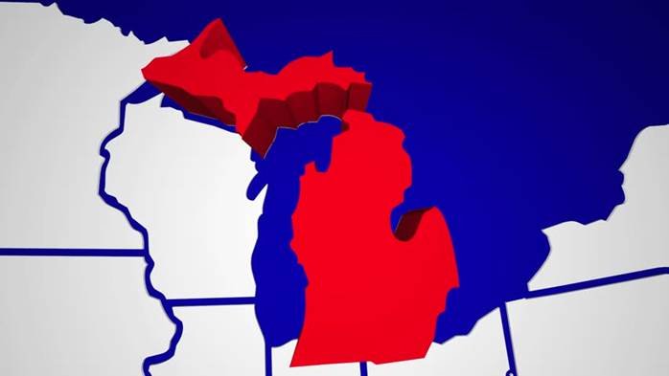
Ignore these colors, but the concept of map placement it good. Either remove PA and NY or leave them if it negatively affects the design.

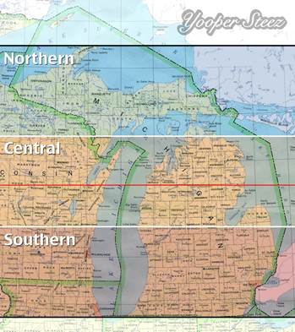
This map is also a good representation of what might work. The traditional map colors are okay but there is too much detail in the state (county boundaries, etc.) No worries that Idaho, MN and MO aren’t included.

