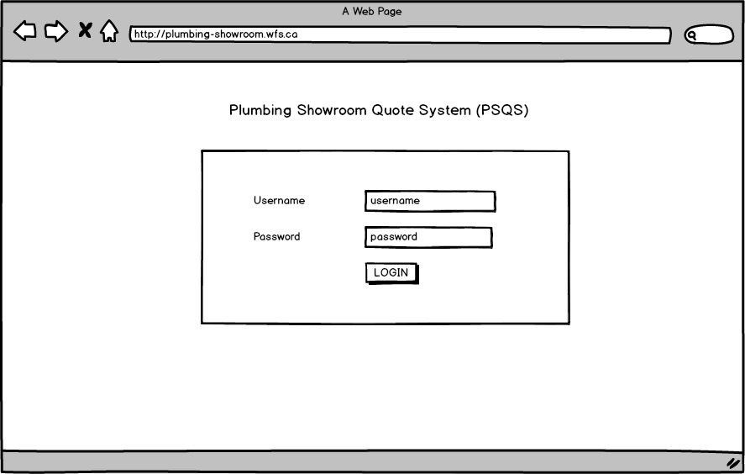

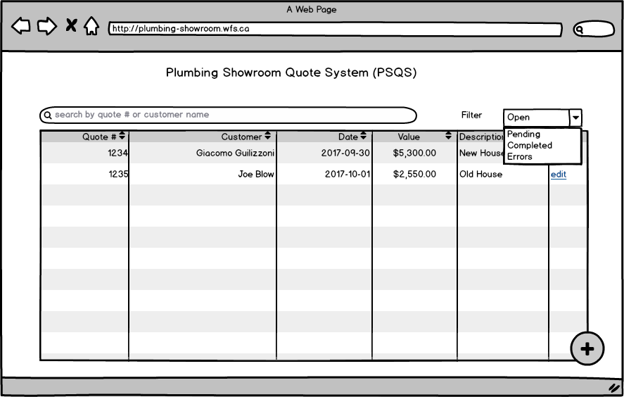
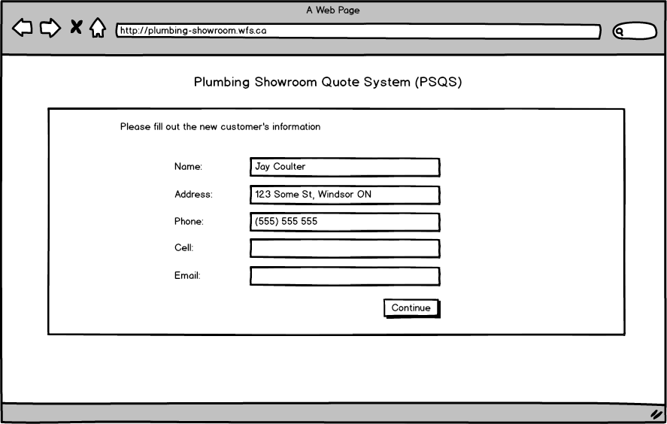

QUOTE CREATION
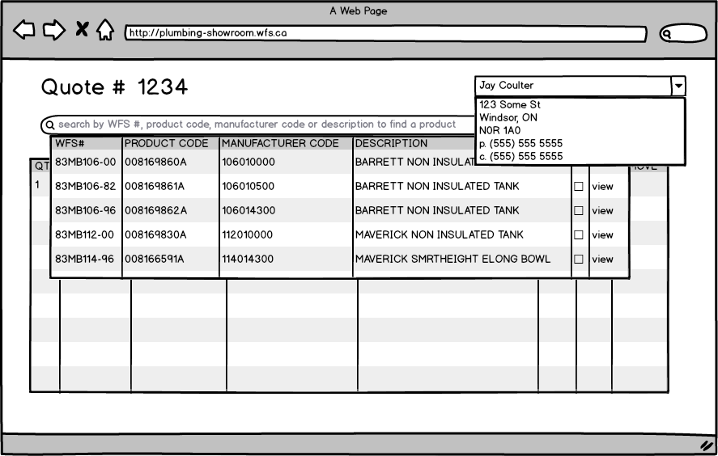

QUOTE VIEW – CUSTOMER – ONLY CUSTOMER COSTS DISPLAYED
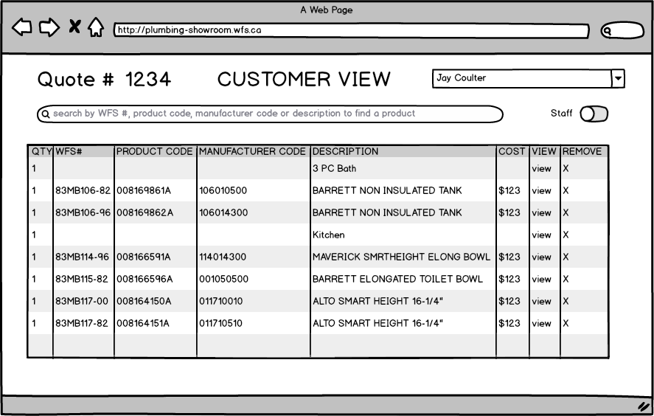
QUOTE VIEW – STAFF – ADDITIONAL COSTS DISPLAYED ON THE FORM
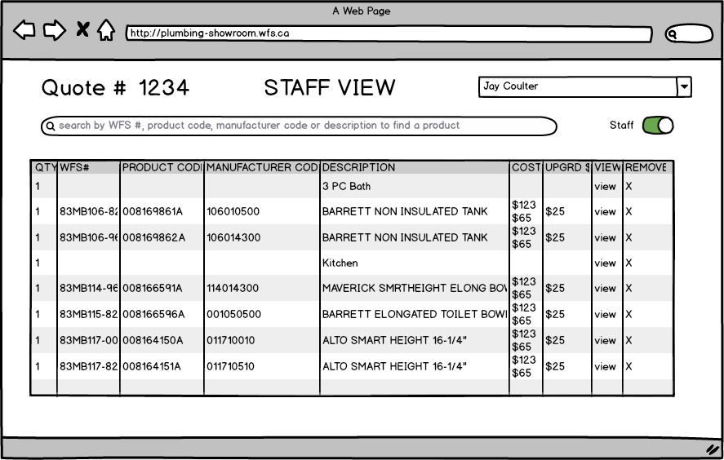
PRODUCT DETAILS - MAIN
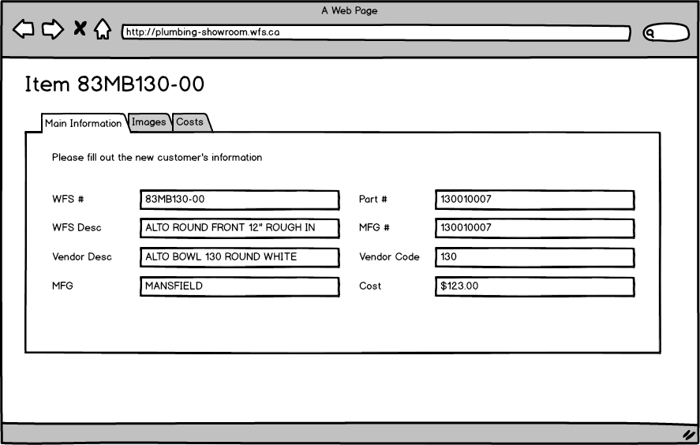
PRODUCT DETAILS - IMAGES
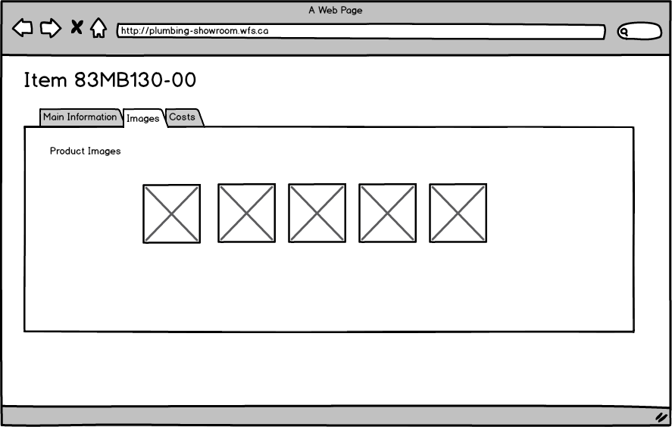

PRODUCT DETAILS - COSTS
