Do you have joint pain?
Some of the initial signs of joint pain include:
- Swelling at the joint
- Joint stiffness
- Ache or tension around the joints
- Grinding sound at the knee when standing up
- Difficulty moving the joint when exercising
- Joint pain during exercise
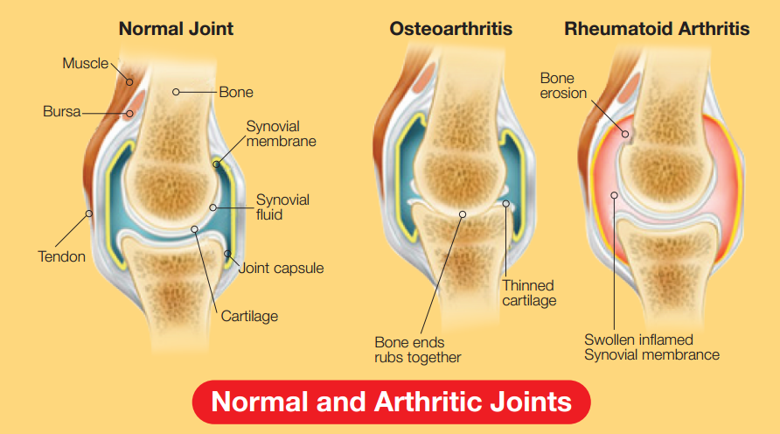

Maintain and relieve joint pain with COLLAWELL.
COLLAWELL contains 100% pure collagen hydrolysate from Germany which helps stimulates cell growth in joint cartilage. It offers a safe and convenient way to help replenish the body’s collagen supply.

Contains only key ingredients without added fats, carbohydrates and preservatives.
COLLAWELL may help to:
- Relieve and comfort your joints
- Increase joint mobility
- Regenerate joint cartilage

Other beneficial effects
- Anti-aging – improvements in skin health like hydrating and firming the skin
- Nourishes body tissues, bones, hair, skin and nails.

What is Collagen?
Collagen is the most abundant and ubiquitous protein in the human and animal body, comprising approximately 30% of total protein⁵. Collagen is found primarily in the bones, skin, muscles, and tendons, where it forms a scaffold to provide strength and structure⁹.

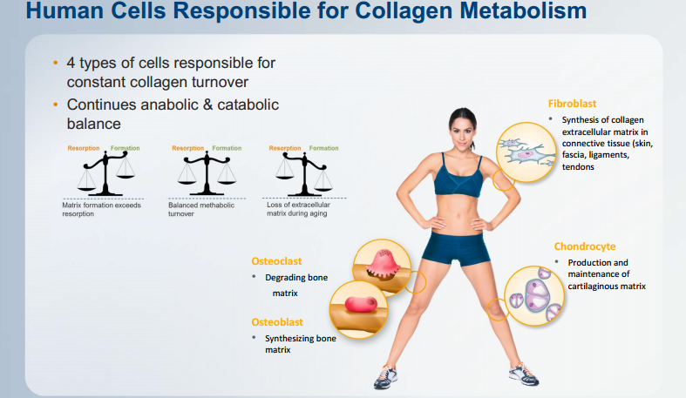

Types of Collagen - Which is suitable for you?

To date, up to 28 different types of collagen have been identified¹⁴. Among them, Type I, II and III take up 80% - 90% of collagens in human body⁷. Various types of collagens have slightly different amino acid compositions and provide other specific functions in our body.

When it comes to choosing a collagen supplement, you should first know which part of the body you wish to benefit in order to bring you the maximum result.

Collagen Type | Tissue Distribution¹⁵ | Major Roles/ Functions^{4,13}
Type I | Skin, bone, tendon, ligament | Most prevalent in our skin which provides structural support to the epidermis
Type II | Cartilage, vitreous body | Major portion of the cartilage that cushions joints and functions as a shock absorber
Type III | Skin, arteries, uterus, intestine | Responsible for the softness and suppleness of skin, flexibility of blood vessels and wound healing

Hydrolyzed Collagen (collagen peptide) for Joint Health

To restore the amount of collagen in the body, the easiest and definitive way is to take collagen supplements. In order for your body to fully absorb and utilize the collagen present in a product, it’s best to pick the highly bioavailable form of collagen hydrolysate.

Through a revolutionary hydrolysis process, collagen molecules are broken down into smaller peptides or amino acids. The resulting short peptides make up collagen hydrolysate which is more easily digested in the gut, able to cross the intestinal barrier, enter the circulation and become available for metabolic processes in the skin, joint and connective tissues^{3, 13}.

Collagen Gelatine Hydrolysed Collagen Peptides

Hydrolyzed collagen stimulates cell growth in joint cartilage. This natural substance induces the formation of new cartilage tissue and restores cartilage degradation resulting from sports activity, work related stress and the natural aging process. People suffering from joint problems can regain mobility and enjoy much-improved quality of life.

Clinical Scientific Substantiation on the Role of Collagen in Joint Health

Numerous clinical studies have shown that hydrolyzed collagen is beneficial to individuals suffering from joint discomfort.

Collagen Hydrolysate Type II used in COLLAWELL – Clinical Scientific Substantiation


- Studies in more than 2,500 patients showing the effect of collagen hydrolysate in joint cartilage.



- Bioactive collagen hydrolysate proven to stimulate growth of connective tissue in joints

1.) 10g of hydrolysed collagen over a 2-month period helps to relief osteoarthritis pain in knee or hip.

Relief of osteoarthritis pain in the knee or hip was noted in a study of patients receiving 10g hydrolyzed collagen daily over a 2-month period^{1, 8}. According to a recent study published in the Journal of the Science of Food and Agriculture, patients with osteoarthritis who were given 10g of hydrolyzed collagen displayed significant improvements in joint health after 13 weeks of treatment⁶.

2.) Accumulation of collagen hydrolysate in joint cartilage 96 hours after oral administration¹⁰.

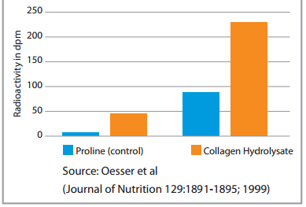

Dr. Steffen Oesser, physiologist at the University of Kiel, Germany, estimated roughly that approximately 90% of the orally administered collagen hydrolysate would be absorbed 5 times faster than just collagen within 6 hours from the gastrointestinal tract with measurable accumulation in cartilage and skin¹⁰.

3.) Rippe Study (2005) confirms significant improvements in joint function in patients with mild osteoarthritis¹².

Design:
- Randomized, double blind, placebo controlled
- 250 patients with symptoms of mild osteoarthritis
- Therapy: 10g collagen hydrolysate Type II or placebo
- 14 weeks trial
- Pain, stiffness, mobility, flexibility and isometric/isokinetic leg strength assessments

Results:
- Consumption of collagen hydrolysate Type II showed significant improvement in joint function by means of isometric and isokinetic leg strength assessments in patients with mild osteoarthritis of the knee

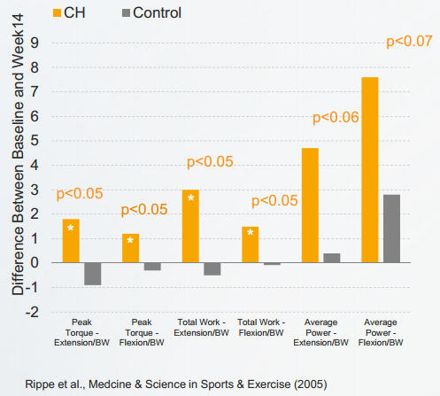

4.) PennState Study (2008): Collagen hydrolysate Type II in Athletes².

Study Design:
- 147 student athletes, randomized, placebo-controlled, double-blind
- Therapy: 10g collagen hydrolysate Type II or placebo over 24 weeks
- Parameters: pain, mobility, flexibility in different joints.

Results:
- Significant improvement in joint problems (especially in the knee)
- Increase of performance & mobility
- Decrease of alternative therapies (massages/ice packs)


5.) Tufts Medical Center Study, Boston (2011) Visualized the Joint Health Effect of Collagen Hydrolysate Type II¹⁶.

Design:
- Prospective, randomized, double blind, placebo controlled
- 30 individuals with mild grade of Osteoarthritis (Kellgrean grade 1 – 2)
- Therapy: 10 g collagen hydrolysate Type II or placebo
- 11 months trial
- dGEMRIC data

Results:
- Proteoglycan density in the knee joint cartilage was significantly increased after collagen hydrolysate Type II treatment

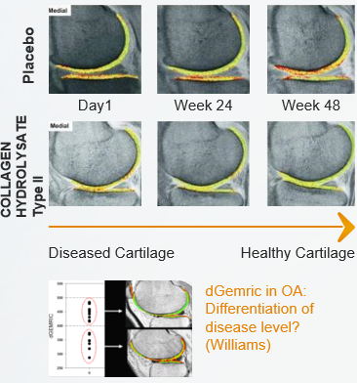
Collagen Hydrolysate Type II Regenerates Cartilage Tissue in Humans

6.) NOCA Observational Study (2012): 5g Collagen Hydrolysate Type II Effective on WOMAC Score⁹.
NOCA = Nordic Orthopedic Competence Association

Design:
- Observational study coordinated by NOCA - 2011/2012
- Random recruitment of patients coming to the doctor‘s office (orthopedist)
- 20 patients with mild / moderate osteoarthritis in knees and hips
- 50% female / 50% male, Age 63 +/- 10
- BMI 27.4 +/- 3.4
- Daily use of 5g collagen hydrolysate Type II - provided in a 10g sachet

Results:
- A collagen hydrolysate Type II dose of 5g/day showed significant effects / Proof of concept

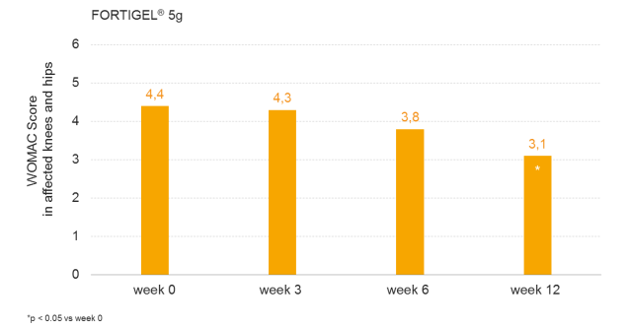

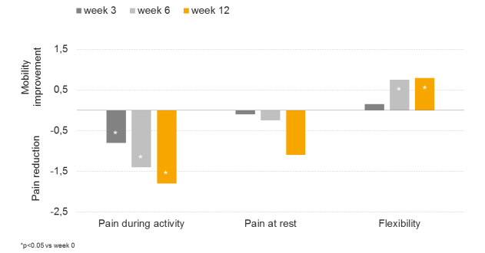

7.) Clinical Study on Collagen Hydrolysate Type II 5g Daily Dosage (2014)
*unpublished

Investigate the effect of orally administered Bioactive Collagen Peptides on young adults suffering from diagnosed activity-related knee joint pain.

Study Design
- Single-Center, prospective, randomized, double-blind, placebo-controlled trial (according to GCP)
- 160 healthy subjects, 18 - 30 years
- Daily intake of 5g collagen hydrolysate Type II or placebo, 12 weeks

Result
- Significant pain reduction after 12 week treatment, first effects after 6 weeks
- First RCT study demonstrating efficacy of a 5g collagen hydrolysate Type II therapy
- First study clearly demonstrating the positive effect on healthy individuals suffering from joint pain (EFSA)

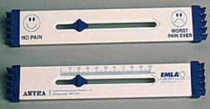

8.) Clinical Study on Collagen Hydrolysate Type II 5g Daily Dosage (2015)
*unpublished

Investigate the effect of orally administered collagen hydrolysate Type II for the treatment of functional-related joint discomfort in healthy adults suffering from diagnosed knee or hip joint pain.

Study Design
- Multi-Center, prospective, randomized, double-blind, placebo-controlled trial (according to GCP)
- ~180 healthy subjects, mean age ~ 50
- Daily intake of 5g FORTIGEL or placebo, 12 weeks

Result
- Significant reduction of joint pain during activity and at rest against placebo
- Second study clearly demonstrating the positive effect on healthy individuals suffering from joint pain (EFSA)

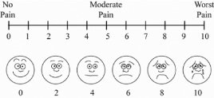

Why Choose COLLAWELL Collagen Hydrolysate Powder?

- 100% pure, highly bioavailable form of hydrolyzed collagen from Germany
- High concentrations of key amino acids: glycine and proline
- Restores and rebuilds collagen in the body
- Helps maintain body’s strength and flexibility
- Well-tolerated and safe for long term consumption
- With no unwanted calories from fillers or flavorings
- Non-GMO, free from gluten, soy, shellfish, fish, egg, milk, peanuts and sugar
- Generally Recognized As Safe (GRAS)
- Packed under Good Manufacturing Practice (GMP) conditions

Who Should Take COLLAWELL Collagen Hydrolysate Powder?

- Anyone who wish to restore the collagen in the body naturally
- Patients suffering from arthritis-related conditions such as joint pain and stiffness
- Post-menopausal women who are at high risk of osteoporosis
- Athletes who are physically active but experience joint pains
- Elderly people

Frequently asked questions about COLLAWELL:
Why should I take COLLAWELL?
The stress placed on our joints means that they are prone to damage in the longer term. Cartilage is worn out and sometimes even lost. Unfortunately the body is sometimes unable to produce sufficient new cartilage to counteract this loss. Studies has shown that COLLAWELL’s ingredient collagen hydrolysate may improve joint health and mobility.

Who can take COLLAWELL?
Studies have shown that collagen hydrolysate in COLLAWELL’s ingredient is an ideal nutritional supplement for anyone wanting to stay fit and well or who want to reduce the risk of degenerative joint disease. Collagen hydrolysate plays an important role for use in individuals at risk for development of joint degeneration. It also benefits Individuals participating in extensive non-occupational physical activities including recreational runners/walkers, cyclists, gym members, self-defense art, soccer/football players; individuals with a past history of significant joint injury such as fracture or ligamentous injury; and individuals with a family history suggesting a genetic predisposition of osteoarthritis.

How should I take COLLAWELL?
Just dissolve COLLAWELL in either warm or room temperature beverage (not in hot water).

How safe is COLLAWELL?
The US Food & Drug Administration (FDA) safety studies confirmed Collagen Hydrolysate as GRAS (Generally Recognized as Safe) status. A GRAS substance is one that is considered safe by experts when added to food.

Both World Health Organization (WHO) and the European Commission for Health and Consumer Protection have confirmed that Collagen Hydrolysate is safe. Collagen Hydrolysate is recognized by WHO to have particular benefit for joint health and is a key focus of WHO’s Bone & Joints Decade Initiative.

Collagen Hydrolysate is a food supplement, not a drug. Thus, long term regular intake is safe and may serve as a preventive measure.

Should I stop taking COLLAWELL if I am experiencing more pain in several areas of my body?
Initial phase of COLLAWELL consumption is not related to the product but may be due to the ‘ups and downs’ of pain in osteoarthritis. People who are diagnosed with osteoarthritis may feel pain on certain days. If you experience pain not related to osteoarthritis, you may want to confirm with medical doctor on your condition before taking COLLAWELL.

How soon should I begin to see any effects?
Studies conducted recommend a daily intake of 10 grams of collagen hydrolysate for at least three months or less. Results vary among individuals.

If I am currently taking glucosamine supplement, should I consider adding in COLLAWELL?
The cartilage is a dense, elastic and very rich in collagen (about 70%) conjunctive tissue. On top of supplementing yourself with glucosamine supplement, you may consider to take COLLAWELL. The hydrolysed collagen is quickly absorbed after ingestion and readily deposited in the body’s tissues which will then help to prevent cartilage degradation and regain joint mobility. You might begin to notice desirable effects after three months or less. Results vary among individuals.

Can I still take COLLAWELL if I am on medication?
COLLAWELL is a food supplement and not a pharmaceutical drug with no known interactions with other medications or food. . If you experience pain not related to osteoarthritis, you may want to confirm with a medical doctor on your condition before taking COLLAWELL products.

Is COLLAWELL a steroid or pain killer?
COLLAWELL is food supplement, not a drug or medication.

Are there any side effects taking COLLAWELL?
COLLAWELL is considered to be well tolerated with no known side effects. Therefore it is safe for long term consumption. Some clinical studies have reported minor side effects such as increased flatulence and diarrhea but such cases are extremely rare and isolated.

Will I gain weight from consumption of COLLAWELL Are there fats contents?
Consumption of COLLAWELL has no effects on weight increase or dietary imbalance. COLLAWELL is protein comprising of only amino acids, water and minerals and contains no fats, carbohydrates or preservatives.

Can I take COLLAWELL if I am pregnant or diabetic?
COLLAWELL is generally safe for pregnant women, diabetics or obese people.

References:
- Adam M. (1991). Therapie der osteoarthrose welche wirkung haben gelatineparaprate? Therapiewoche, 41:2456–61.
- Clark et al. (2008). 24-Week study on the use of collagen hydrolysate as a dietary supplement in athletes with activity-related joint pain. Current Medical Research and Opinion 24(5): 1485 - 1496
- Daneault, A. et al. (2015). Biological effect of hydrolysed collagen on bone metabolism. Critical Reviews in Food Science and Nutrition, 15, 0.
- Diegelmann, R.F. et al. (2001). Collagen Metabolism. Wounds, 13(5).
- Hashim, P. et al. (2015). Collagen in food and beverage industries. International Food Research Journal, 22(1), 1-8.
- Kumar, S. et al. (2015). A double-blind, placebo-controlled, randomised, clinical study on the effectiveness of collagen peptide on osteoarthritis. Journal of the Science of Food and Agriculture, 95(4):702-707.
- Lodish, H. et al. (2000). Molecular Cell Biology, 4th edition. New York: W. H. Freeman.
- Moskowitz, R.W. (2000). Role of collagen hydrolysate in bone and joint disease. Seminars in Arthritis and Rheumatism, 30(2):87-99.
- NOCA Observational Study (2012)
- Oesser, S. & Seifert, J. (2003). Stimulation of type II collagen biosynthesis and secretion in bovine chondrocytes cultured with degraded collagen. Cell & Tissue Research, 311:393-399.
- Ricard-Blum, S. (2011). The collagen family. Cold Spring Harbor Perspectives in Biology, 3(1), a004978. doi: 10.1101/cshperspect.a004978.
- Rippe et al. Medcine & Science in Sports & Exercise (2005)
- Sibilla, S. et al. (2015). An overview of the beneficial effects of Hydrolysed Collagen as a Nutraceutical on Skin Properties: Scientific Background and Clinical Studies. The Open Nutraceuticals Journal, 8, 29-42.
- Silvipriya, K.S. et al. (2015). Collagen: animal sources and biomedical application. Journal of Applied Pharmaceutical Science, 5(03):123-127. doi: 10.7324/JAPS.2015.50322.
- Thomas, D. et al. (1998). Principles of Medical Genetics, 2nd edition. USA: Lippincott Williams & Wilkins, page 144.
- Tufts Medical Center Study, Boston (2011).

