Digital Project Brief

Brief details

Client: Alcovit Document version: v0.1
Project: Alcovit Website Author: Bryn Newman
Briefing Date: 21/09/17 Job Number: 001

Project understanding

Background information:

We are rebranding a hangover prevention and liver detox product called Alcovit. You mix it with water and drink before you go to bed after a night of drinking.

The previous websites have been clunky, ugly, with poor design and very little purpose. We need a clean UI that takes the user through how it works, to the products, to the cart, all with a simple to use platform.

http://demo.exceldesigns.com.au/alcovit-cms/

Theme: http://shopkeeper.wp-theme.design/home/home-product-landing-2

The design MUST be similar to the theme to minimise custom coding.

Objectives:

- Increase awareness
- Increase sales
- Redesign brand to elevate look

Proposition:

- Detox your liver
- Reduce chances of hangovers
- Use a product that works compared to its competitors because of its scientific production.

Target Audience:

Men and women who love to drink alcohol and want to prevent hangovers.

Identified audience is 30-55 years (we will start by targeting 28-40), the USP is superior product performance based on health benefits of reduction of alcohol through the liver, secondarily hangover symptom reduction. Premium brand for health conscious consumers. Superior replacement for the go-to-hangover meds, ie. Panadol, Nurofen, Berrocca - aids the process and digestion as opposed to inhibiting. Brand look and feel re-design to be relevant to identified target audience.

What functionality is needed

This site covers a lot of what we want: https://www.webalive.com.au/ecommerce-website-features/

MOBILE FIRST DESIGN
Video on homepage
Email popup
Add to cart from home page
Coupon code
Facebook Messenger Chat
Quick fill credit card info at checkout
Reviews
Mobile friendly
Detailed shipping info (can be a secondary header bar with FREE shipping over $30 promo)
Money back guarantee page (return policy)
Contact page phone, email, and an online form + connect with us on Facebook and Instagram
Favicon
Referral program
SEO text boxes on home page
Newsletter sign up in footer

Sections to show: REVIEWS/TESTIMONIALS and REFER A FRIEND and MONEY BACK GUARANTEE
Needs a call to action SHOP NOW button at the bottom of the page (see https://thinco.me/)
Needs payment icons in the footer (paypal / Visa / Mastercard for now)

Pages Required:

https://drive.google.com/a/digitalathlete.com.au/file/d/0BzbWZGpe22VNMGdFUm44N3NXYlU/view?usp=sharing

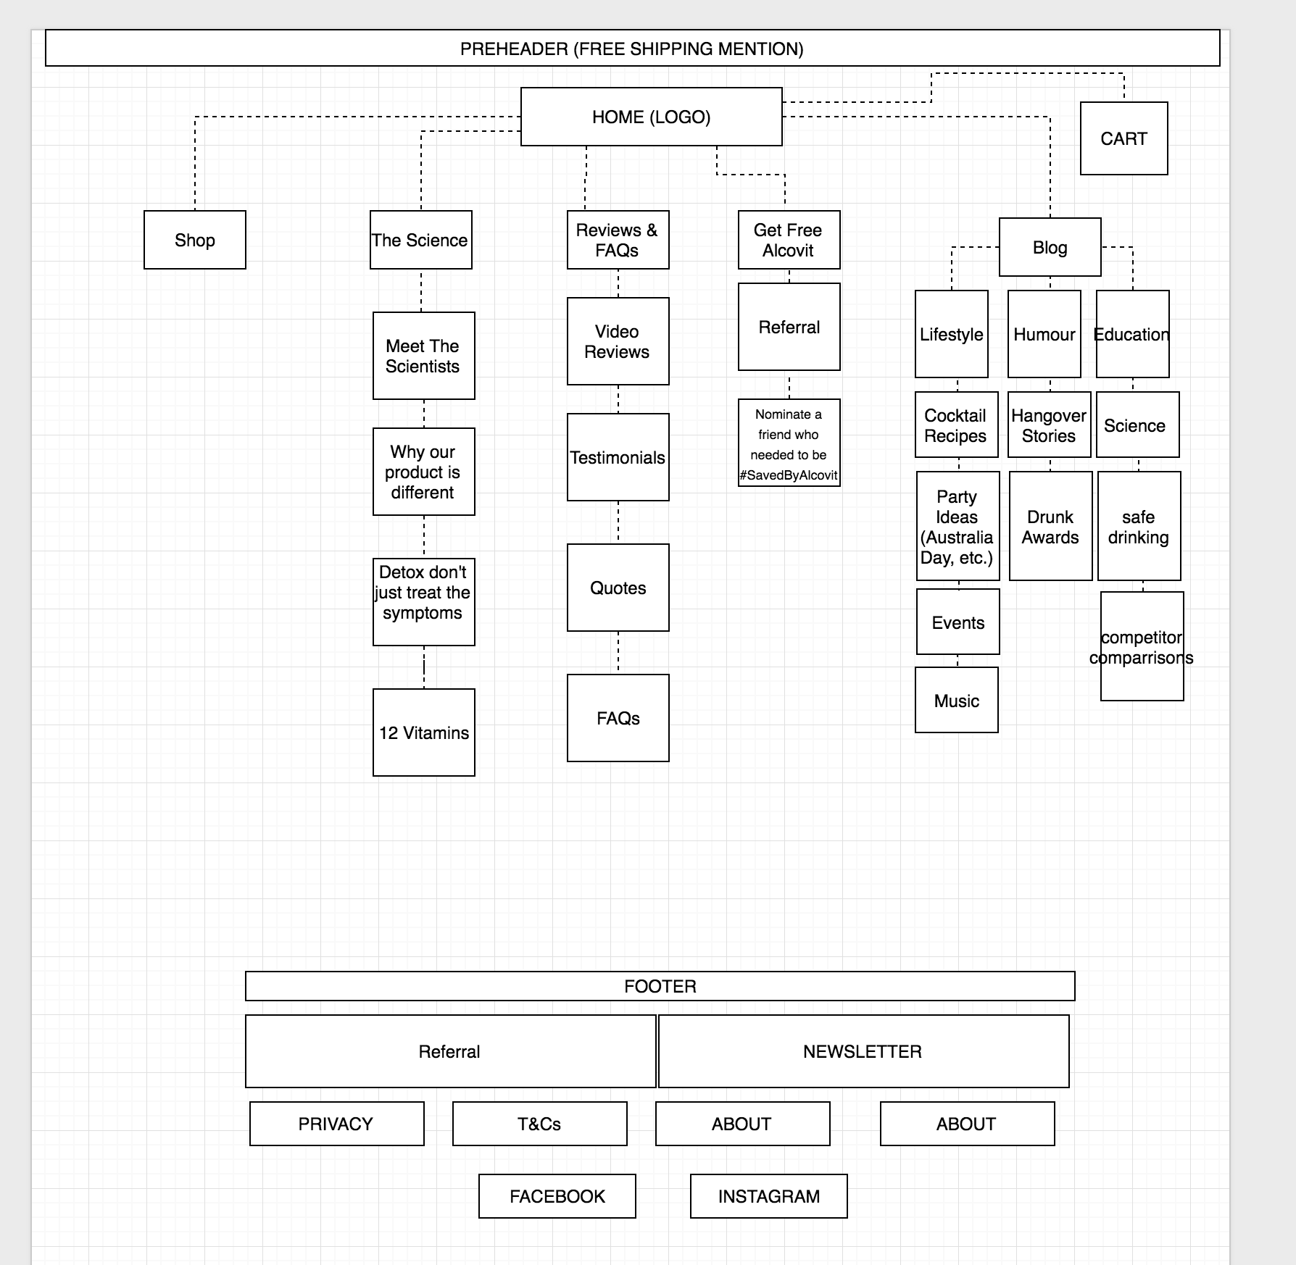

Important dates and critical path:
(Are there any specific dates we need to be aware of? Review dates, launch dates, availability of decision makers throughout the project.)

We would like the site launched by Mid November

Creative considerations

Branding folder: https://drive.google.com/open?id=0BzbWZGpe22VNUTYzcnZrbjVmczg

Brand guidelines: (only use fonts and colours from here)

https://drive.google.com/open?id=0B1PKweO149gZZl82MDlEdG9rbms

Example of how the scientist should be displayed on the homepage: https://drive.google.com/open?id=0BwgwZk2XUATKajdGRDdqN1pDVms

Another example: https://drive.google.com/open?id=0BwgwZk2XUATKWG5jbW9aM0dZUkU

Copy to be used for home page:
https://docs.google.com/document/d/1fu0en7hhZrIJzwr-XBsO2ft9nrrTdXAvqm4IKVdar5o/edit

If needed, use copy placeholder text from these websites - http://www.alcovitnomorehangovers.com/ or http://demo.exceldesigns.com.au/alcovit-cms/

Add a product image on the home page with shop now button

Brand vision and values:
(What are the core values of the brand?)

1. Fun
2. Funny
3. Health, take care of your liver.
4. Scientifically better than competitors
5. Education (safe drinking, minor element)

Tone of voice & Key Messages:

Funny, witty, relates to 28-40 audience. Alcovit is for people who don't want to ruin their next day at work with a hangover OR cherish their weekends so much they would never want to waste a Saturday or Sunday. The characters telling the brand stories are two scientists, Dr. Reinhard Nickchen and Dr. Klaus Juelicher.

Likes & Dislikes:

Loves design wise: https://mailchimp.com/

Other inspiration
https://www.pinterest.com/pin/474285404494163209/
https://www.pinterest.com/pin/475200198166081933/
https://www.pinterest.com/pin/181692166197049862/
https://www.pinterest.com/pin/293156256984803604/
https://www.pinterest.com/pin/482025966346092082/
https://www.pinterest.com/pin/425238389801779277/

http://addiction.mobydigg.de/
https://thecoolclub.co/

Mandatory creative elements:
(What should be included as a minimum – logo, tagline, guidelines, and company details, any other information?)

Logo, collage elements, scientists.

https://drive.google.com/open?id=0BwgwZk2XUATKc182TUJqZDItMXc

Use this logo: https://drive.google.com/open?id=0BwgwZk2XUATKdDlfQzdEMmtQd2s

Website elements can be taken from these email designs: https://drive.google.com/open?id=0BzbWZGpe22VNWXVqWHl3bkxqWXM

Imagery & Brand collateral reference materials:
(Existing resources to access and leverage, including images, fonts, styleguides)

https://drive.google.com/open?id=0BwgwZk2XUATKc182TUJqZDItMXc

Deliverables

Deliverable list:

May need to source some images, we have a Bigstock account so please ask us if you’d like us to get any images from there.

Technical considerations

Browsers:
(Which browsers should be considered)

☒ ☒Safari ☒ Firefox: ☒ Chrome

Mobile & Tablet version?:
(Does this project need to be mobile and tablet friendly? Does it need a mobile optimised version for an additional cost?)

MOBILE FIRST MENTALITY

