Briefing Logo Cielo October 2017

Please find below the briefing for the logo development of a boutique advisory in Capital Raising and Commercial Advisory, called Cielo. Read this document thoroughly before starting with the concept of the desired logo.

Profile Cielo
Having worked literally all across the world, commercial and capital advisor Neil Martin returned to his birth country New Zealand where his global, diverse knowledge will now be readily available to the elite business community of Hawke’s Bay and beyond.

Key features profile Cielo:
- Professional
- Integrity
- Get things done. Hands-on and results-driven.
- Commercially and financially astute
- Passionate
- Environmentally aware

USP’s:
- Global experience in capital raising and investment management
- Experience across all business sizes and sectors. From start-up through to 30,000 employee-companies
- Top consulting firm quality bundled in 1 individual: no need to deal with massive corporations
- Results-driven approach, not afraid to roll up sleeves and get hands dirty

The name Cielo:
Is Spanish for ‘Sky/Heaven’ and serves as a symbol for the growth companies will achieve with the help of Cielo.

Logo direction:

Colour: Possibly, blue is optional. Simple black also welcome.
Style: Simple, elegant, boutique. Has to instil a sense of trust, solid knowledge, someone to depend on
Symbol: We tend to lean towards the simplicity of the name. But a simple symbol we don’t exclude, as long as it is classy and meaningful.
Extra: The two components of this advisory firm revolve around:
- Capital Raising
- Commercial Advisory.
These two C’s could be visually used as part of the logo. See sketches below as a source of inspiration or direction (but feel equally free to create a very different concept):

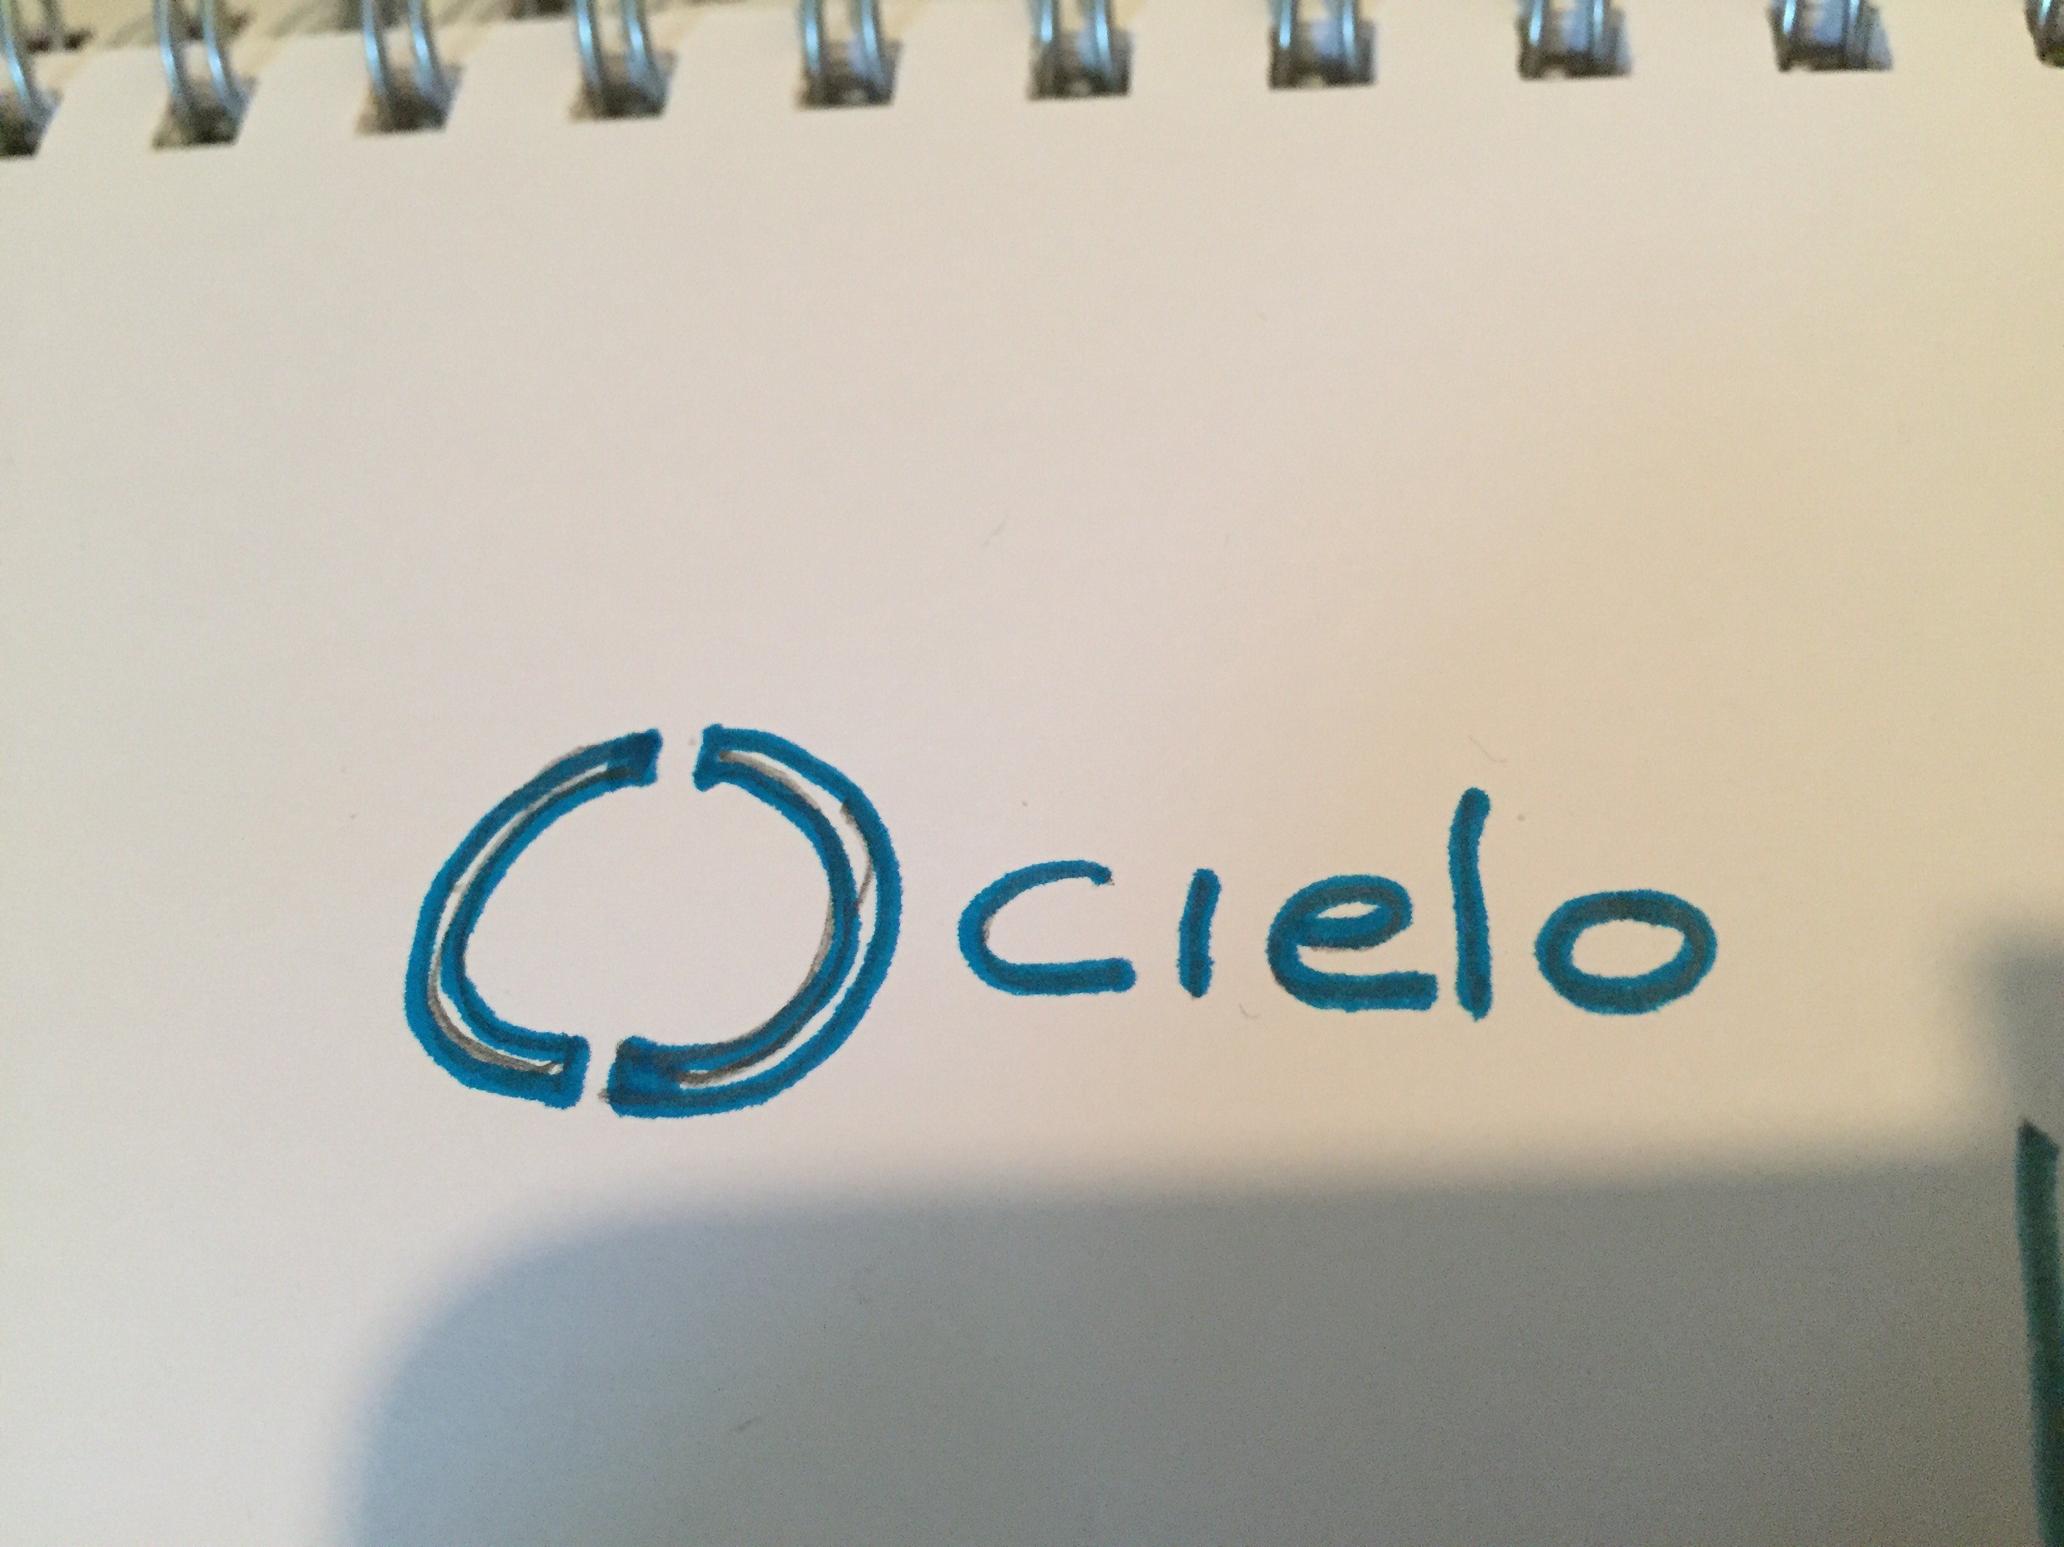
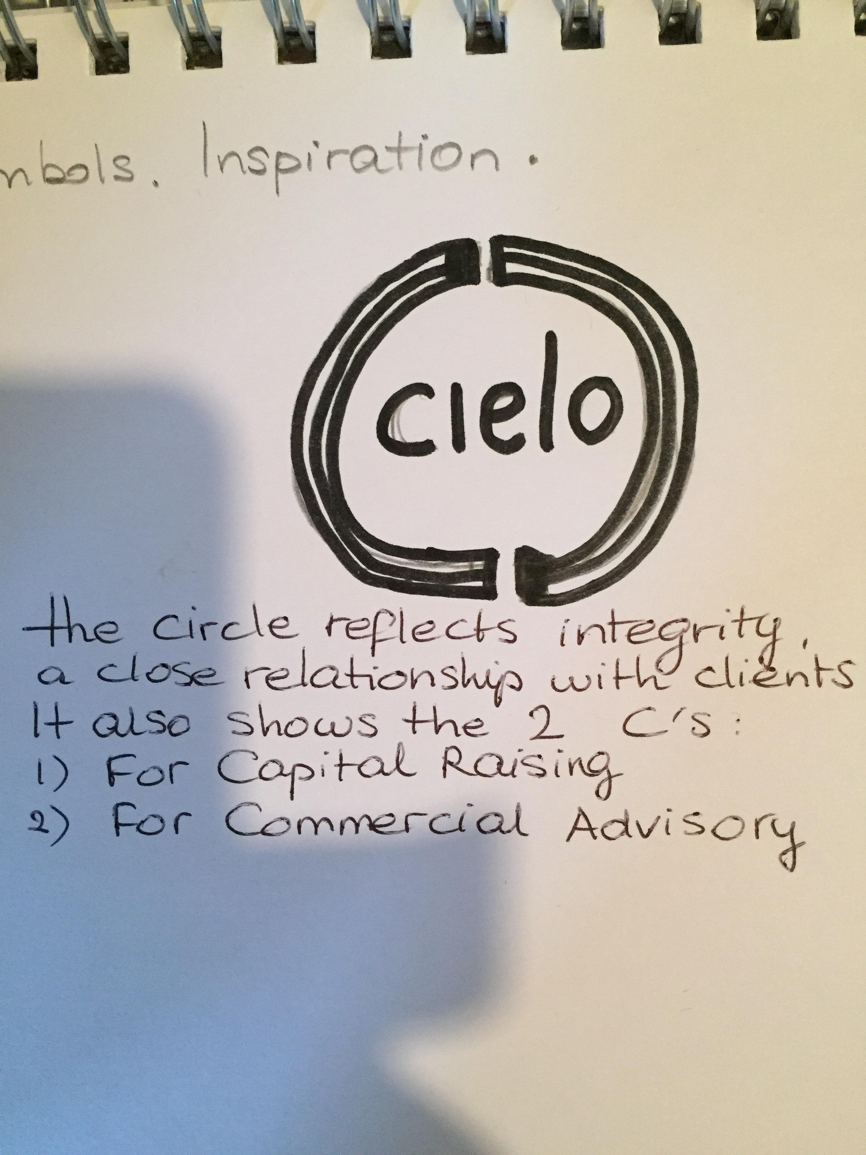

Example logo:
One logo that we find quite elegant in its simplicity and style, is the logo of Macquarie Bank:
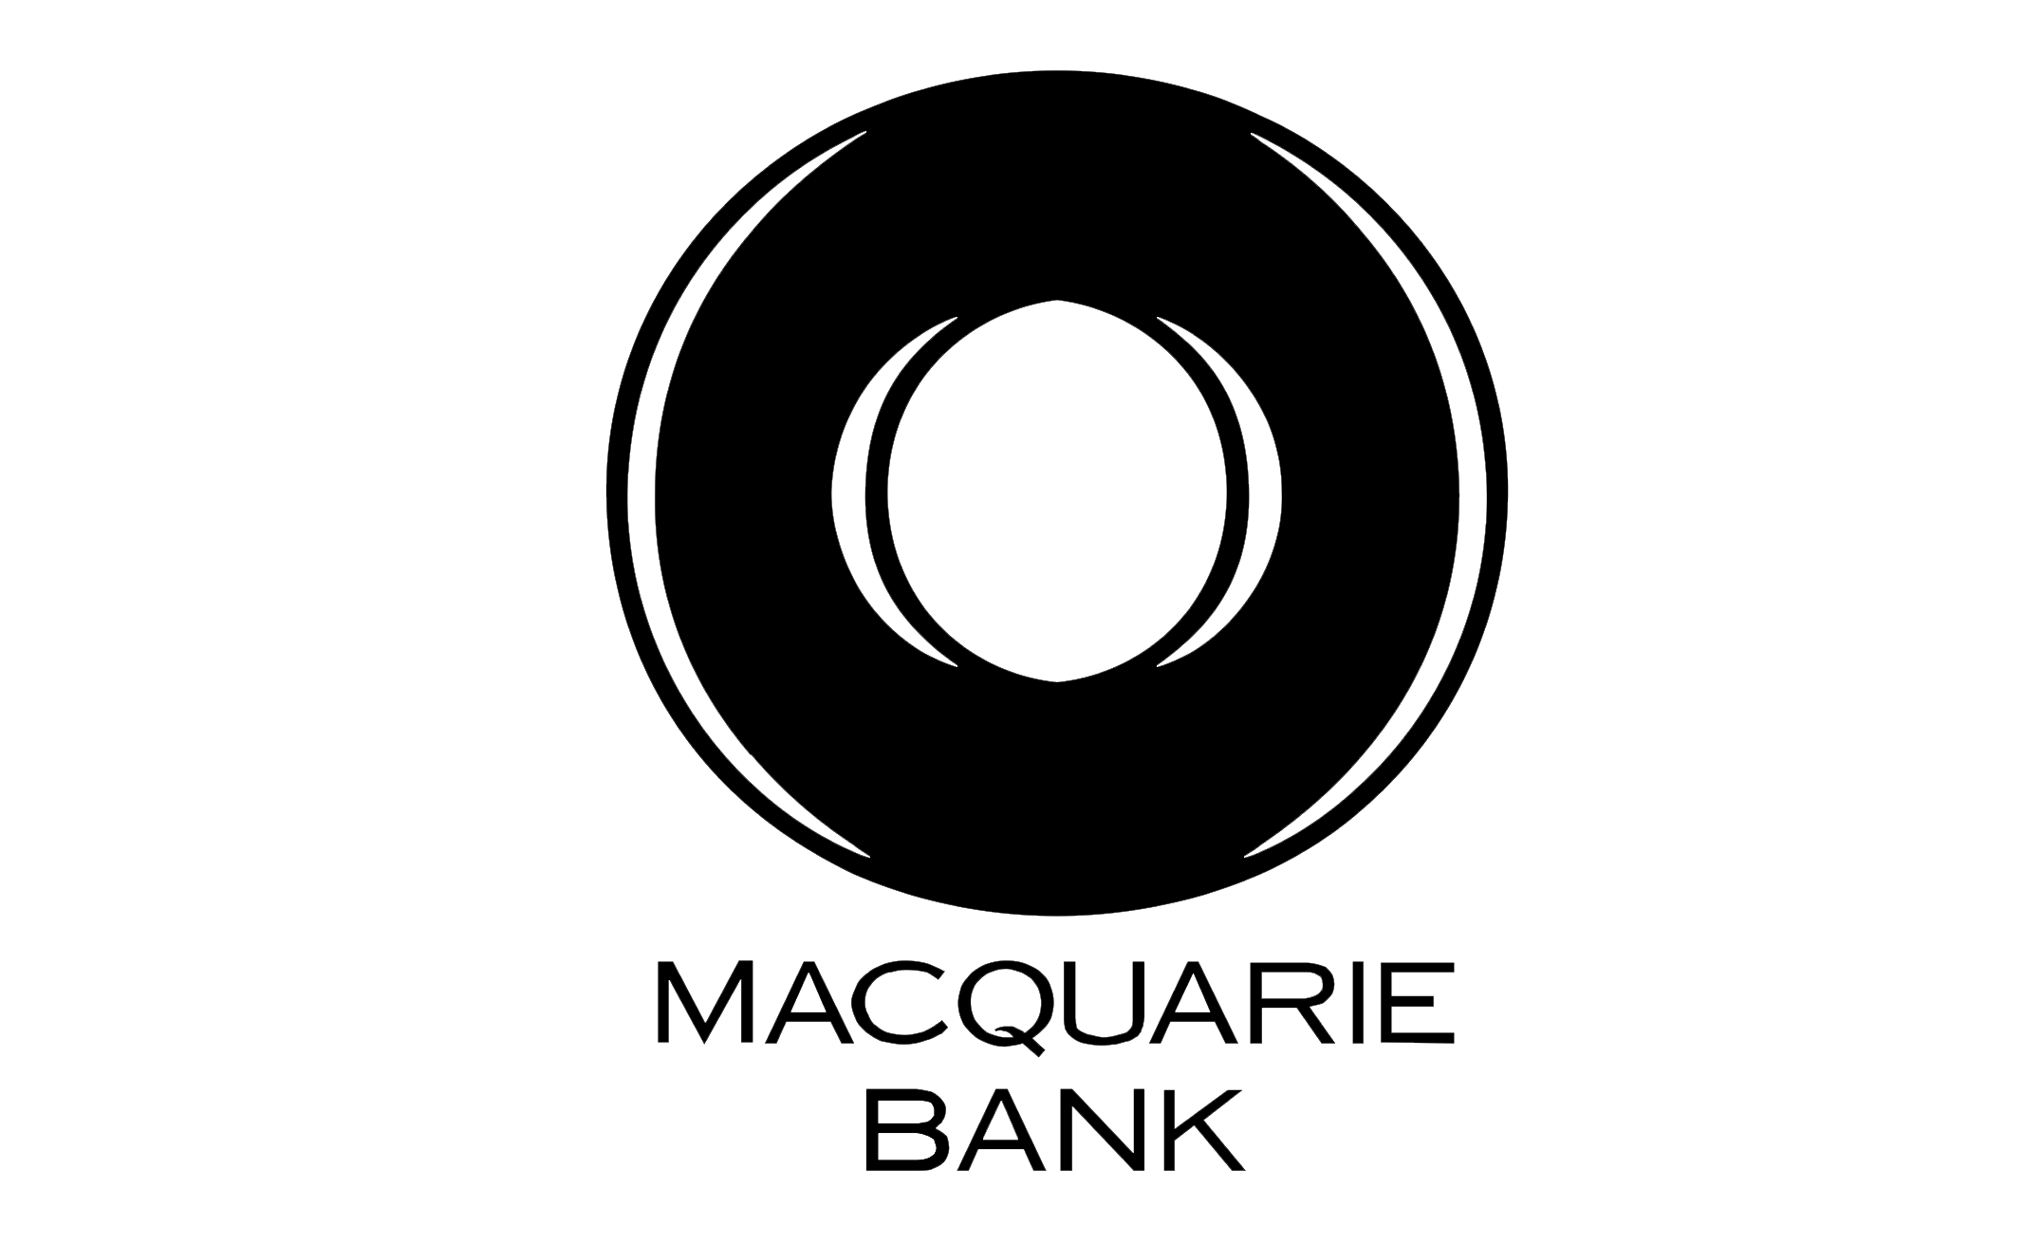
The Macquarie logo does have a symbol, a simple one, which through its design is quite dimensional. The font used here is clean and clear yet vivid and boutique.

Tagline?
We have chosen not to add a tagline to our logo, to keep it clean, simple and elegant. Cielo operates in an industry where word of mouth generates most projects, so explaining it’s services or values through a tagline would not add anything.

Deadline
We would like to receive first logo concept designs before Wednesday 8 November, so we can choose the winning concept. A week later, Wednesday 15 November, we would like to have finalised the Cielo logo.

