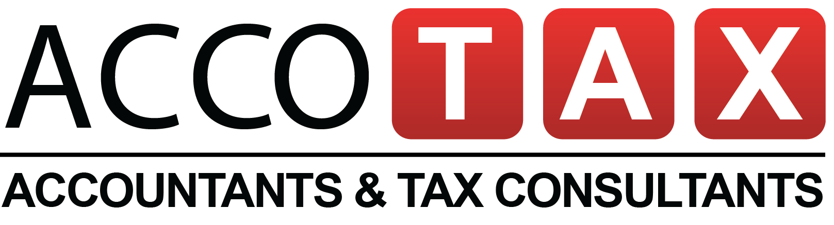
Our Services:
- Company Formation - Business Start-up Advice
- Company Accounts - Company Tax Returns
- Non Resident Landlord Taxes - Personal Tax Returns
- Landlords Tax Returns - C.I.S - Tax Refunds
- Tax Investigations - Tax Planning
- Payroll & PAYE - Work Place Pension
- Bookkeeping - Registered Office Address
Why us?

- Qualified & experienced team - Fixed Fees – No surprise bills
- Over 40 years of combined experience - Dedicated accounts manage
- Monthly Newsletters & tax tips - Work on time, Every Time
- Free telephone & email support - Guaranteed Satisfaction
- Never miss any deadline* - Excellent Customer Service

For Free Consultation, Call us now

Meets your business needs beyond numbers.

T: 0203 4411 258 T: 0800 644 1258
E: info@accotax.co.uk W: www.accotax.co.uk

Address : 12 London Road, Morden, SM4 5BQ

