Feedback on brochure v2
11-6-17

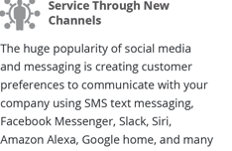
Capitalize Home of Google Home.


In the bottom URL do not capitalize any letters and delete the duplicate .net


Do not change the font and color in the word forward


Do not all cap the first three words


This is the bottom of the first page. Do not capitalize any letters in the URL.

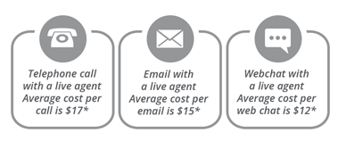
Add A on telephone call. A telephone call….(Note to no longer capitalize the t in telephone)
Add An on email. An email with…(Note to no longer capitalize the e in email.)
Add A on webchat with… (Note to no longer capitalize the W in webchat.)


Make the font size much larger in “ENGAGMENT MODEL”

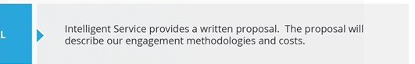

Change this text to: Intelligent Service provides a written proposal that describes our engagement methodology, costs, and report content.

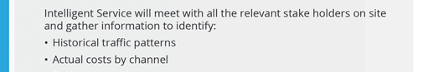
Change the first sentence to this: Intelligent Service will meet with all the stakeholders to identify:

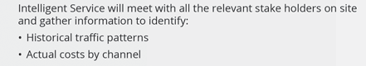
Change the second bullet point to: Actual costs of services per channel

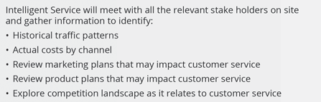
In the last bullet point above, change it to: Explore the competitive landscape as it relates to customer service.

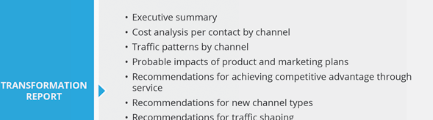
In the second bullet point, change it to: Cost analysis by channel

