Snoober’s Brexit
“Help Snoober escape the U.K. and start a new life overseas!”
Project Brief for Illustrators
Snoober cat wants to escape the U.K. Both I and Snoober MUST give away our country house, otherwise we cannot move overseas!
I am relying on YOU to draw:
a) Snoober grumpy in the U.K / at home at the Chapel I am giving away in the competition. Show Snoober in different locations during her “escape”, e.g. at Manchester Airport, catching a cab, having her bags searched at customs… and around the U.K at key locations, doing many things. She looks very miserable, wherever she is.
b) Show Snoober on her global travels! Show her in a range of new countries. Where is she and what is she doing? She will enjoy many activities but still look grumpy and unimpressed… that’s just Snoober. But at least she’s overseas in exotic places! Where will you put her?

A FINE BALANCE
Convey that the UK is a really nice place actually…but, that nothing at all makes Snoober happy!
The dissatisfaction is about Snoober, and doesn’t show the house and England in a bad light. Snoober sees everything negatively.

WHAT’S SNOOBER LIKE?
She is white, longhaired, scruffy.
There is silver to her top coat. She is a “silver chinchilla” Persian cat.
I don’t mind if you show her stark white or white and silver. Her spirit is more important. You can make her fatter, rounder, grumpier, cuter, scruffier, wilder, sillier. It doesn’t matter; you can do whatever it takes to make her more appealing.
However, people should be able to then see photos of Snoober and accept it’s the cat from the illustrations.
The ad images can over-emphasise her scruffiness as it makes a Persian cat cuter!
She is fluffy, can be shown as a puffball with little definition if that works for you.
She has NO TAIL.
She has tufted paws, i.e. where the claws emerge, (you don’t ever see or show the claws) she has pointed fur tufts.
She has short ear tufts.
I would like her with small ears, as Persians usually do have short ears on a big, broad, fat head.
She is very round, has a squished flat face, and piercing emerald GREEN eyes with black eyeliner.
She has a pink nose.
She has black toes. If ever we see the underneath of her paws, remember that.
Snoober LOVES chicken.
WARNING
Snoober is grumpy. She is “a” grumpy cat.
But SHE IS NOT GRUMPY CAT (the character).
Any resemblance to the character Grumpy Cat, will fail.
Grumpy Cat is a different breed and a recognised public figure,
and our cat must be worlds apart from this.
We want Snoober cat, not Grumpy Cat.

GRAPHICS TIPS:

Your work is:
- simple, fresh, colourful, fun, engaging;
- mostly free of words. Facebook BANS ads with too much writing.
- cartoonish/funny—they must make people smile.
DO:
- experiment with Photoshop! Photoshop your Snoober onto any photos of the property, images from around the U.K. and overseas;
- DRAW/ paint the current house in the background. You do not HAVE TO use Photoshop;
- be silly!
- be playful;
- try to show more than one Snoober position. If you show me several good images, you will get one of the commissions because I can see you’re able to produce several;
- make your cat look like Snoober!
- give her short ears, flat, downturned…
- make her fat and fluffy;
- give her a small nose;
- give her big, fat paws;
- put Snoober in awkward/embarrassing situations;
- make Snoober cute! Enhance any features that will make her cute.

DON’T:
- give her a tail;
- Give her the wrong colour eyes (they are GREEN with black eyeliner;
- over-work one design. Show it to me rough; I will say if it works. If it does, you can work it to completion;
- worry that you send me sketches that are unfinished. I am HAPPY to see rough sketches!
- most of all DON’T make Snoober look like any other white longhaired cat. Look at her face, make her Snoober, not just any cat. Page fans must recognise her characteristics.
SNOOBER U.K SUGGESTIONS
Snoober at home (use the photos in Gallery on www.yourcountrychurch.com.) …Snoober at the airport… Snoober in London… Snoober at Stonehenge…Snoober meeting the Queen’s Guards…Snoober up a British mountain… Snoober on a sunbed in the rain!.... Snoober in the Cotswolds… Snoober in the pub.
These are just examples. Be creative!
SNOOBER ‘ESCAPE’ SETTING SUGGESTIONS:
Snoober on a beach… Snoober in a treehouse… Snoober at the airport with luggage… Snoober in a limousine outside a palace… Snoober at a luxurious dining table in the Middle East, being served exotic dishes… Snoober exploring the jungle…Snoober in the rainforest… Snoober eating ice cream on a ferry boat… Snoober up the Eiffel Tower… Snoober eating German sausages… and so on.
Snoober’s clothes will also be fun. What would Snoober wear?
Below are SNOOBER PHOTOS: Scroll to see them all.

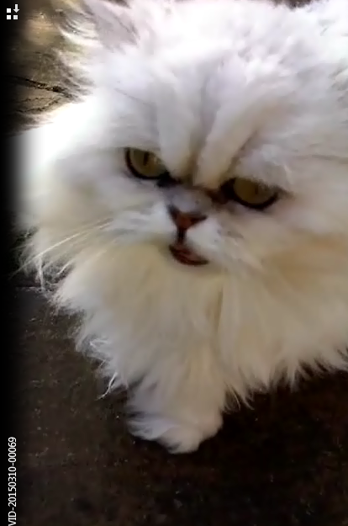

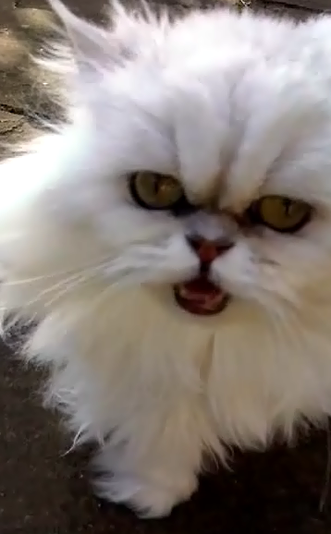

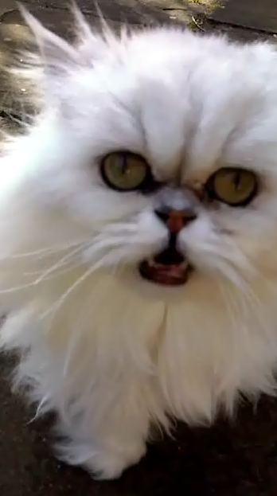
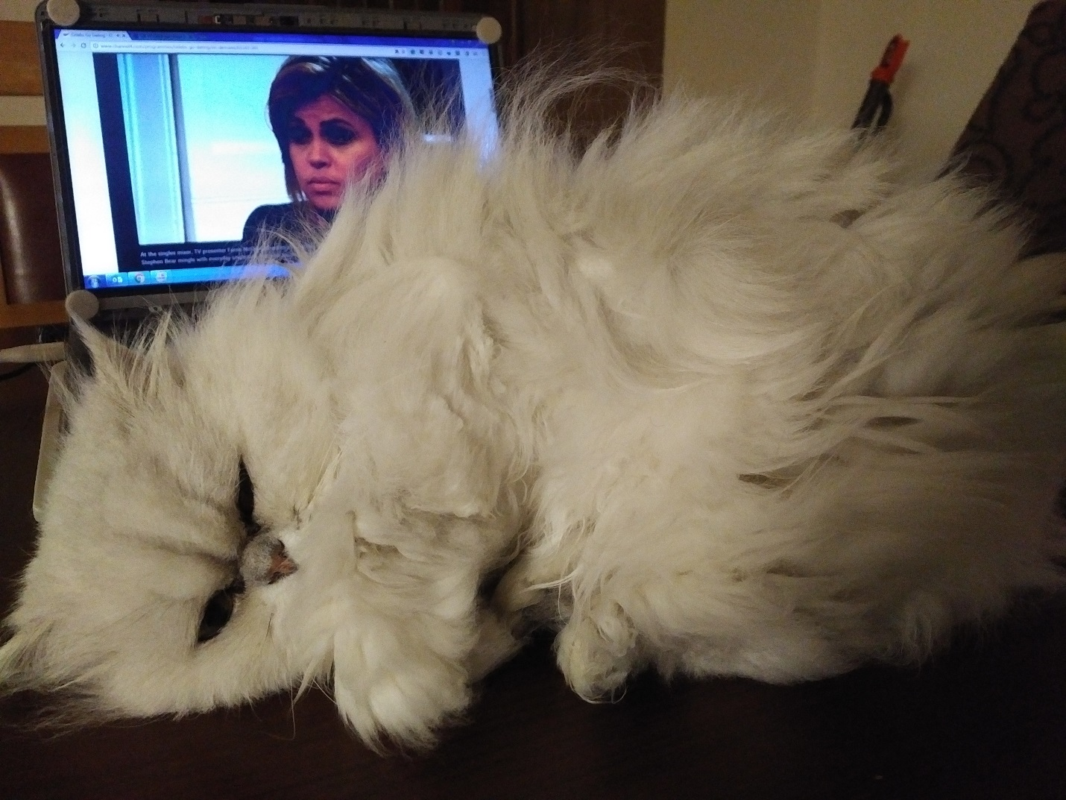
This image (above) has the best Snoober eyes. I like the half-closed look.
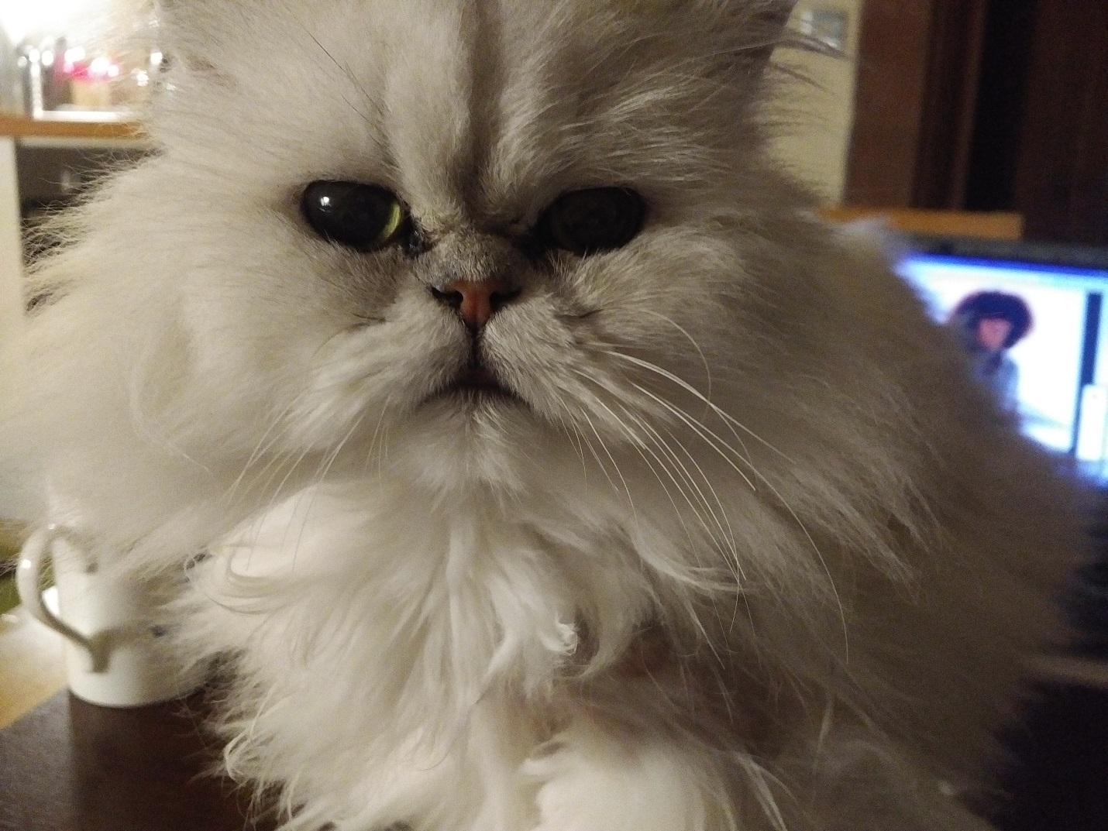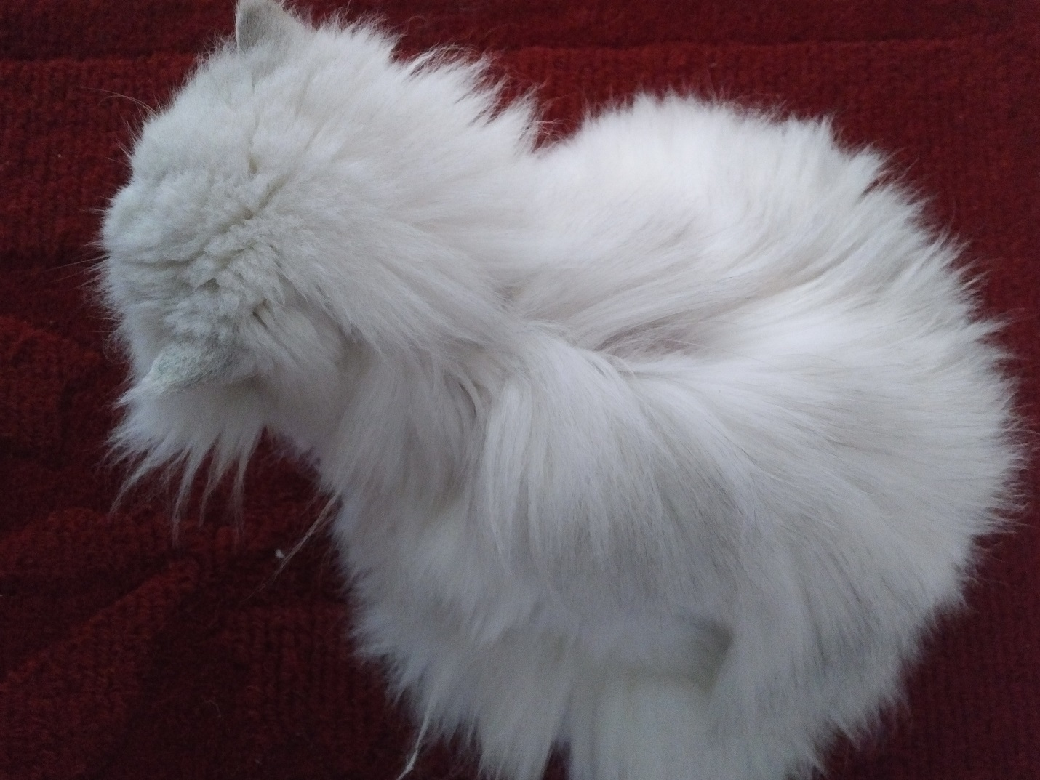
See the big fat body, the round head… show her fat-headed but with an even fatter body.
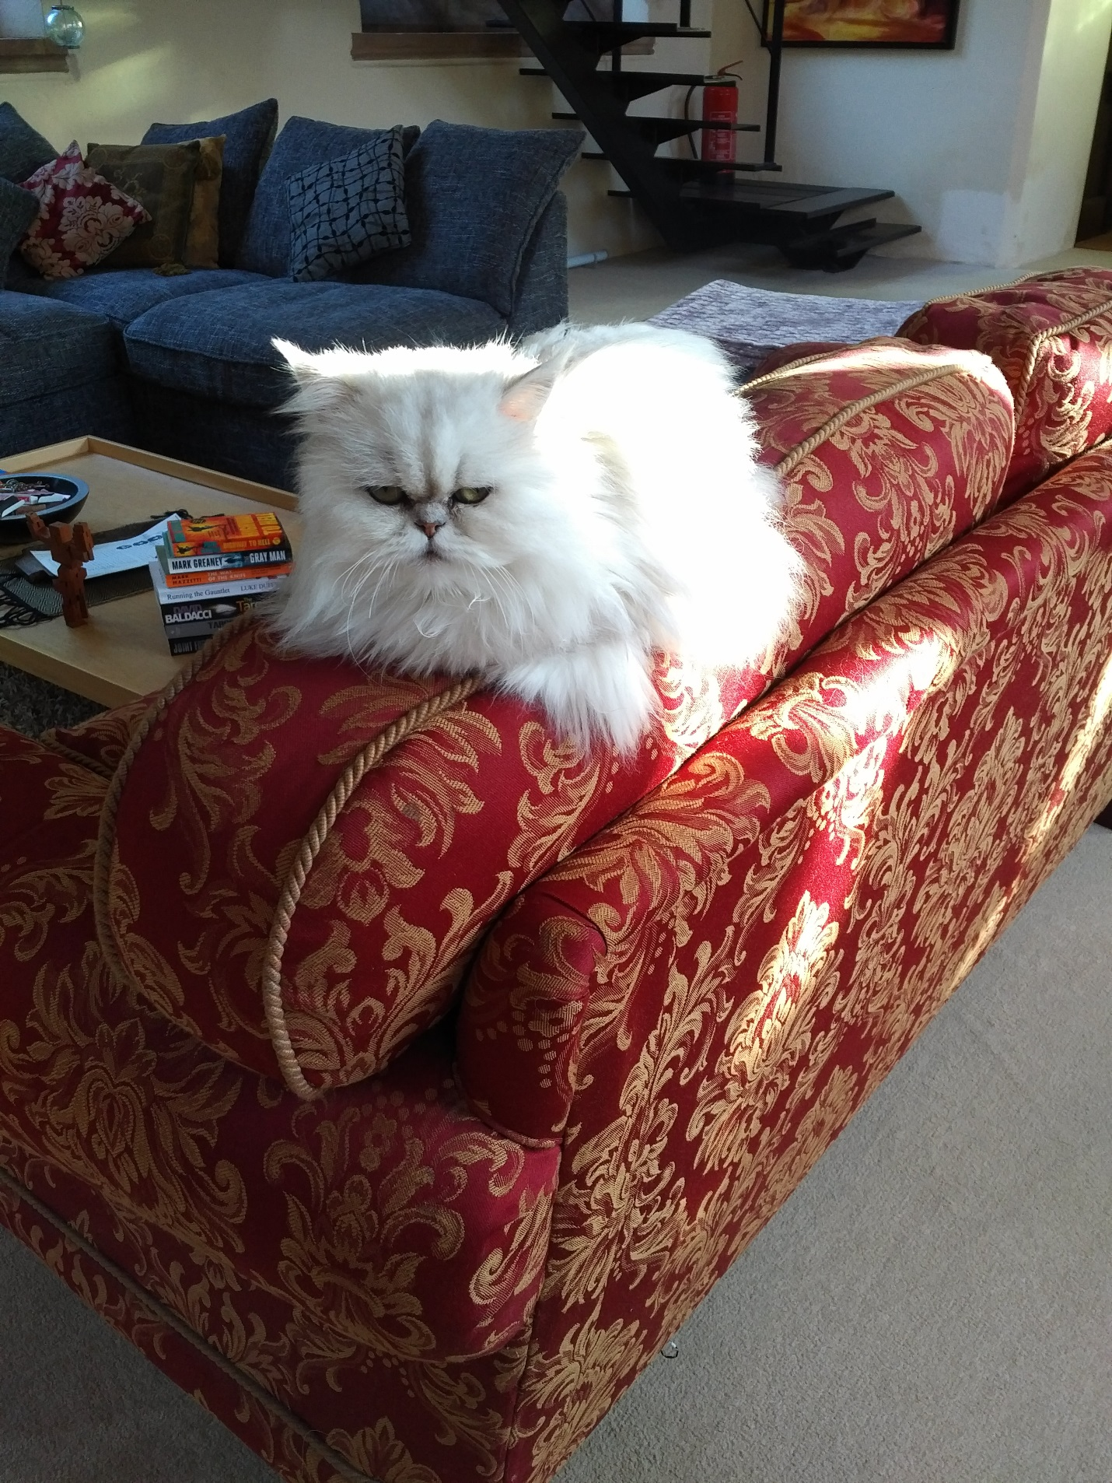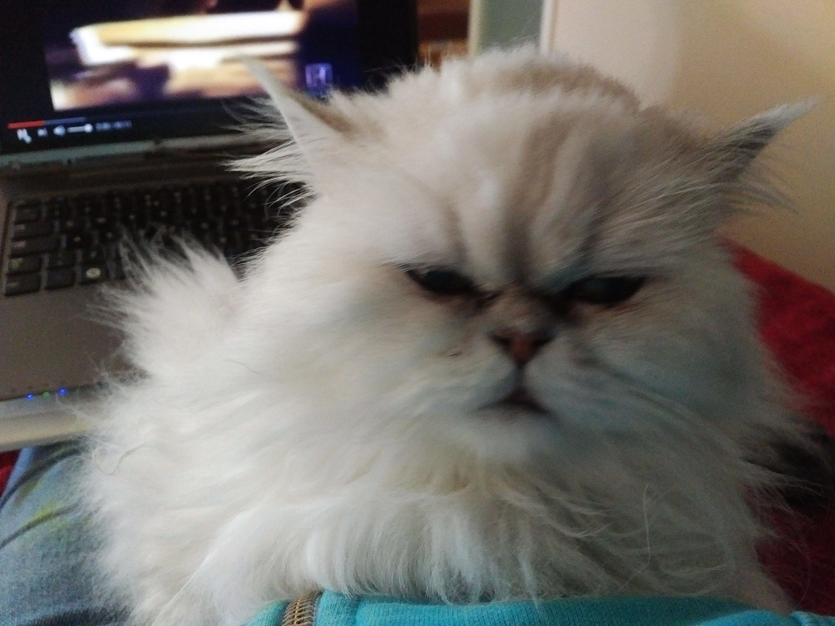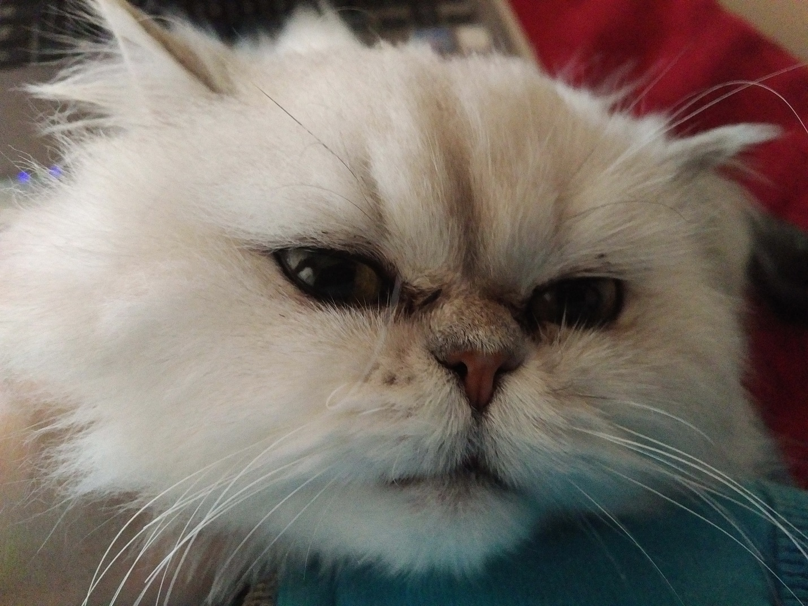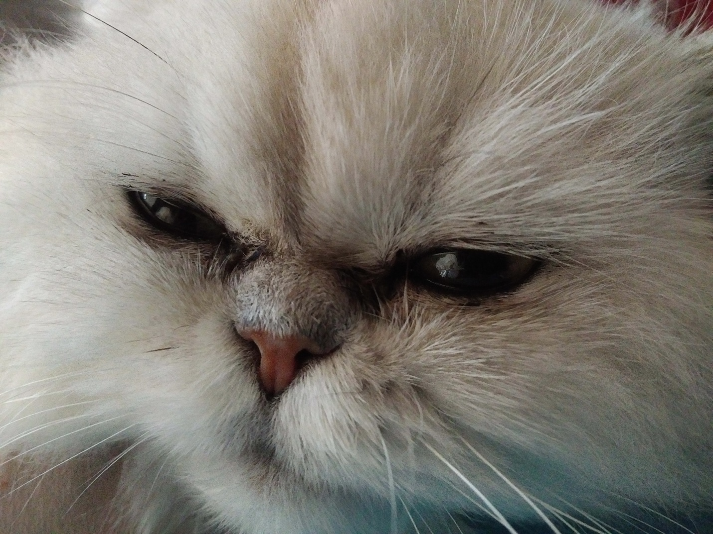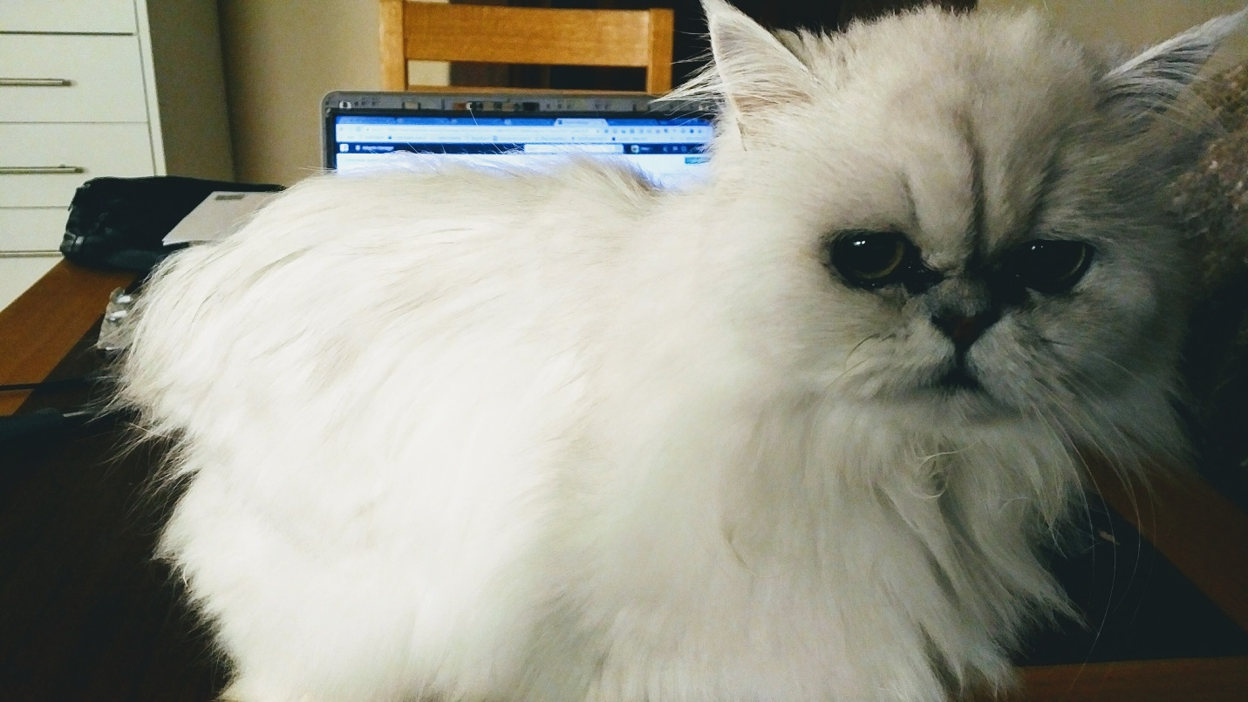
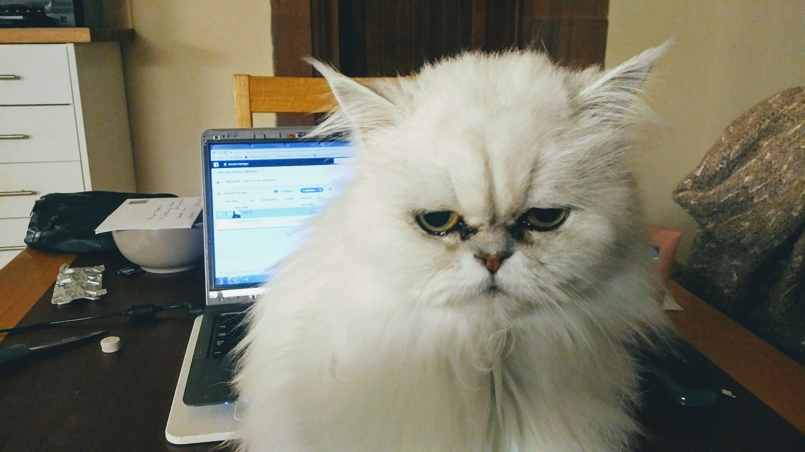
These ears are too big for a cartoon/funny cat. Give her small, short ears!
Illustration Examples
These were the first sketches from a Deigncrowd designer I worked with on a previous project. He took a different cat I owned, and transformed him into a dynamic character with personality.
This is the kind of style I like: the cat is in many situations and doing many things. See the next pages!

