Baby Led
Weaning App

Contents
1. Introduction 3
2. Requirements 3
2.1. App Requirements 3
2.2. Backend Requirements 5
3. User Interface 5
4. Project goals and deliverables 5

Introduction
This document introduces the specifications and the design for both the client (Android and Apple app) and server side of BLWApp, a mobile application aiming to show the User information about baby led weaning and recipes.
The project includes the development of the app and the relative backend.

Requirements

App Requirements

The following are the requirements for the App:
- The App should be implemented for both Android and Apple platforms.
- The App should display content loaded from the database in the backend.
- No authentication is required for the App.
- The App has a main dashboard with 6 buttons to navigate to the other sections. The sections are:
  - Theory
  - How to start
  - Recipes
  - Guidelines
  - Accessories
  - F.A.Q.
- 5 of these sections (Theory, How to start, Guidelines, Accessories and FAQ) display contents defined in the backend.
- The content includes long text and images.
- The App should be able to display formatted text (e.g . bold, different fonts, headings, etc.).
- The User shall be able to scroll the text if required.
- The “Recipes” section is an archive of recipes.
- Each recipe will have different attributes:
  - Popular (boolean). At the beginning only the administrator decides which recipes are popular.
  - Time to make it (hours/mins)
  - Categories (a recipe can have 1 or more categories)
  - Title
  - Short summary displayed in the list of recipes
  - Picture
  - Ingredients
  - Directions
  - Servings (e.g. 4 people)
- Recipe categories are:
  - Quick & Easy
  - Snacks
  - Lunch
  - Dinner
  - Vegetarian
  - Treats
- Recipes section has 2 tabs
  - Popular: it displays a list with all the recipes with popular attribute = true
  - Explore: it displays 6 buttons, each button with a specific category. Clicking on a category will display a list of all the recipes with that category.
- The list of recipes will display for each recipe:
  - Small picture
  - Title
  - Short summary
  - Time to make it
  - Popular icon if recipe is marked as “popular”
  - “Easy” icon if recipe has “easy” attribute
  - “Vegetarian” icon is recipe has “vegetarian” attribute
Example:
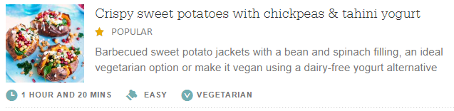
- When the User selects a recipe, the recipe should be displayed with the following format:

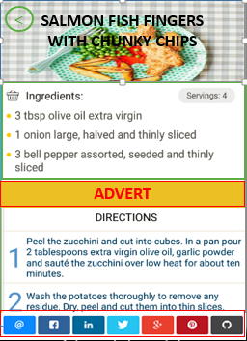
The following elements needs to be displayed:
- Image
- Title
- Ingredients and servings
- Advert
- Directions
- Buttons to share the recipe on the socials
- Button to navigate back
- The User should be able to share any recipe on the socials (Facebook, Google+, Twitter, etc.)
- If the internet connection is not available, the App should displayed the following message: “Please connect to the Internet to continue”.
- All the screens of the App except for the Dashboard will contain adverts.
- The App UI and the content displayed should be localizable.
- The App should be developed at the beginning for 2 languages: Italian and English.

Backend Requirements

- The Backend should store the contents for the App and the App should be able to retrieve it through an API (e.g. RESTful API).
- The Backend should include a basic content management to allow the App manager to add/edit/delete content in the database (e.g. file import, database queries, etc.) and to manage the recipes (Add/Delete/Edit) with relative attributes for different languages.

User Interface

See BLW_AppDesign.pptx.

Project goals and deliverables

- Android and Apple App implementation -> source code
- App backend implementation -> source code
- Apps are delivered to Android and Apple market places -> apps are visible on market places and anybody will be able to download them.

