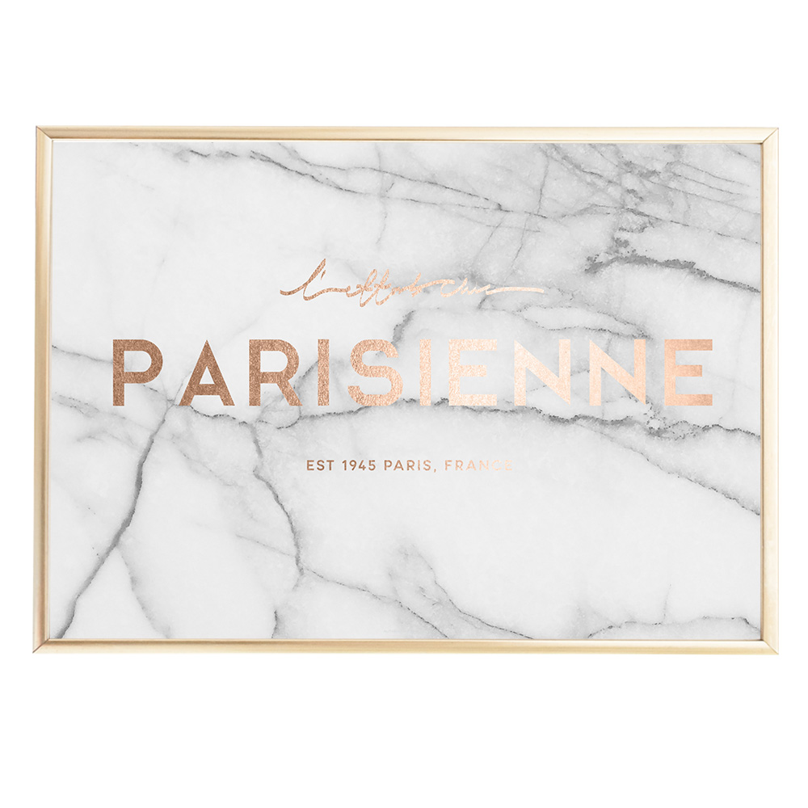
An example attached foil rose gold effect with marble background
Create Elegant fine Jewellry logo design
Design a logo for MD and create an elegant text Clear text for Mike Diamonds ,i will be using a white marble background so my colour preference is rose gold for the logo Also Text "Mike Diamonds"

