CREATIVE BRIEF / www.awty.com.au
ARE WE THERE YET? LOGO DESIGN
REQUIREMENT
Logo Design
Uses Cases: on website, social media platforms, video watermarks and marketing collateral
INDUSTRY/ BACKGROUND
Are We There Yet? is a profit-for-purpose grassroots advocacy organisation which delivers high quality resources, credible information and cutting-edge research about what our children need to be secure, happy and independent in a rapidly evolving future.
With significant discussion (often negative) on our rapidly changing world, including the work and social impacts from automation, robots and artificial intelligence, we want to help shift the paradigm and start a movement toward ensure we’re not only ready and prepared, but we’re in control and flourishing. AWTY is a social enterprise aimed at better understanding the changing world and equipping and supporting our children to not only navigate this but to thrive and in turn find ways to make it better for others.
We are ‘PAYING IT FORWARD’. We care deeply that all children are provided with the key competencies (behaviours, skills and attitudes) to not only feel successful but to lead lives of purpose, have a passion and live passionately, be curious, be innovative, social game-changers, emotionally intelligent and that they feel positive about both themselves and the possibilities in the world. We don’t want to wait until it’s too late. We are taking charge on creating the future and making it better for our kids.
The premise is simple – the future is closer than we think and we want to support and equip the next generation to redefine success and not only prepare for the future but create it: create a better future for themselves.
AWTY is also the parent site (mothership brand) for two (currently) product solutions, focused on supporting families and educators. One is a business directory combined with well curated informative and inspirational content aimed at future-curious parents to get their families future ready.
The second is a family and educator’s event concept from the US, STEAM Carnival - a travelling demonstration of Science, emerging Tech and Art using the power of play.
RELEVANT INFO
Are We There Yet? suggests that we all have a course ahead of us and it will take a new set of skills (technical and life) and positive mind-set to navigate it. It is analogous/symbolic/metaphoric for being on a journey where the destination is yet to be discovered. It also reflects on an eagerness to arrive at an exciting destination and taps into the natural curiosity of children.
We: suggests all of Australian society has a role to play in how well we steer into the future. We are all in it together.
The question is often posed on long routes of travel (mostly by curious and eager kids), and the beauty of that question in this context is that the future is already here, some of us have yet to understand or experience it and incorporate the opportunities that it presents, into our lives. It has a humorous and (for parents) familiar feel to it, nodding towards our natural optimism and hope for the future of our kids.
OBJECTIVE(S)
The website will look and feel:
Bold, personable, intentional, cutting-edge, and accessible. A good balance between fun and serious because of the broad audience.
Inspired, being brave, collaborative, optimistic, influential/supportive and authentic are high on the list of our brand values. We’d like to inspire curiosity, so font and colours should convey this. Warm or primary palette.
WHO ARE WE TALKING TO?
The audience consists of future-curious parents, industry, community groups, educators, and government located in Australia’s CBD’s and highly populated towns.
TONE/PERSONALITY
Optimistic, confident, always well informed. Never know-it-all or cocky. Never overly-casual
MANDATORIES: Avoid anything too corporate or too child-like.
FINAL NOTE:
As we are using the acronym AWTY, a graphic or symbol representing the brand’s purpose – driving toward a bright future - (as per the below as basic examples only) is essential. Creative take on this is ideal.

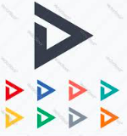

Logo inspiration: Ideally, the logo and font will be modern but timeless, simple but strong, it will be confident and seen as a beacon or leader but without being unattainable or elite. It should reflect forward motion, future-facing thinking, optimism and leadership. Not over-complicated graphics. It should be reflect creative, critical and lateral thinking.



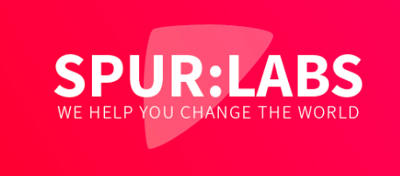

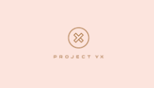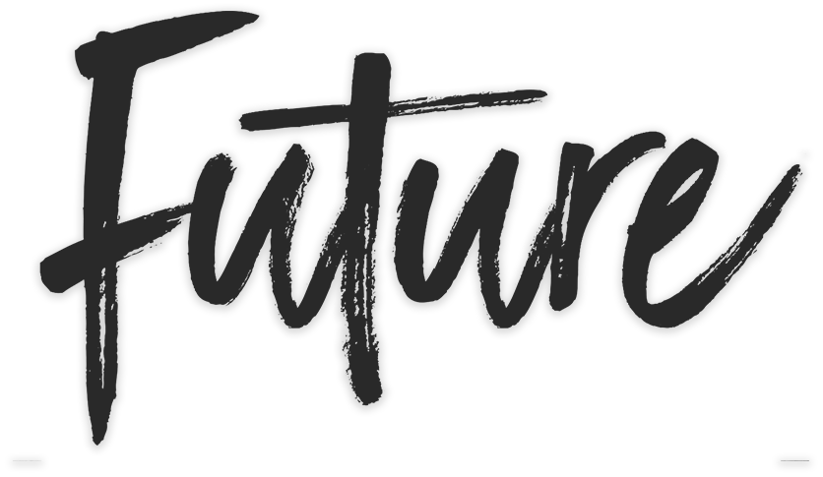

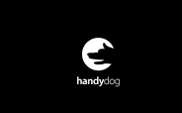

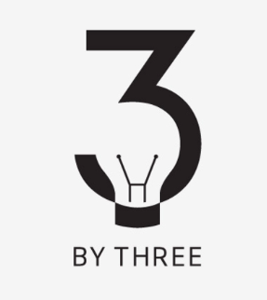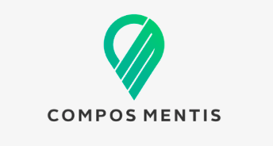



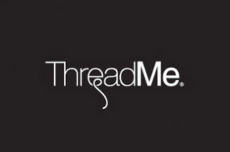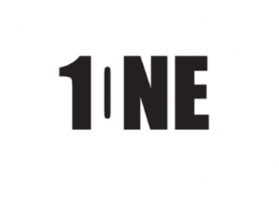

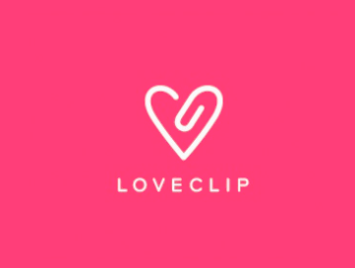

Jules – inspo: symbols for movement, hope, inspiration.


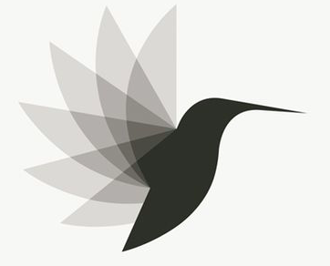


ARE WE THERE YET?

AWTY

