

DATA PROTECTION
All desktop and mobile device apps are kept in the datacenter or cloud with granular access policies and advanced monitoring – ensuring sensitive data accessed from Windows, Mac, Linux, Android and IOS mobile devices are safe.

BRING YOUR OWN DEVICE (BYOD)
XIP provides employees and outside contractors “clientless” browser based secure access from their personal devices.

BOOST PRODUCTIVY AND REDUCE COSTS
XONA XIP enables employees and outside contractors to work anywhere improving operation efficiencies, streamlining applications management and reducing costs.

WHY XONA XIP?

consulting

Introducing – The Xona Isolation Platform (XIP)

Deliver applications SECURELY to ANY device from a standard web browser
Use Cases

Contract Workers
IT organizations struggle to enable outside contractor access to their sensitive data because policy driven client apps such as VPN and EMM cannot be deployed on temporary contractors’ desktops and mobile devices and desktops. Xona XIP allows secure, policy compliant “clientless” access from any device.

Healthcare
Deliver HIPAA compliant and seamless, secure clientless access to patient information across facilities or between medical providers so clinicians can focus on patient care instead of IT policies or compliance regulations.

Finance
Empower financial institutions to shield against cyber threats and meet compliance mandates for both their employees as well as consumers.

Government
Deliver secure FIPS 140-2 compliant isolation platform and integrate with existing compliant systems. Save money by saving on endpoint agents and support costs.

The enterprise workforce is often a blend of permanent and contract employees. IT organizations struggle to enable the contractors’ access t
Feugait nulla facilisi. Lorem ipsum dolorsit amet, conse ctetuer laoreet dolore magna aliquam erat volutpat.

Magna aliquam erat volu isi enim ad minim veniam melo eratta dolore magnus.

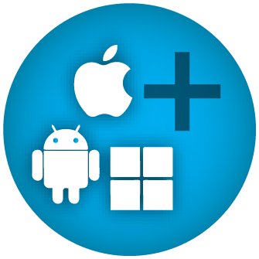
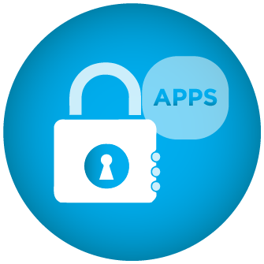
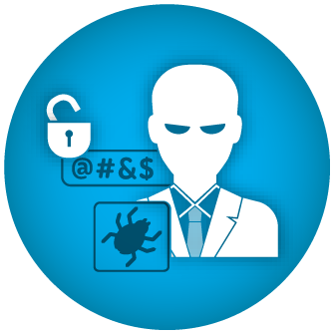

Xona XIP software platform components --
- XIP Zero Client. Renders applications and desktop environments securely through encrypted session accessible through a standard browser.
- XIP Adaptive Canvas. Adapts to your device type and expresses the applications naturally to your a laptop, tablet or smartphone.
- XIP Director. Provides session based auditing and optional video replay. Provides additional layer of security for highly regulated industries.

For more info contact: info@xonaystems.com


Xona XIP
High Assurance Architecture
XIP reduces the risk of data loss by securely delivering access to business applications in the datacenter or cloud. The XIP architecture is built from the ground up with hardened software components. XIP utilizes protocol isolation and seamless converts remoting protocols to encrypted display which can be presented into any web browser.

Adaptive Agility
XIP addresses a broad range of use cases delivering full desktop or applications based on user role or device. XIP’s rich set of capabilities and flexible architecture enables IT to meet a workplace that includes employees, contractors, consultants and customers.
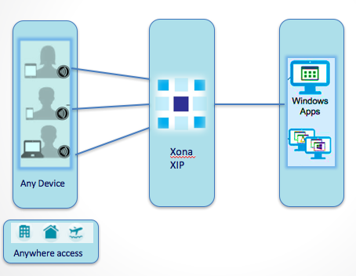
Applications are securely streamed to web browser
No Enterprise data-at-rest on Endpoint
No endpoint agents to manage - lowering TCO

