Mission Statement
We stand ready to serve, inspire hope and provide aid during crises through a global network of members, volunteers and donors.
Global HERO Project Vision
Our vision is to streamline the volunteer and donor processes domestically and internationally in support of first responders, disaster relief, global education, humanitarian aid, human rights, natural resource conservation and the eradication of world poverty.
Executive Summary/About Us (Web)
Global HERO Project (GHP) was founded under the inspiration of diminishing human suffering, providing better opportunities, and enriching the life of others. GHP seeks to provide individuals, families, communities, and countries with the needed tools and personnel resources to complete short and long-term relief efforts before and after a catastrophic event. Our organization utilizes CORE (Community, Operations and Relief Efforts) personnel to support capabilities projects, small and large, that can further improve and/or address displacement, potable water, food, medicine, and overall aid for the community. GHP partners with disaster relief organizations to augment safe evacuations, search and rescue, debris removal, humanitarian aid, and post-reconstruction.
We are artists, civilians, doctors, educators, engineers, farmers, fire fighters, laborers, peace officers, scientists, social workers, veterans, all volunteers to help those in need of critical aid. GHP responds to the overwhelming need for Humanitarian aid, Emergency response, Relief efforts, and Outreach services (HERO). GHP is not only limited to disaster relief and humanitarian aid, its goals encompass stable and good governance and sustainable agricultural projects designed to end hunger and poverty while building self-reliant communities
The list of projects is endless for GHP. As a non-profit organization, GHP will not limit volunteer capabilities and services. We envision a global community of volunteers and charitable organizations coming together for a common cause to help humanity and our planet’s survival. GHP is part of an existing global structure for all to join, donate and help bring aid to those in need. Whether we are conducting search and rescue, distributing medical aid, rebuilding post-crisis, or protecting endangered animals, Global HERO Project members are working to build a better future for our children, families, and communities.
Our Efforts/Services
As a Global HERO Project volunteer, below is a list of efforts one can also participate in to support GHP’s vision. While the list is not all inclusive, we do make the effort to update it with the most relevant efforts our volunteers are involved with:
Humanitarian Aid – provide immediate aid such as food, water, medicine, and shelter. Alleviate human suffering and save lives.
Emergency Response – search and rescue, debris removal, crisis management/evacuation, and coordinating the delivery of emergency supplies.
Relief – assist those in need of disaster relief with material and financial support, provide communications, comfort, council and ways to rebuild.
Outreach – provide education, innovative farming, good health, gender equality, good governance, clean water, human rights, conflict resolution, and help establish sustainable communities.
Veteran Reintegration – harness the skills of veterans such as first-responders, fire fighters, peace officers and our military, to aid in disaster response under a unified purpose.
Volunteer Readiness

Volunteers maintain readiness by performing local community service projects, training with their respective local first responders, and refining their skills through further education. This enables Global HERO Project to quickly mobilize teams to any catastrophic event and maintain a steady stream of volunteers to accomplish our vision.

Our LOGO
The globe represents our international network and community. The shield represents our volunteers, heroes of peace. When we don our uniform, we become heroes to our communities. The four spheres/pins represent GHP’s core values IRIS.
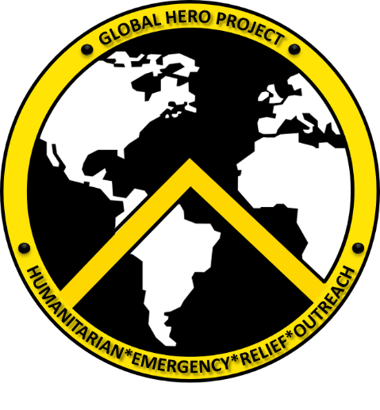
Logo is transforming to become a double-sided coin and available for purchasing and donor recognition.
Our MOTTO
Misericordia Pro Hominibus – Compassion for Humans
Global HERO Project core values (IRIS)
Integrity – Do what is right legally and morally, trust is built on integrity. It takes courage to do the right thing.
Respect – Treat those we serve and whom we work with, with dignity and respect. Respect cultures, views, and opinions different of one’s own.
Innovation – Forward thinking, planning, and execution to expand our horizons. Constantly looking for creative ways to change, solve problems and find solutions, both internally and for the global community.
Selfless Service – Place the needs and welfare of others before our own.
Founder/History
The core of Global HERO Project was founded by a U.S. Army Veteran, in early September 2017. Serving in various conflicts inspired him to diminish human suffering and enrich the life of others. World catastrophes such as the terror attack of 9/11, Hurricane Katrina (2005), the earthquake in Haiti (2010), famine in Africa, and a global refugee crisis weighed heavy on his mind. As the years went on so did his hope to serve in a broader capacity and then disaster struck close to home. Hurricanes Harvey, Irma, Jose, Maria, and two recent earthquakes in Mexico, precipitated his action. He revived his domestic and international alliances, along with fundraising and partnering with other disaster relief organizations, to establish Global HERO Project. He envisions a united front to address and resolve our global issues, which transcend beyond national boundaries.

