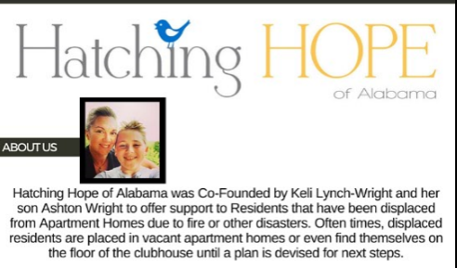

dISASTER RELIEF KIT SUPPLy list
- Twin Air Mattress (8.00 at Walmart)
On almost all occasions, property management will place a resident into a vacant apartment. Our disaster relief kits give them everything that victims of disaster need to take refuge for the first few nights. Most often our kits are all that these families have.
- Standard Pillows (2.37 at Walmart)
- Air Pumps (13.00 Walmart)
- Blankets/Throws (2.88 at Walmart)
Small rolled fleece throws. We also take handmade items/must be new
- Towels/Washcloths/Flat Sheets
- Flip Flops- Solid Colors-All sizes (Walmart $1)
Most often victims of disaster are not wearing shoes due to the rushed escape, etc. We provide them with flip flops on scene
- Dollar Tree Items All $1
Brush/Comb Combo, Toothbrush/Paste Travel Combo, Wipes, Deodorant, Hand Sanitizer, Soap, Shampoo, Conditioner
We prefer travel sized to ensure that it fits into our boxes and does not leak.
- Cases of Bottled Water
Hatching Hope of Alabama is a Birmingham, Alabama based 501c3 nonprofit organization that provides disaster relief to Residents displaced from Apartment Homes across the state of Alabama.
Facebook: Hatching Hope
Hatchinghopeofalabama.org

