FURTHER GUIDANCE FOR LOGO DESIGN
I like a clean, straight and upright kind of font – see below. I don’t like curly or frilly fonts
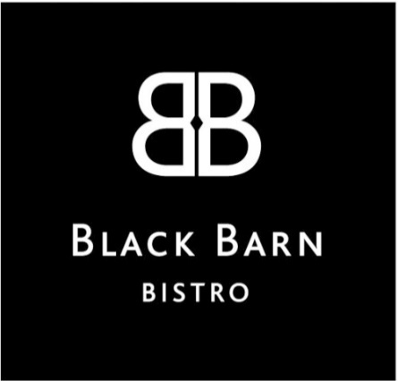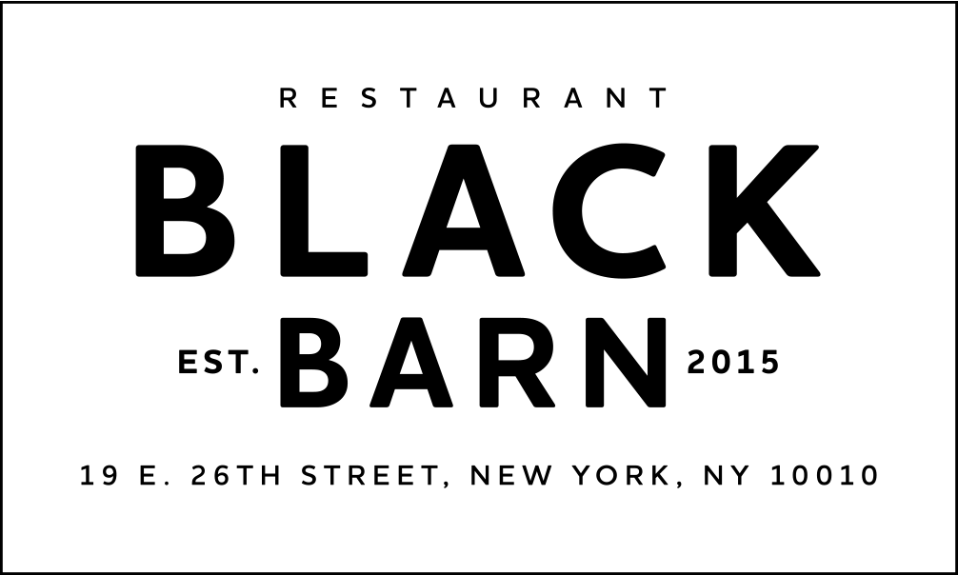

Balance of Black and White, I’d prefer to NOT have a black dominant background as that limits what I can do. So not a black box like above, consider it being a white background like below
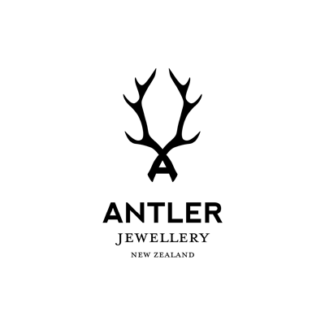
Keep the logo generic – don’t have it specific to anything like products or internet or anything. The only imagery you should draw upon is the board and batten detailing

I may use the logo as an authentication mark, so am not averse to seeing one version as a stamp styled look – as per this logo below – but not a circle
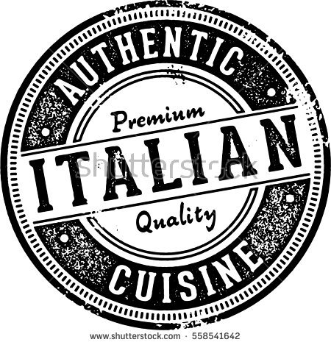

Logos that I really like for their clean and professional yet dramatic image look, thinking outside the box not a traditional logo look appeals. Ensuring it isn’t too feminine or too blokey – it must be gender neutral:
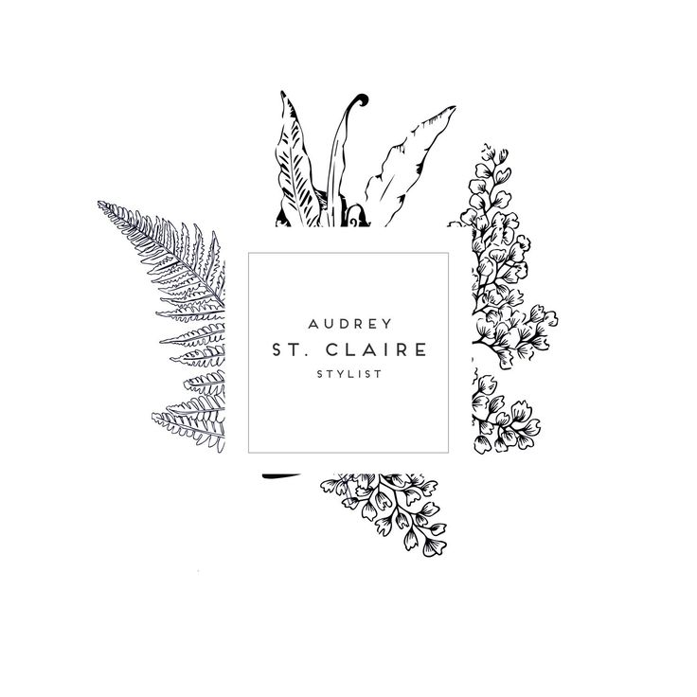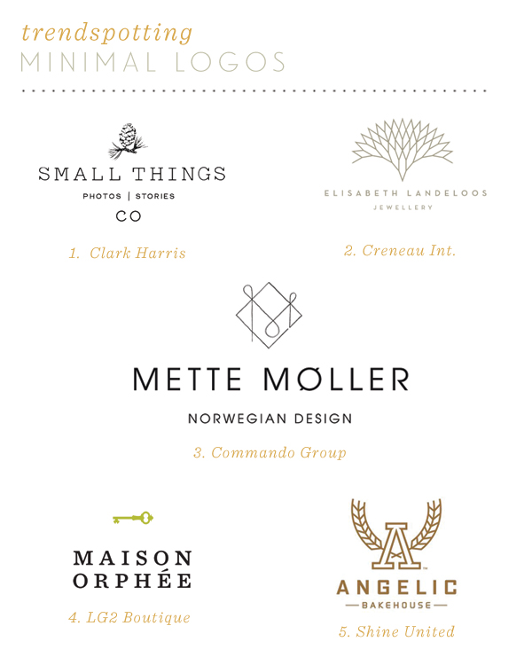
On a final note, the logo must impart LUXURY and PREMIUM cues even though it is representing craft products. As we are targeting a high end Asian and European market.

WHAT I DO NOT WANT – I don’t like the overt nature of these logos, they are not clever or stylised – they are a simplistic and too obvious an answer to the brief and too down home crafty:
