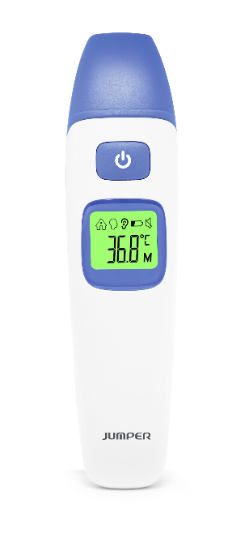
Package Includes:
o Infrared Thermometer
o Pouch
o 2 AAA Batteries
o Instruction Manual

Normal Temperature Reading Chart and Thermometer Warnings
Range | Sounds | Backlight
Forehead temperature
95.0℉-99.5℉ | A long beep | Green
99.6℉-108.0℉ | 3 short double beeps | Red
Ear temperature
89.6℉-99.5℉ | A long beep | Green
99.6℉-108.0℉ | 3 short double beeps | Red
Object temperature
32.0℉-212℉ | A long beep | White

* The normal body temperature range slightly varies with age and gender. Newborns or children have higher body temperature than adults, and adults have higher body temperature than the elderly. Time of day is another factor contributing to varying normal body temperature range.

