logo design questionnaire

What name do you want in your logo? Healthylicious Kitchen

Do you have a slogan you want incorporated in your logo? Can be added

- Describe what your organization or product does and its target audience: It offers select range of nutritious and delicious meals – combination of salads & continental food free from additives/preservatives. We are running a delivery kitchen to bring this food to the customer’s premises. . (People have this notion here that health food n salads are boring n bland , our food tries to dispel this myth )
- The target audience > typically millennials and busy executives, fitness lovers who are always looking for nutritious & delicious food

Select the types of logos you like:
Pictorial mark name & Graphic or character mascot idea sounds good- we are open ,

Do you have any example logos you like?
example pasted at the end of page

What style do you want your logo designed in:

Modern - clean lines, simple colors, typically a sans serif font
Whimsical - fun and flowing, bold/bright colors, decorative font
Corporate - sharp and bold, typically a serif font
Grunge - hand-drawn style, worn out areas Worn Vintage - retro styled fonts, worn areas Clean Vintage - retro styled fonts, clean lines
Earthy/Natural - handwritten styled fonts, warm design

Do you have any specific colors in mind? Not really would be keen to look at options.

What values should your logo communicate?

Feminine.....Masculine Unisex Young.....Mature
Luxury.....Economical I wd say premium but not luxury
Modern.....Classic
Playful.....Serious
Loud.....Quiet
Simple.....Complex
Subtle.....Obvious

Are there any specific images or graphics you’d like included in the design?
Nothing specific – avoid stereotypes

Some logo ideas we liked while surfing..

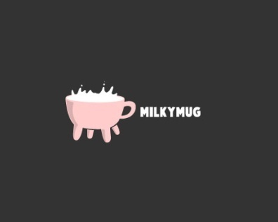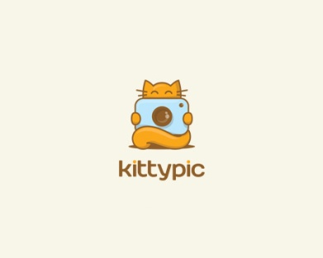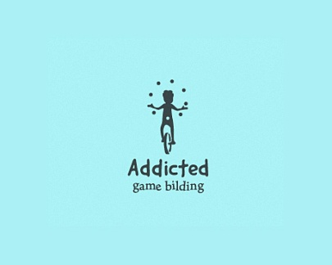

http://pin.it/ZNPU-j2
http://pin.it/iblv1lq
http://pin.it/o06pag7
http://pin.it/F_lKbXr
http://pin.it/Q14K3-3

