Hello 😊

This project is to create content for our website –

verifymymeds.com

We have a logo for verifymymeds.com which we like.

The Logo is attached in various formats to the job description.

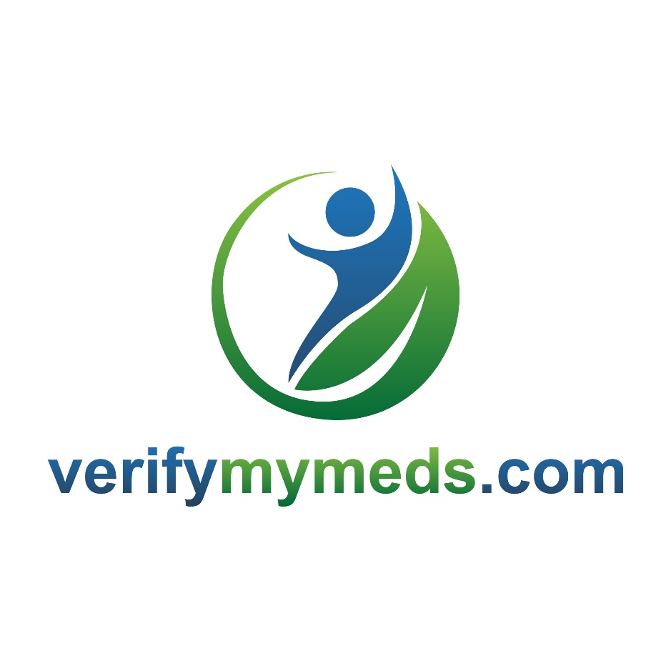

verifymymeds.com website content/overview:

The whole idea of this app is that it is a really simple idea, really simple to use, its free and (because it is backended on a Blockchain architecture) it’s totally secure and anonymised.
We are looking for a very simple look and feel, strong on graphics, with three pages:
Home page – with a modern flow down look and feel (example: www.endeavourtechnology.com) content below
About us – Content below
FAQ’s – content below

verifymymeds.com website content

Home page

30% of all medicine bought online is counterfeit
Are you sure that the medication you take is genuine?

Be Safe, Authenticate
Protect your health with verifymymeds

Scan the verifymymeds QR code which is printed on your medication using your phone or tablet
verifymymeds will authenticate your medicine against the manufacturers own production records and verifymymeds will tell you immediately if your medicine is genuine

Its Quick, Its Secure, Its Free

Guaranteed Authenticity
verifymymeds has a unique and highly secure Blockchain database which contains details of billions of batches of medicines manufactured across the world
Each time a manufacturer produces a batch of medicine, they send the details of that product to our secure Blockchain database. Our database records details of that batch of medicine and issues a unique encrypted QR code for every single batch. This code is printed on the medicine packet and it’s packaging
You simply scan the QR code from your meds using your phone or tablet. The verifymymeds app unencrypts this code, verifies it against the details provided by the manufacturer and confirms if the medication is genuine or not directly to you on your device

Guaranteed Anonymity
Your health and personal information are yours, and only yours!
verifymymeds does NOT record any personal or health information
You don’t have to log on to verifymymeds and we don’t ask you to register

Guaranteed Security
verifymymeds are the first and only company in the world to use a (patent pending) encrypted specifically designed secure Blockchain database architecture for asset recording and authentication
A Blockchain database is made up of a large network of independent database servers, each of which are in sync with each other. As soon as a record is appended to the database, all instances of the database simultaneously update
Every record added to the database must contain encrypted keys before it is accepted by the Blockchain database. These keys form an interlinking chain
This multitude of in-sync databases and verified-chain data structure makes the verifymymeds database impossible to hack

Guaranteed Safety
If you are taking medication you are doing so for a specific reason. It is imperative that your medication has been produced in accordance with strict international standards and that your medication contains the correct medicinal dosage
The international pharmaceutical industry carefully manages their production processes to ensure the highest standards of product manufacture, production and distribution
However, as in many industries, counterfeiting is a high value business. Counterfeit medicines cost the pharmaceutical industry more than €110 billion annually, €110 billion which otherwise would be invested into medical research and treatment development
The financial cost is nothing compared to the loss of life. More than one million people’s lives are lost each year due to counterfeit drugs. Counterfeit medicine often contains no active medicinal content or can contain a dangerous mix of ingredients. Whatever the mix, the medicine is not what it is claimed to be and the consequences of taking it can be lethal

FAQ’s

How does it work?
Each time a pharmaceutical company produces medicine, they communicate with our Blockchain database and request a unique QR code from us. This unique QR code is printed on the foil/packaging for the medicine.
When you receive your medicine, simply scan the QR code with your phone or tablet using your verifymymeds app. The app will decrypt the QR code, verify its digital signature and will check the code against the Blockchain database.
If it is a valid code then the product details will be displayed in the app on your device. If the code fails then you will be advised that this product is not genuine and should be returned.

A unique code for every packet of medicine?? Surely this is impossible??
There are more QR code combinations available than there are atoms in the known universe! So there are a few to go around! One of the many advantages of using a (patent pending) Blockchain architecture is the speed of processing. Our Blockchain database processes millions of transactions every minute. Our servers are distributed across the planet so there is always one near you for faster communications.

So, will verifymymeds keep a log of the medicines I take???
No!
Never!
One of the many advantages of our (patent pending) Blockchain architecture is that the transactions are anonymised. We will never be able to associate any medical products to a specific person or group of persons.
When you download the app to your device the app generates a random user key (128 digits of gibberish!) which we use to log the scans you take. That’s it! You don’t register to use the app, and we don’t take any personal details from your device either.

What’s to stop a fraudster creating their own QR codes??
A fraudster can create as many fake QR codes as they like, but none of them will get past our encryption!! The first thing our app does when you scan a QR code is to decrypt the code using our encryption keys. Only genuine QR codes, created by our Blockchain database, will be able to be decrypted by the verifymymeds app. If you scan a fake code then the app will tell you straight away that this is a fake code and that the product should be returned.

OK, they can’t create genuine verifymymeds.com QR codes, but what is to stop a fraudster simply copying a genuine code??
Our product tracking system will flag this up and tell you (via the app) that this is a copied code and hence the product is not genuine. We track the movement of the product through the supply chain and we know where each product is distributed from and to where they go. We have an AI system which uses several criteria to verify if the code has been fraudulently copied.

How much does this cost me??
Nothing. Zero.

Will I be hounded by ads??
Nope. We don’t, and nor will we ever, carry any form of advertising.

Will you resell any of my information??
Nope. We don’t collect any personal information on you in the first place, and even if we did, we wouldn’t sell it, to anyone, ever.

Who pays for this then?
We charge each of the pharmaceutical companies a fee for providing the service. It is in their interest to ensure that the medication you are taking is 100% genuine. That is what we are trying to ensure, and that is our only driver.

About us

Founded by two long time and highly experienced friends, Charlie Sherlock and Christopher Karatzinis, verifymymeds is dedicated to reducing the number of people who suffer due to counterfeit medical products.
The pharmaceutical industry is leading the way in terms of investing in anti-counterfeiting solutions to protect consumers. However, counterfeit medicine is a huge business, estimated to be worth over €100 billion annually.
Using their combined knowledge and experience in the data security and anti-fraud industries, Charlie and Christopher have developed a (patent pending) highly secure, fast and free solution to protecting people against counterfeit medicines.

The Founders

Charlie Sherlock, CEO
Charlie is a global business leader who has been on the founding team of a number of software companies, leading with patented solutions. Charlie has a proven reputation and ability to ‘start from scratch’ in new markets, developing sales, marketing and delivery organisations.
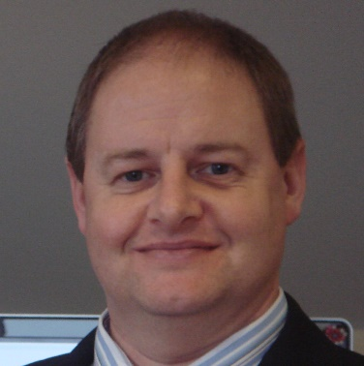

Christopher Karatzinis, CIO
Christopher is a highly experienced technologist, innovator, visionary and entrepreneur specializing in Architectural and Network Security, Blockchain Deployments, Distributed Architecture and Cloud Computing. Christopher has over twenty-five years of professional experience, with the last fifteen as founder and CEO of a number of IT and Software companies.
