Logo Design:
Please could we have the logo designed similar to these logos:
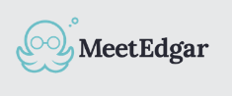

But for the logo/icon here, could we have an outline of an old English gentlemans head? Similar to the below:
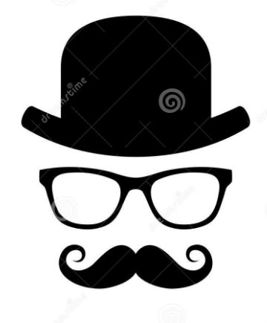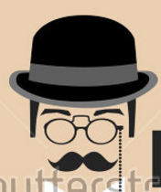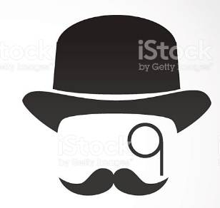

And for the text next to the English gentlemans head to be: Clarence
Here is an example of a (poor!) design I quickly created, to give you a bit more of an idea of what I mean:
