
We Are a Full Service

Tax & Accounting business
Open year round
Our services include:

Accounting
Tax Service
Notary
Covered California
AFLAC

ACCOUNTING SERVICE

- BOOKKEEPING
- PAYROLL
- W2’S
- 1099’S

tax SERVICE

- INDIVIDUAL
- PARTNERSHIPS
- TRUSTS
- back taxes
- CORPORATIONS
  - LLC
  - S - CORP
  - C - CORP
oTHER SERVICES
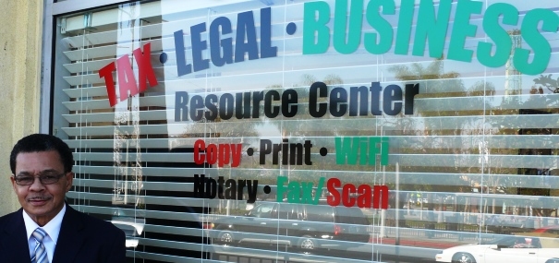

NOTARY SERVICE
cOVERED CALIFORNIA
AFLAC
ACCESS TO
LEGAL SHIELD
SCAN, FAX, COPY

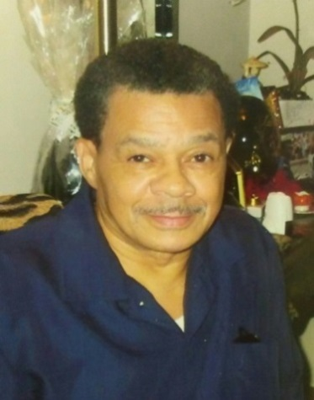

TAYLOR MAYFIELD
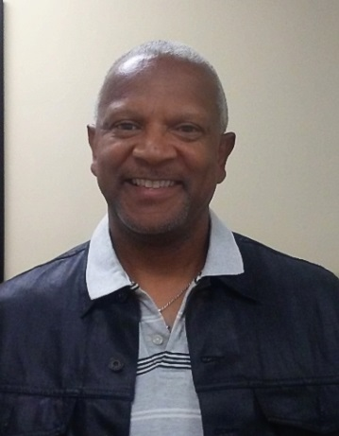
David spencer
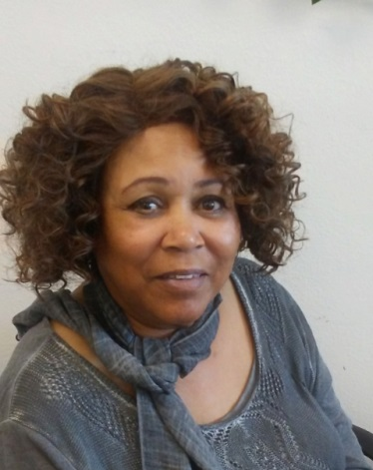
GINA HARDIN
GEORGINA PEREIDA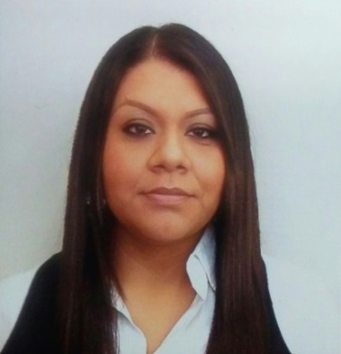
“a COMPANY DESIGNED WITH THE COMMUNITY IN MIND”
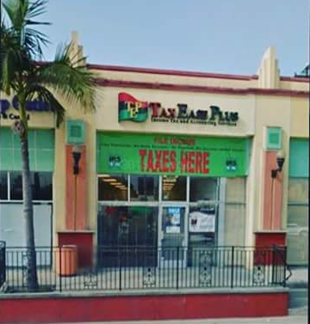
hOURS OF OPERATION:
mON - saT 10 A.M. – 6 P.M
SUNDAY BY APPOINTMENT ONLY

We will pick you up for free! 4371 Crenshaw Blvd Unit B2
(within 3.0 miles radius) Los Angeles, CA 90008
(323) 293-7093
