HOW SECURE IS YOUR WEBSITE? GOOGLE SSL UPDATE 2017
Posted September 28, 2017 by George Keith
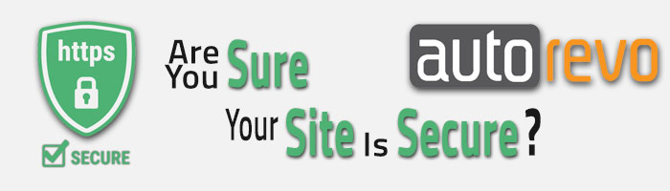

Picture this…
Your ideal customer is sitting in their home, or office, and wants to find that perfect used car. After searching Google, they come to your site, ready to peruse and possibly purchase. Instead of the warm and fuzzy feeling that they should get when looking over your inventory, they are stunned to be presented with this before your domain name:
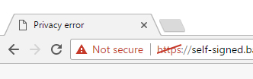

Suddenly, that happy feeling disappears and they can’t get off of your site fast enough; you not only lose a potential sale but that customer’s trust and business for the foreseeable future.
Absolutely terrifying, right?
Luckily, this isn’t reality…yet. But it soon could be. Google has announced that in October, they will be marking all sites without an SSL Certificate as “Not Secure”.

What is SSL?
SSL (Secure Socket Layer) is technology that provides encryption of your customer’s data. Browsers see the SSL Certificate and identify the website as “safe”. It ensures that all data going back and forth between the browsers and web server is private and secure.
Sites with an SSL Certificate will look like this:
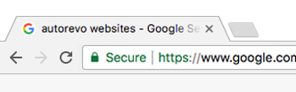

Why Do You Need SSL Today?
It gives the visitors to your site peace of mind and comfort to know that you care enough about their data to make it as secure as possible.
This October update will affect all sites with any type of input box, even if it’s just site search. Even if the customer is not inputting sensitive, personal information, like filling out a credit application. (Which has always been secure through AutoRevo, so don’t panic!)
Google ranks secure sites higher than non-secure sites.
While the update will only affect the Google Chrome browser, for now, all browsers are heading in this direction; this will become the standard very quickly. Besides, Chrome is currently the most used browser, far surpassing Internet Explorer and it’s only growing. Can you afford to have 59% of your customers scared off by a non-secure website?
The warnings will only get worse. HTTPS (Hyper Text Transfer Protocol Secure) and SSL are here to stay and Google will only get more serious about moving towards a more secure web. It’s time to make a change.

What Can AutoRevo Do For You?
Luckily, you have AutoRevo on your side. With our industry-leading PageSpeed and SSL Certificates, we have formed a two-pronged attack to keep your customer’s data secure and keep your site ranking high on Google. And just like that, your ideal customer is back to viewing your site with renewed confidence and all is right with the world.
Fill out the form to the right to give your customers the peace of mind they deserve and get secure, today!

