IS YOUR SITE READY FOR THE FAST LANE? 3 WAYS TO OPTIMIZE PAGESPEED!
Posted September 14, 2017 by George Keith

Does your site’s PageSpeed leave a little to be desired? Do your customers get tired of waiting for your site to load and bounce over to your competitor? Is your site actually costing you business?
These are the questions that you should be asking yourself about your current website and provider. Simply put, the faster your site is, the faster your customers are going to see your vehicles, and the faster you are going to sell them. Google has also indicated that site speed is one of the ranking factors for its algorithm. Which means a faster site could have your ranking higher on Google searches, which also means more sales.
Studies have shown that 47% of all users expect a web page to load in under two seconds and 40% of people will abandon a website that takes more than 3 seconds to load. Don’t let your site be the next one abandoned!
You can check your PageSpeed here to see if it’s speeding in the fast lane or puttering along in the breakdown lane. Just enter your site’s address into the bar and click Analyze, within moments you have your site’s PageSpeed score.
There are 3 major ways that you can improve this score:

Enable Compression
Use a compression application to compress all CSS, HTML, and JavaScript files that are over 150 bytes. We recommend using GZIP, but your site provider may use their own. You just have to talk to them. As a side note, we don’t recommend compressing photos with GZIP, use PhotoShop or an online photo compression tool instead, this allows for better quality images.

Optimize Images
You will have anywhere from 10 – 150 cars on display (some dealerships with much more!), and dealership websites tend to be image heavy. Making sure that your photos are not any larger than they need to be, compressed properly, and in the correct file type, go a long way to helping your PageSpeed score. If you don’t have PhotoShop, we recommend the online photo compression tool Compressor.io. Just be careful! The smaller you go, the more the photo quality can degrade. The trick is to find a happy medium.
A good rule of thumb is that JPEGs are ideal for photographs of vehicles, office, and employees while PNG files are better for graphics like that banner for your upcoming holiday sale.

Minify CSS, JavaScript, and HTML
You can optimize your code by removing spaces, commas, code comments, and all unnecessary characters, which will give your PageSpeed another boost! Your provider should already be doing this, but checking with them won’t hurt.
Contacting your website provider and having them implement these changes will go a long way to having a faster site and selling more cars.
OR
***SHAMELESS PLUG***
You could go with us and our new SuperSonic platform. Our sites have all of these changes (AND MORE) built right into the platform. Our sites are the fastest in the automotive industry. But don’t to take our word for it:

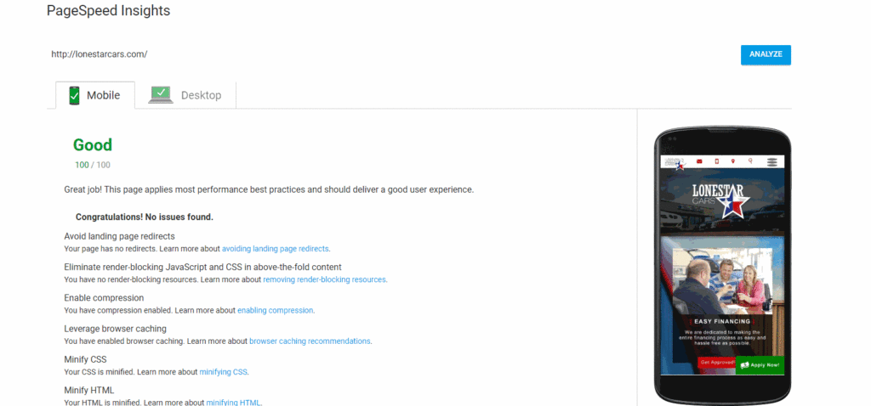

Fill out the form to the right and one of our Account Consultants will help you shift your site over to the fast lane, today!

