Cover Page




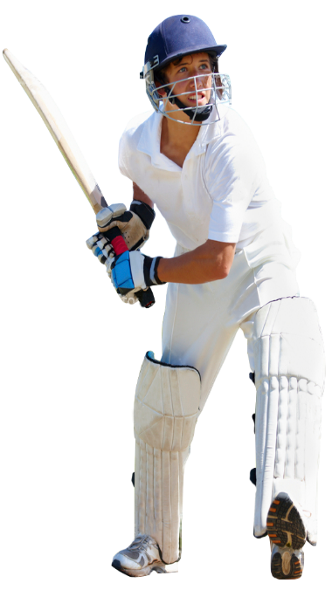


INTERNATIONAL MULTISPORTS TOURS
RUGBY HOCKEY NETBALL BASKETBALL CRICKET RUGBY SOCCER

HORIZONS GROUP TRAVEL LOGO

DESTINATIONS (DOUBLE INTERNAL PAGE)

World Map with pinpoint for each of the below destinations with the sports listed alongside/underneath
New Zealand – Rugby, Soccer, Netball, Hockey, Basketball, Volleyball, Cricket
United Kingdom – Rugby, Netball, Soccer, Cricket, Hockey
South Africa – Rugby, Cricket, Netball, Soccer, Hockey, Water Polo
France – Soccer, Netball, Hockey
Singapore & Malaysia – Soccer, Netball, Hockey, Volleyball
Sri Lanka – Cricket, Netball
India – Cricket, Hockey
Argentina – Soccer, Rugby, Netball, Hockey
USA – Volleyball, Basketball, Rugby, Soccer, Hockey, Water Polo, Swimming

Rear Page

Horizons Group Travel logo

Horizons Group Travel has been in operation since 2001 providing customised Sport Tour Packages to all corners of the globe. Horizons have sent thousands of tour participants to every inhabited continent of the planet.

Our tour packages include Flights, Accommodation, Transport, Organisation of Fixtures, Training, Sightseeing and Activities.

We pride ourselves on the level of service we provide which includes:
- Customising packages to your individuals needs
- Face to Face client Meetings
- Hosted Information Evenings
- Regular Tour Updates
- Risk Assessment Templates
- Tour Kit Partner Offers
- Tour Leader Package inclusive of Tour Leader Manual with comprehensive vouchers and documents, Individual Ticket Wallets and Bag Tags
- Airport Check in Assistance

Please contact us on:
(02) 9764 3421 or enquiry@horizons-sport.com.au
to schedule a time for one of our team to meet you and discuss the options available.

