Book Cover

8.5 X 11

Spine APPROXIMATELY .350 (will give you exact specs in a few days)

Details
See JPG below. I have put numbers on the SAMPLE COVER. We have written our thoughts/desires/revisions for a new cover that CORRESPOND to the numbers on the JPG.
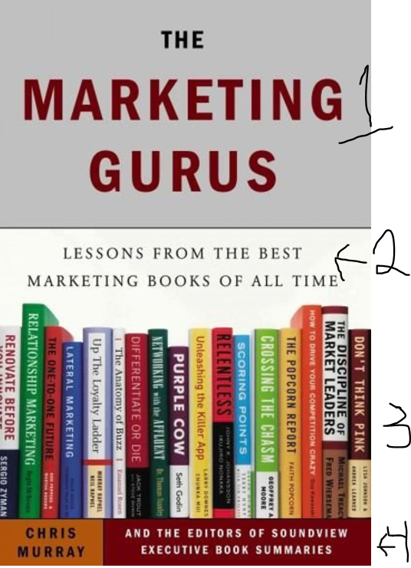
Introduction:
We are requesting a book cover. We are providing a JPG of book cover that we want to base our NEW cover on. *What we REALLY like about the cover, and want on our new cover, is a shelf of books with our authors and titles on those books.
See my NUMBERED comments below which correspond to the NUMBERED areas on JPEG.

*NOTE: We are providing GENERAL DESIGN thoughts, but request you use YOUR ARTISTIC creativity to make this new cover project POP.
- Main Title area: Our title will go here (see #1 in JPEG). PLACE our title here, it is: Research-Based Strategies to Grow Student Learning
- PlACE our Subtitle will go here: Our subtitle is: Insights and Strategies from 23 Classroom Teachers, Principals, School Executives and More!
  - For the title and subtitle, please pick font styles/types/sizes of your choice. Whatever YOU think makes the title POP.

Once again, PLEASE FEEL FREE in Title and SubTitle sections (1 & 2) to use YOUR CREATIVE DESIGN IDEAS. For example, see the jpeg (the title and subtitle section). We think the title and subtitle area (including the fonts and background) are boring and bland. We want you to make it better. Use colors and design that make the book title and subtitle appealing.

- We want you to MAKE UP 24 (TWENTY-FOUR) books like in the picture.
  - Next, we want you to put the title of the book on the top of the spine, as in JPG
*TITLES AND AUTHORS NAMES ARE BELOW
  - Next, we want you to put the Authors Name below the title, as in the JPG.
*TITLES AND AUTHORS NAMES ARE BELOW

Each book spine you design (23 in total) should:
  - Be unique. They should all look different, as in JPG.
  - Have the title on the spine (given below)
  - Have the authors name on the spine (given below)

Below are the names of authors AND short titles I want on each book. *It is important you put the CORRECT AUTHOR WITH CORRECT TITLE, as given below:

Tanya K. Moore
Challenging Opportunities

Arthur L. Williams, PH.D.
Managing Time

Mark Dessauer
Silent Thief

Eric Combs, M.S. Ed.
Preventing Cheating

Suzanne Wolf
Flexibility in Education

Jeffrey L. Kuhlman
Education in Distressed Environments

Glenna M. Kuhlman
Being Memorable

Kathleen Hartman Shiverdecker
School Attendance

Kathleen Hartman Shiverdecker
Juggling Roles

Johanna M. Bonds
Balancing Authority and Rapport

Allan and Julie Dodson
Developing Empathy

Allan and Julie Dodson
Parent Communication

Selma D. Davis
Tension and Stress

Teri A. Regan
Diverse Learners

Dr. Marilynn Kish-Molina
Collegial Interactions

Dr. Susan Hammack
Organization for Success

Pam Beech
Engaging Students

Billie. G. Mathews
Teachable Moments

Suzanne Wolf
Student Perceptions

Dr. Jacqueline Krohn
Testing Success

Dr. Jacqueline Krohn
Making the Grade

Dahlgren & Faulk
Issues Impacting Learning

Patricia H. Marino, Ph.D.
Cultural Differences

Kathryn Granato, M.Ed.
Real World Connection

- We will leave this area up to you. We DON’T like what they did and want you to make this space better. For example (ideas only)
  - Put our subtitle in this space? Instead of at top? Or…
  - Remove wording completely and just move the BOOKS to the bottom of the cover, Or…
  - If you have a different idea, tell us!

BACK OF BOOK COVER

We are leaving this ENTIRELY up to you. We want you to tie the theme of the front onto the back. Perhaps a STACK off books instead of standing like on the front???? Or…..?

Additionally, we have a jpg BARCODE that needs to go on the back. Leave a spot for that.

